Principles of bot design

The Bot Framework enables developers to create compelling bot experiences that solve a variety of business problems. By learning the concepts described in this section, you'll become equipped to design a bot that aligns with best practices and capitalizes on lessons learned thus far in this relatively new arena.

## **Designing a bot**

If you are building a bot, it is safe to assume that you are expecting users to use it. It is also safe to assume that you are hoping that users will prefer the bot experience over alternative experiences like apps, websites, phone calls, and other means of addressing their particular needs. In other words, your bot is competing for users' time against things like apps and websites. So, how can you maximize the odds that your bot will achieve its ultimate goal of attracting and keeping users? It's simply a matter of prioritizing the right factors when designing your bot.

## **Factors that do not guarantee a bot's success**

When designing your bot, be aware that none of the following factors necessarily guarantee a bot's success:

* **How “smart” the bot is**: In most cases, it is unlikely that making your bot smarter will guarantee happy users and adoption of your platform. In reality, many bots have little advanced machine learning or natural language capabilities. Of course, a bot may include those capabilities if they're necessary to solve the problems that it's designed to address. However, you should not assume any correlation between a bot's intelligence and user adoption of the bot.
* **How much natural language the bot supports**: Your bot can be great at conversations. It can have a vast vocabulary and can even make great jokes. But unless it addresses the problems that your users need to solve, these capabilities may contribute very little to making your bot successful. In fact, some bots have no conversational capability at all. And in many cases, that's perfectly fine.
* **Voice**: It isn’t always the case that enabling bots for speech will lead to great user experiences. Often, forcing users to use voice can result in a frustrating user experience. As you design your bot, always consider whether voice is the appropriate channel for the given problem. Is there going to be a noisy environment? Will voice convey the information that needs to be shared with the user?

## **Factors that do influence a bot's success**

Most successful apps or websites have at least one thing in common: a great user experience. Bots are no different in that regard. Therefore, ensuring a great user experience should be your number one priority when designing a bot. Some key considerations include:

* Does the bot easily solve the user’s problem with the minimum number of steps?
* Does the bot solve the user’s problem better/easier/faster than any of the alternative experiences?
* Does the bot run on the devices and platforms the user cares about?
* Is the bot discoverable? Do the users naturally know what to do when using it?

Note that none of these questions directly relates to factors such as how smart the bot is, how much natural language capability it has, whether it uses machine learning, or which programming language was used to create it. Users are unlikely to care about any of these things if the bot solves the problem that they need to address and delivers a great user experience. A great bot user experience does not require users to type too much, talk too much, repeat themselves several times, or explain things that the bot should automatically know.

Tip

Regardless of the type of application you're creating (bot, website, or app), make user experience a top priority.

The process of designing a bot is like the process of designing an app or website, so the lessons learned from decades of building UI and delivering UX for apps and websites still apply when it comes to designing bots. Whenever you are unsure about the right design approach for your bot, step back and ask yourself the following question: how would you solve that problem in an app or a website? Chances are, the same answer can be applied to bot design.

# Design a bot's first user interaction

## **First impressions matter**

The very first interaction between the user and bot is critical to the user experience. When designing your bot, keep in mind that there is more to that first message than just saying "hi." When you build an app, you design the first screen to provide important navigation cues. Users should intuitively understand things such as where the menu is located and how it works, where to go for help, what the privacy policy is, and so on. When you design a bot, the user's first interaction with the bot should provide that same type of information. In other words, just saying "hi" won’t be enough.

## **Language versus menus**

Consider the following two designs:

### **Design 1**

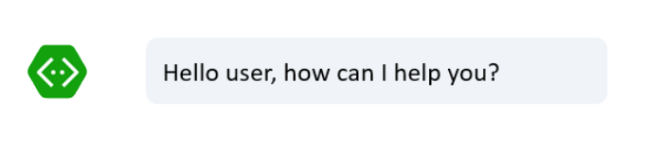

### **Design 2**

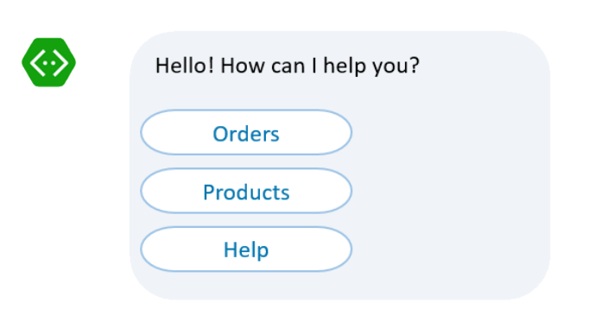

Starting the bot with an open-ended question such as "How can I help you?" is generally not recommended. If your bot has a hundred different things it can do, chances are users won’t be able to guess most of them. Your bot didn’t tell them what it can do, so how can they possibly know?

Menus provide a simple solution to that problem. First, by listing the available options, your bot is conveying its capabilities to the user. Second, menus spare the user from having to type too much. They can simply click. Finally, the use of menus can significantly simplify your natural language models by narrowing the scope of input that the bot could receive from the user.

Tip

Menus are a valuable tool when designing bots for a great user experience. Don’t dismiss them as not being "smart enough." You may design your bot to use menus while still supporting free form input. If a user responds to the initial menu by typing rather than by selecting a menu option, your bot could attempt to parse the user's text input.

## **Other considerations**

In addition to providing an intuitive and easily navigated first interaction, a well-designed bot provides the user with access to information about its privacy policy and terms of use.

Tip

If your bot collects personal data from the user, it's important to convey that and to describe what will be done with the data.

# Design and control conversation flow

In a traditional application, the user interface (UI) is a series of screens. A single app or website can use one or more screens as needed to exchange information with the user. Most applications start with a main screen where users initially land and provide navigation that leads to other screens for various functions like starting a new order, browsing products, or looking for help.

Like apps and websites, bots have a UI, but it is made up of **dialogs**, rather than screens. Dialogs enable the bot developer to logically separate various areas of bot functionality and guide conversational flow. For example, you may design one dialog to contain the logic that helps the user browse for products and a separate dialog to contain the logic that helps the user create a new order.

Dialogs may or may not have graphical interfaces. They may contain buttons, text, and other elements, or be entirely speech-based. Dialogs also contain actions to perform tasks such as invoking other dialogs or processing user input.

## **Using dialogs to manage conversation flow**

This diagram shows the screen flow of a traditional application compared to the dialog flow of a bot.

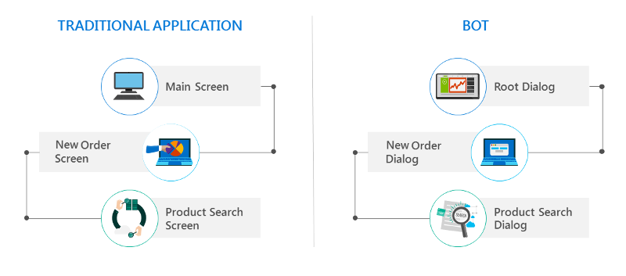

In a traditional application, everything begins with the **main screen**. The **main screen** invokes the **new order screen**. The **new order screen** remains in control until it either closes or invokes other screens. If the **new order screen** closes, the user is returned to the **main screen**.

In a bot, everything begins with the **root dialog**. The **root dialog** invokes the **new order dialog**. At that point, the **new order dialog** takes control of the conversation and remains in control until it either closes or invokes other dialogs. If the **new order dialog** closes, control of the conversation is returned back to the **root dialog**.

For a detailed walkthrough of managing conversation flow using dialogs and the Bot Builder SDK, see:

* [Manage conversation flow with dialogs (.NET)](https://docs.microsoft.com/en-us/bot-framework/dotnet/bot-builder-dotnet-manage-conversation-flow)
* [Manage conversation flow with dialogs (Node.js)](https://docs.microsoft.com/en-us/bot-framework/nodejs/bot-builder-nodejs-manage-conversation-flow)

## **Dialog stack**

When one dialog invokes another, the Bot Builder adds the new dialog to the top of the dialog stack. The dialog that is on top of the stack is in control of the conversation. Every new message sent by the user will be subject to processing by that dialog until it either closes or redirects to another dialog. When a dialog closes, it's removed from the stack, and the previous dialog in the stack assumes control of the conversation.

Important

Understanding the concept of how the dialog stack is constructed and deconstructed by the Bot Builder as dialogs invoke one another, close, and so on is critical to being able to effectively design the conversation flow of a bot.

## **Dialogs, stacks and humans**

It may be tempting to assume that users will navigate across dialogs, creating a dialog stack, and at some point will navigate back in the direction they came from, unstacking the dialogs one by one in a neat and orderly way. For example, the user will start at root dialog, invoke the new order dialog from there, and then invoke the product search dialog. Then the user will select a product and confirm, exiting the product search dialog, complete the order, exiting the new order dialog, and arrive back at the root dialog.

Although it would be great if users always traveled such a linear, logical path, it seldom occurs. Humans do not communicate in "stacks." They tend to frequently change their minds. Consider the following example:

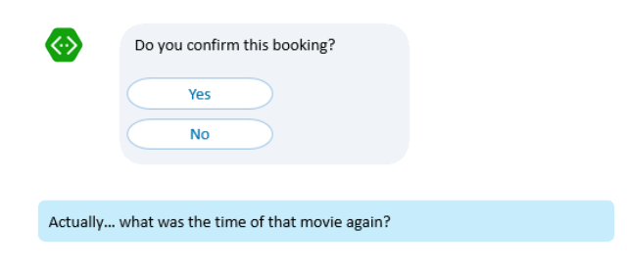

While your bot may have logically constructed a stack of dialogs, the user may decide to do something entirely different or ask a question that may be unrelated to the current topic. In the example, the user asks a question rather than providing the yes/no response that the dialog expects. How should your dialog respond?

* Insist that the user answer the question first.
* Disregard everything that the user had done previously, reset the whole dialog stack, and start from the beginning by attempting to answer the user's question.
* Attempt to answer the user's question and then return to that yes/no question and try to resume from there.

There is no right answer to this question, as the best solution will depend upon the specifics of your scenario and how the user would reasonably expect the bot to respond.

# Design bot navigation

Users can navigate websites using breadcrumbs, apps using menus, and web browsers using buttons like **forward** and **back**. However, none of these well-established navigation techniques entirely address navigation requirements within a bot. As discussed [previously](https://docs.microsoft.com/en-us/bot-framework/bot-service-design-conversation-flow#dialogs-stacks-and-humans), users often interact with bots in a non-linear fashion, making it challenging to design bot navigation that consistently delivers a great user experience. Consider the following dilemmas:

* How do you ensure that a user doesn't get lost in a conversation with a bot?
* Can a user navigate "back" in a conversation with a bot?
* How does a user navigate to the "main menu" during a conversation with a bot?
* How does a user "cancel" an operation during a conversation with a bot?

The specifics of your bot's navigation design will depend largely upon the features and functionality that your bot supports. However, regardless of the type of bot you're developing, you'll want to avoid the common pitfalls of poorly designed conversational interfaces. This article describes these pitfalls in terms of five personalities: the "stubborn bot", the "clueless bot", the "mysterious bot", the "captain obvious bot", and the "bot that can't forget."

## **The "stubborn bot"**

The stubborn bot insists upon maintaining the current course of conversation, even when the user attempts to steer things in a different direction. Consider the following scenario:

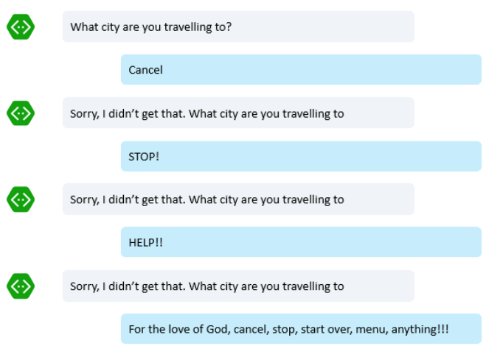

Users often change their minds. They can decide to cancel. Sometimes they want to start over altogether.

Tip

**Do**: Design your bot to consider that a user might attempt to change the course of the conversation at any time.

**Don't**: Design your bot to ignore user input and keep repeating the same question in an endless loop.

There are many methods of avoiding this pitfall, but perhaps the easiest way to prevent a bot from asking the same question endlessly is to simply specify a maximum number of retry attempts for each question. If designed in this manner, the bot is not doing anything "smart" to understand the user's input and respond appropriately but will at least avoid asking the same question in an endless loop.

## **The "clueless bot"**

The clueless bot responds in a nonsensical manner when it doesn't understand a user's attempt to access certain functionality. A user may try common keyword commands like "help" or "cancel" with reasonable expectations that the bot will respond appropriately.

Consider the following scenario:

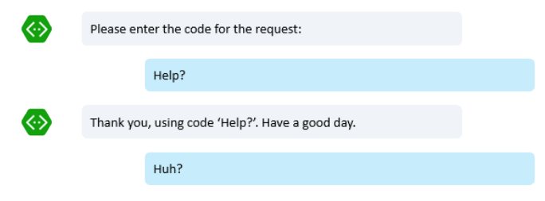

Although you may be tempted to design every dialog within your bot to listen for, and respond appropriately to, certain keywords, this approach is not recommended.

Tip

**Do**: Implement global message handlers (using [.NET](https://docs.microsoft.com/en-us/bot-framework/dotnet/bot-builder-dotnet-global-handlers) or [Node.js](https://docs.microsoft.com/en-us/bot-framework/nodejs/bot-builder-nodejs-dialog-actions)) that will examine user input for the keywords that you specify (ex: "help", "cancel", "start over", etc.) and respond appropriately.

**Don't**: Design every dialog to examine user input for a list of keywords.

By defining the logic in **global message handlers**, you're making it accessible to all dialogs. Using this approach, individual dialogs and prompts can be made to safely ignore the keywords, if necessary.

## **The "mysterious bot"**

The mysterious bot fails to immediately acknowledge the user's input in any way. Consider the following scenario:

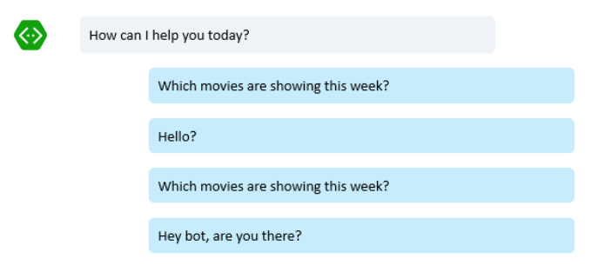

In some cases, this situation might be an indication that the bot is having an outage. However, it could just be that the bot is busy processing the user's input and hasn't yet finished compiling its response.

Tip

**Do**: Design your bot to immediately acknowledge user input, even in cases where the bot may take some time to compile its response.

**Don't**: Design your bot to postpone acknowledgement of user input until the bot finishes compiling its response.

By immediately acknowledging the user's input, you eliminate any potential for confusion as to the state of the bot.

## **The "captain obvious bot"**

The captain obvious bot provides unsolicited information that is completely obvious and therefore useless to the user. Consider the following scenario:

Tip

**Do**: Design your bot to provide information that will be useful to the user.

**Don't**: Design your bot to provide unsolicited information that is unlikely to be useful to the user.

By designing your bot to provide useful information, you're increasing the odds that the user will engage with your bot.

## **The "bot that can't forget"**

The bot that can't forget inappropriately integrates information from past conversations into the current conversation.

Consider the following scenario:

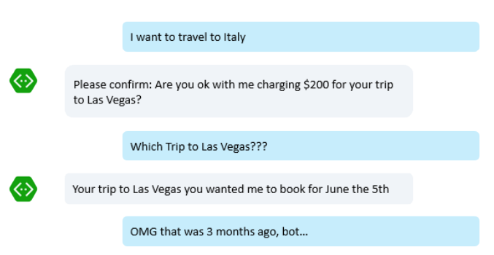

Tip

**Do**: Design your bot to maintain the current topic of conversation, unless/until the user expresses a desire to revisit a prior topic.

**Don't**: Design your bot to interject information from past conversations when it is not relevant to the current conversation.

By maintaining the current topic of conversation, you reduce the potential for confusion and frustration and increase the odds that the user will continue to engage with your bot.

# Design the user experience

Bots typically use some combination of **rich user controls**, **text and natural language**, and **speech** to exchange information with users.

## **Rich user controls**

**Rich user controls** are common UI controls such as buttons, images, carousels, and menus that the bot presents to the user and the user engages with to communicate choice and intent. A bot can use a collection of UI controls to mimic an app or can even run embedded within an app. When a bot is embedded within an app or website, it can represent virtually any UI control by leveraging the capabilities of the app that is hosting it.

For decades, application and website developers have relied on UI controls to enable users to interact with their applications. These same UI controls can also be very effective in bots. For example, buttons are a great way to present the user with a simple choice. Allowing the user to communicate "Hotels" by clicking a button labeled **Hotels** is easier and quicker than forcing the user to type "Hotels." This especially holds true on mobile devices, where clicking is greatly preferred over typing.

When designing your bot, do not automatically dismiss common UI elements as not being "smart enough." As discussed [previously](https://docs.microsoft.com/en-us/bot-framework/bot-service-design-principles#designing-a-bot), your bot should be designed to solve the user's problem in the best/quickest/easiest manner possible. Avoid the temptation to start by incorporating natural language understanding, as it is often unnecessary and just introduces unjustified complexity.

Tip

Start by using the minimum UI controls that enable the bot to solve the user's problem, and add other elements later if those controls are no longer sufficient.

## **Text and natural language understanding**

A bot can accept **text** input from users and attempt to parse that input using regular expression matching or **natural language understanding** APIs such as [LUIS](https://www.luis.ai/). There are many different types of text input that a bot might expect from a user. Depending on the type of input that the user provides, natural language understanding may or may not be a good solution.

In some cases, a user may be **answering a very specific question**. For example, if the bot asks, "What is your name?", the user may answer with text that specifies only the name, "John", or with a sentence, "My name is John". Asking specific questions reduces the scope of potential responses that the bot might reasonably receive, which decreases the complexity of the logic necessary to parse and understand the response. For example, consider the following broad, open-ended question: "How are you feeling?". Understanding the many possible permutations of potential answers to such a question is a very complex task. In contrast, specific questions such as "Are you feeling pain? yes/no" and "Where are you feeling pain? chest/head/arm/leg" would likely prompt more specific answers that a bot can parse and understand without needing to implement natural language understanding.

Tip

Whenever possible, ask specific questions that will not require natural language understanding capabilities to parse the response.

In other cases, a user may be **typing a specific command**. For example, a DevOps bot that enables developers to manage virtual machines could be designed to accept specific commands such as "/STOP VM XYZ" or "/START VM XYZ." Designing a bot to accept specific commands like this makes for a good user experience, as the syntax is easy to learn and the expected outcome of each command is clear. Additionally, the bot will not require natural language understanding capabilities, since the user's input can be easily parsed using regular expressions.

Tip

Designing a bot to require specific commands from the user can often provide a good user experience while also eliminating the need for natural language understanding capability.

In the case of a knowledge base bot or questions and answers bot, a user may be **asking general questions**. For example, imagine a bot that can answer questions based on the contents of thousands of documents. [QnA Maker](https://qnamaker.ai/" \t "_blank) and [Azure Search](https://azure.microsoft.com/en-us/services/search/) are both technologies which are designed specifically for this type of scenario. For more information, see [Design knowledge bots](https://docs.microsoft.com/en-us/bot-framework/bot-service-design-pattern-knowledge-base).

Tip

If you are designing a bot that will answer questions based on structured or unstructured data from databases, web pages, or documents, consider using technologies that are designed specifically to address this scenario rather than attempting to solve the problem with natural language understanding.

In other scenarios, a user may be **typing simple requests based on natural language**. For example, a user may type "I want a pepperoni pizza" or "Are there any vegetarian restaurants within 3 miles from my house open now?". Natural language understanding APIs such as [LUIS.ai](https://www.luis.ai/)are a great fit for scenarios like this. Using the APIs, your bot can extract the key components of the user's text to identify the user's intent. When implementing natural language understanding capabilities in your bot, set realistic expectations for the level of detail that users are likely to provide in their input.

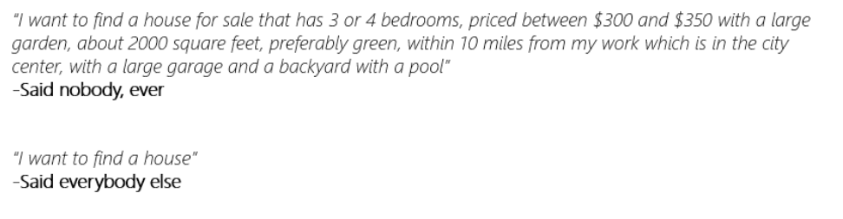

Tip

When building natural language models, do not assume that users will provide all the required information in their initial query. Design your bot to specifically request the information it requires, guiding the user to provide that information by asking a series of questions, if necessary.

## **Speech**

A bot can use **speech** input and/or output to communicate with users. In cases where a bot is designed to support devices that have no keyboard or monitor, speech is the only means of communicating with the user.

## **Choosing between rich user controls, text and natural language, and speech**

Just like people communicate with each other using a combination of gestures, voice, and symbols, bots can communicate with users using a combination of rich user controls, text (sometimes including natural language), and speech. You do not need to choose one over another. For example, imagine a "cooking bot" that helps users with recipes. The bot may provide instructions by playing a video or displaying a series of pictures to explain what needs to be done. Some users may prefer to flip pages of the recipe or ask the bot questions using speech while they are assembling a recipe. Others may prefer to touch the screen of a device instead of interacting with the bot via speech. When designing your bot, incorporate the UX elements that support the ways in which users will likely prefer to interact with your bot, given the specific use cases that it is intended support.

# Create task automation bots

A task automation bot enables the user to complete a specific task or set of tasks without any assistance from a human. This type of bot often closely resembles a typical app or website, communicating with the user primarily via rich user controls and text. It may have natural language understanding capabilities to enrich conversations with users.

## **Example use case: password-reset**

To better understand the nature of a task bot, consider an example use case: password-reset. The Contoso company receives several help desk calls each day from employees who need to reset their passwords. Contoso wants to automate the simple, repeatable task of resetting a employee's password so that help desk agents can devote their time to addressing more complex issues.

John, an experienced developer from Contoso, decides to create a bot to automate the password-reset task. He begins by writing a design specification for the bot, just as he would do if he were creating a new app or website.

### **Navigation model**

The specification defines the navigation model:

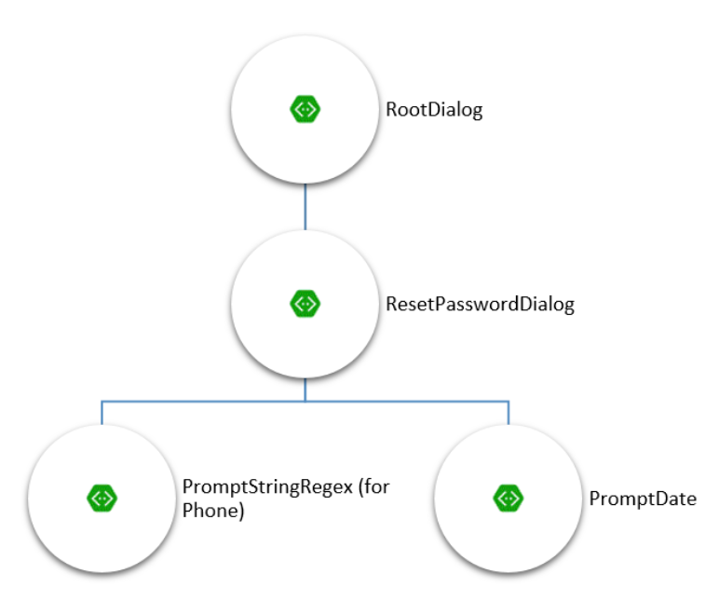

The user begins at the RootDialog. When they request a password reset, they  
will be directed to the ResetPasswordDialog. With the ResetPasswordDialog, the bot will prompt the user for two pieces of information: phone number and birth date.

Important

The bot design described in this article is intended for example purposes only. In real-world scenarios, a password-reset bot would likely implement a more robust identity verification process.

### **Dialogs**

Next, the specification describes the appearance and functionality of each dialog.

#### **Root dialog**

The root dialog provides the user with two options:

1. **Change Password** is for scenarios where the user knows their current password and simply wants to change it.
2. **Reset Password** is for scenarios where the user has forgotten or misplaced their password and needs to generate a new one.

Note

For simplicity, this article describes only the **reset password** flow.

The specification describes the root dialog as shown in the following screenshot.

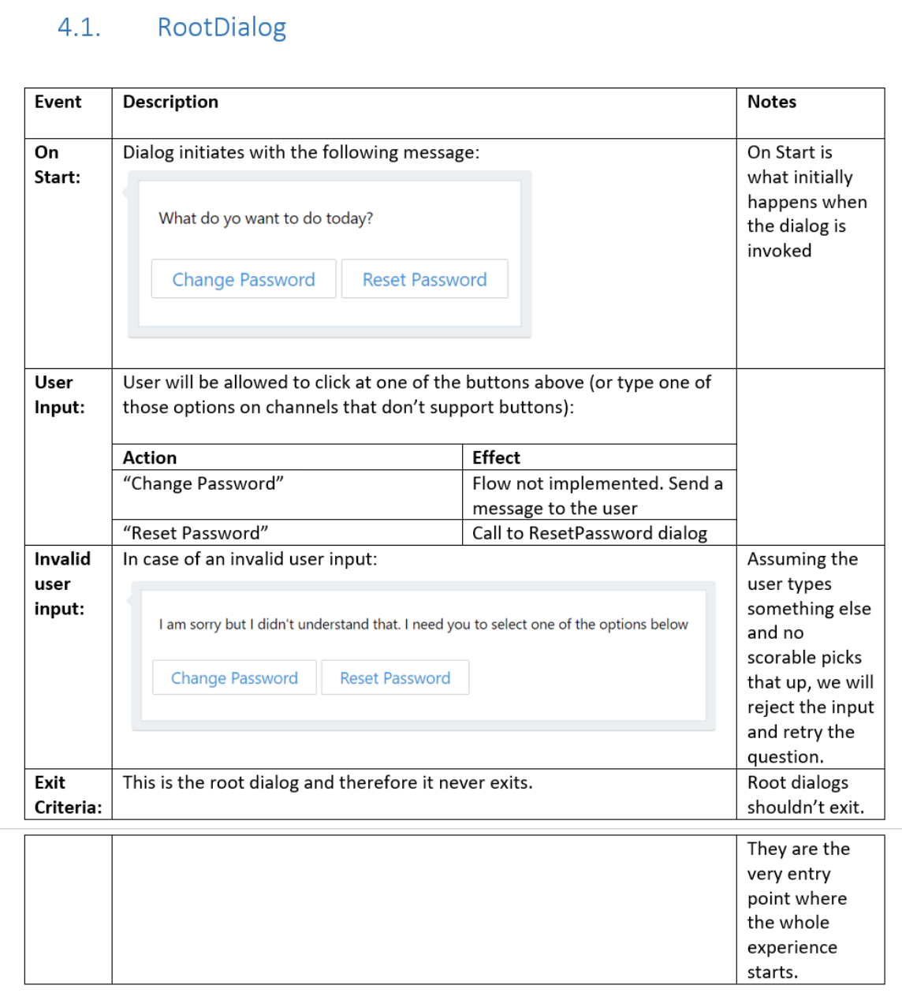

#### **ResetPassword dialog**

When the user chooses **Reset Password** from the root dialog, the ResetPassword dialog is invoked. The ResetPassword dialog then invokes two other dialogs. First, it invokes the PromptStringRegex dialog to collect the user's phone number. Then it invokes the PromptDatedialog to collect the user's date of birth.

Note

In this example, John chose to implement the logic for collecting the user's phone number and date of birth by using two separate dialogs. The approach not only simplifies the code required for each dialog, but also increases the odds of these dialogs being usable by other scenarios in the future.

The specification describes the ResetPassword dialog.

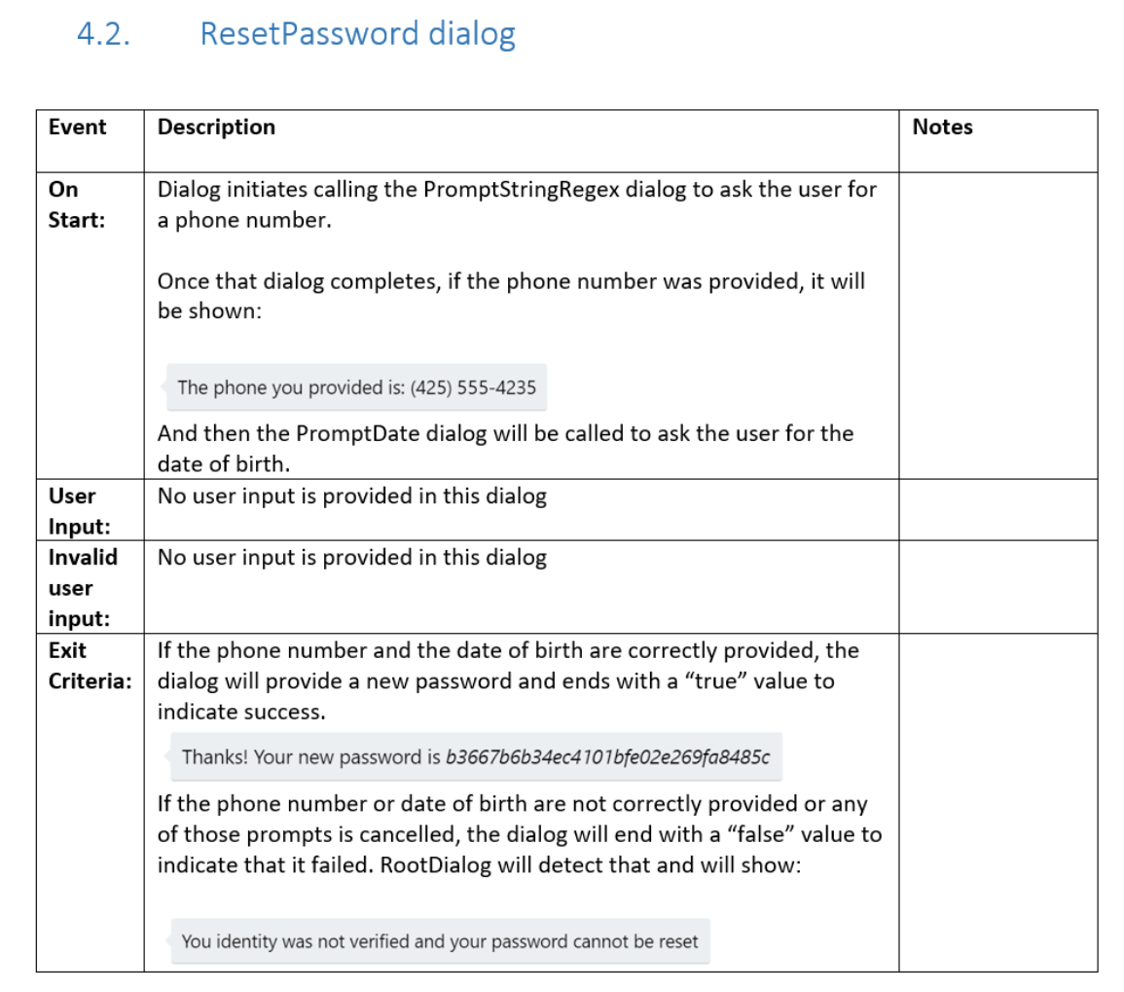

#### **PromptStringRegex dialog**

The PromptStringRegex dialog prompts the user to enter their phone number, and verifies that the phone number that the user provides matches the expected format. It also accounts for the scenario where the user repeatedly provides invalid input. The spec describes the PromptStringRegex dialog.

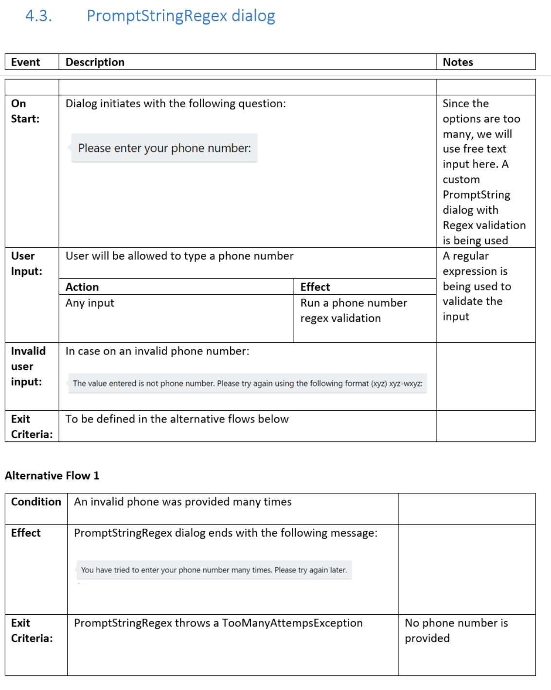

### **Prototype**

Finally, the spec provides an example of a user communicating with the bot to successfully complete the password-reset task.

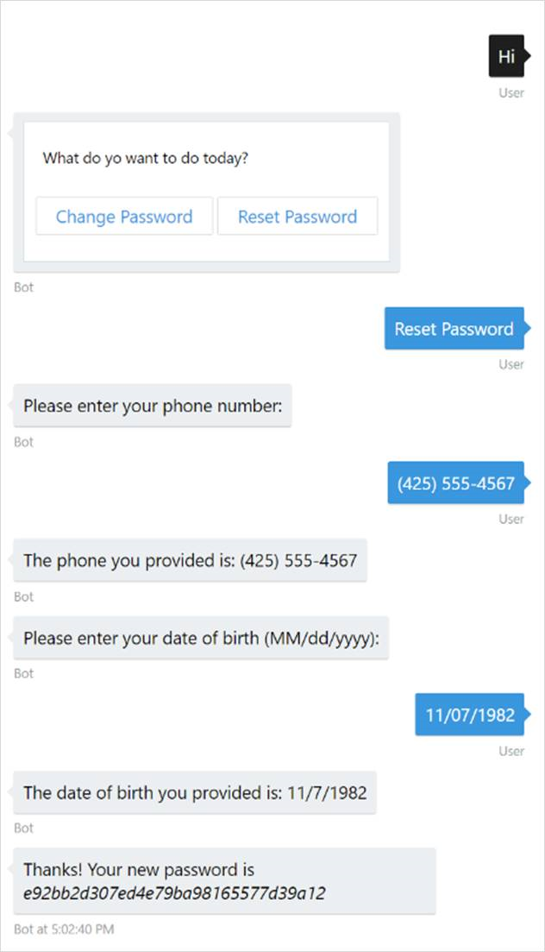

## **Bot, app, or website?**

You may be wondering, if a task automation bot closely resembles an app or website, why not just build an app or website instead? Depending on your particular scenario, building an app or website instead of a bot may be an entirely reasonable choice. You may even choose to embed your bot into an app, by using the [Bot Framework Direct Line API](https://docs.botframework.com/en-us/restapi/directline3/#navtitle) or [Web Chat control](https://github.com/Microsoft/BotFramework-WebChat). Implementing your bot within the context of an app provides the best of both worlds: a rich app experience and a conversational experience, all in one place.

In many cases, however, building an app or website can be significantly more complex and more expensive than building a bot. An app or website often needs to support multiple clients and platforms, packaging and deploying can be tedious and time-consuming processes, and the user experience of having to download and install an app is not necessarily ideal. For these reasons, a bot may often provide a much simpler way of solving the problem at hand.

Additionally, bots provide the freedom to easily expand and extend. For example, a developer may choose to add natural language and speech capabilities to the password-reset bot so that it can be accessed via audio call, or she may add support for text messages. The company may setup kiosks throughout the building and embed the password-reset bot into that experience.

## **Sample code**

For a complete sample that shows how to implement simple task automation using the Bot Builder SDK for .NET, see the [Simple Task Automation sample](https://github.com/Microsoft/BotBuilder-Samples/tree/master/CSharp/capability-SimpleTaskAutomation) in GitHub.

For a complete sample that shows how to implement simple task automation using the Bot Builder SDK for Node.js, see the [Simple Task Automation sample](https://github.com/Microsoft/BotBuilder-Samples/tree/master/Node/capability-SimpleTaskAutomation) in GitHub.

# Design knowledge bots

A knowledge bot can be designed to provide information about virtually any topic. For example, one knowledge bot might answer questions about events such as, "What bot events are there at this conference?", "When is the next Reggae show?", or "Who is Tame Impala?" Another might answer IT-related questions such as "How do I update my operating system?" or "Where do I go to reset my password?" Yet another might answer questions about contacts such as "Who is John Doe?" or "What is Jane Doe's email address?"

Regardless of the use case for which a knowledge bot is designed, its basic objective is always the same: find and return the information that the user has requested by leveraging a body of data, such as relational data in a SQL database, JSON data in a non-relational store, or PDFs in a document store.

## **Search**

Search functionality can be a valuable tool within a bot.

First, "fuzzy search" enables a bot to return information that's likely to be relevant to the user's question, without requiring that the user provide precise input. For example, if the user asks a music knowledge bot for information about "impala" (instead of "Tame Impala"), the bot can respond with information that's most likely to be relevant to that input.

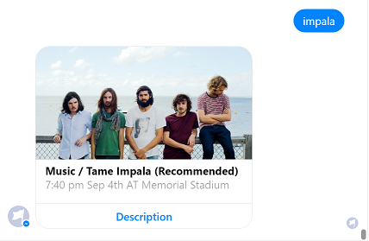

Search scores indicate the level of confidence for the results of a specific search, enabling a bot to order its results accordingly, or even tailor its communication based upon confidence level. For example, if confidence level is high, the bot may respond with "Here is the event that best matches your search:".

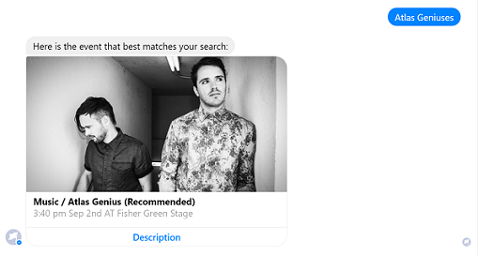

If confidence level is low, the bot may respond with "Hmm... were you looking for any of these events?"

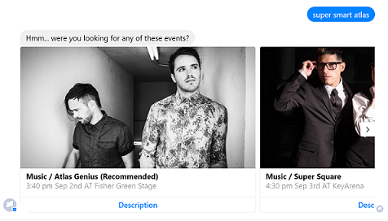

### **Using Search to Guide a Conversation**

If your motivation for building a bot is to enable basic search engine functionality, then you may not need a bot at all. What does a conversational interface offer that users can't get from a typical search engine in a web browser?

Knowledge bots are generally most effective when they are designed to guide the conversation. A conversation is composed of a back-and-forth exchange between user and bot, which presents the bot with opportunities to ask clarifying questions, present options, and validate outcomes in a way that a basic search is incapable of doing. For example, the following bot guides a user through a conversation that facets and filters a dataset until it locates the information that the user is seeking.

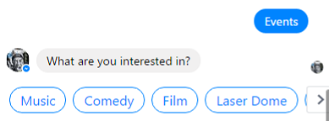

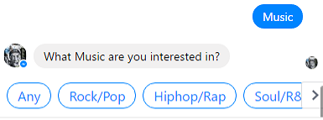

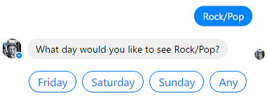

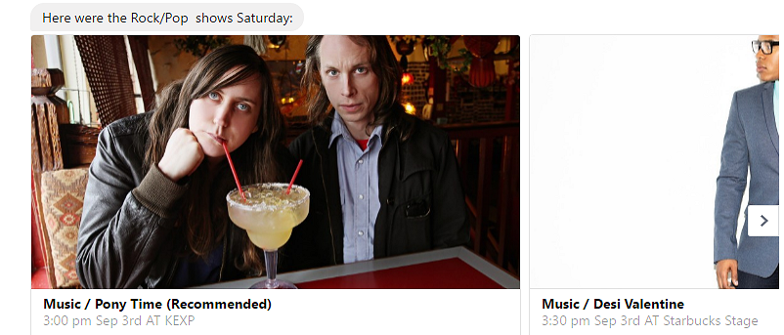

By processing the user's input in each step and presenting the relevant options, the bot guides the user to the information that they're seeking. Once the bot delivers that information, it can even provide guidance about more efficient ways to find similar information in the future.

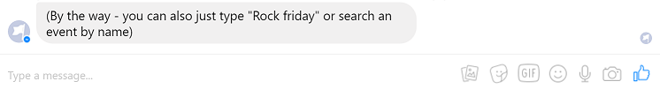

### **Azure Search**

By using [Azure Search](https://azure.microsoft.com/en-us/services/search/), you can create an efficient search index that a bot can easily search, facet, and filter. Consider a search index that is created using the Azure portal.

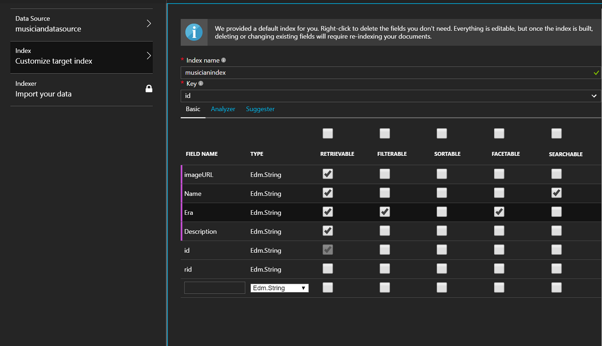

You want to be able to access all properties of the data store, so you set each property as "retrievable." You want to be able to find musicians by name, so you set the **Name** property as "searchable." Finally, you want to be able to facet filter over musicians' eras, so you mark the **Eras**property as both "facetable" and "filterable."

Faceting determines the values that exist in the data store for a given property, along with the magnitude of each value. For example, this screenshot shows that there are 5 distinct eras in the data store:

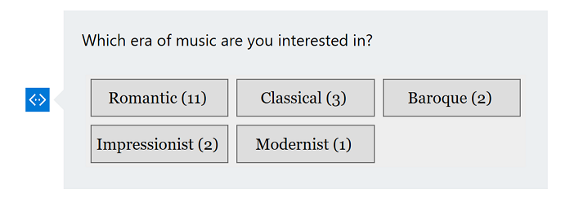

Filtering, in turn, selects only the specified instances of a certain property. For example, you could filter the result set above to contain only items where **Era** is equal to "Romantic."

Note

See [a sample bot](https://github.com/ryanvolum/AzureSearchBot) for a complete example of a knowledge bot that is created using Azure Document DB, Azure Search, and the Microsoft Bot Framework.

For the sake of simplicity, the example above shows a search index that is created using the Azure portal. Indices can also be created programatically.

## **QnA Maker**

Some knowledge bots may simply aim to answer frequently asked questions (FAQs). [QnA Maker](https://www.microsoft.com/cognitive-services/en-us/qnamaker" \t "_blank)is a powerful tool that's designed specifically for this use case. QnA Maker has the built-in ability to scrape questions and answers from an existing FAQ site. It also allows you to manually configure your own custom list of questions and answers. QnA Maker has natural language processing (NLP) abilities, enabling it to even provide answers to questions that are worded slightly differently than expected. However, it does not have semantic language understanding abilities. It cannot determine that a puppy is a type of dog, for example.

Using the QnA Maker web interface, you can configure a knowledge base with three question and answer pairs:

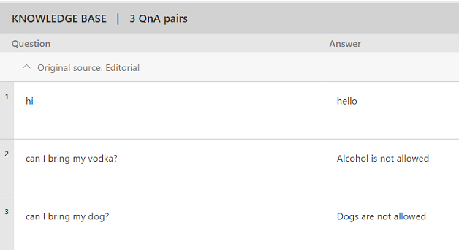

Then, you can test it by asking a series of questions:

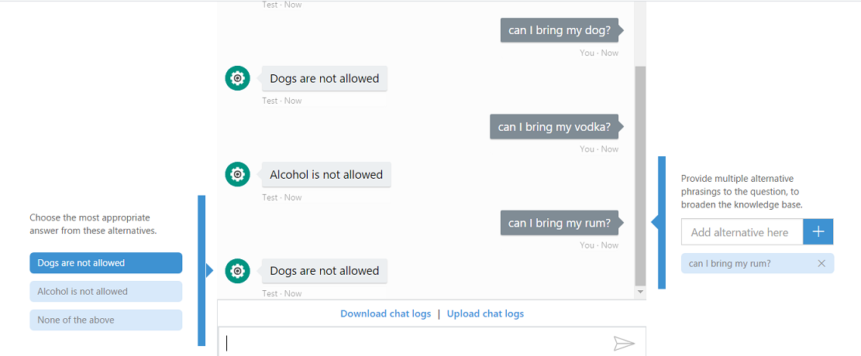

The bot correctly answers the questions that directly map to the ones that were configured in the knowledge base. However, it incorrectly responds to the question "can I bring my rum?". Because this question is most similar in structure to the question "can I bring my dog?" and because QnA Maker does not inherently understand the meaning of words, i.e., it does not know that "rum" is a type of liquor, it answers "Dogs are not allowed."

Tip

Create your QnA pairs and then test and re-train your bot by using the menu on the left side of the conversation to select an alternative answer for each incorrect answer that is given.

## **LUIS**

Some knowledge bots require natural language processing (NLP) capabilities so that they can analyze a user's messages to determine the user's intent. Language Understanding (LUIS) provides a fast and effective means of adding NLP capabilities to bots. LUIS enables you to use existing, pre-built models from Bing and Cortana whenever they meet your needs. It also allows you to create specialized models of your own.

When working with huge datasets, it's not necessarily feasible to train an NLP model with every variation of an entity. In a music playing bot, for example, a user might message "Play Reggae", "Play Bob Marley", or "Play One Love". Although a bot could map each of these messages to the intent "playMusic", without being trained with every artist, genre and song name, an NLP model would not be able to identify whether the entity is a genre, artist or song. By using an NLP model to identify the generic entity of type "music", the bot could search its data store for that entity, and proceed from there.

## **Combining Search, QnA Maker, and/or LUIS**

Search, QnA Maker and LUIS are each powerful tools in their own right, but they can also be combined to build knowledge bots that possess more than one of those capabilities.

### **LUIS and Search**

In the music festival bot example [covered earlier](https://docs.microsoft.com/en-us/bot-framework/bot-service-design-pattern-knowledge-base#search), the bot guides the conversation by showing buttons that represent the lineup. However, this bot could also incorporate natural language understanding by using LUIS to determine intent and entities within questions such as "what kind of music does Romit Girdhar play?". Then the bot could search against an Azure Search index using musician name.

It would not be feasible to train the model with every possible musician name since there are so many potential values, but you could provide enough representative examples for LUIS to properly identify the entity at hand. For example, consider that you train your model by providing examples of musicians:

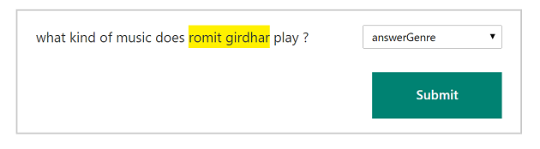 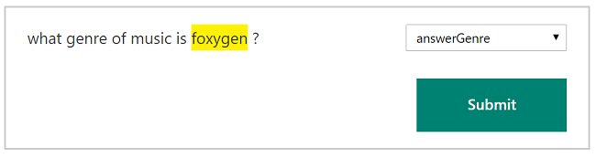

When you test this model with new utterances like, "what kind of music do the beatles play?", LUIS successfully determines the intent "answerGenre" and the identifies entity "the beatles." However, if you submit a longer question such as "what kind of music does the devil makes three play?", LUIS identifies "the devil" as the entity.

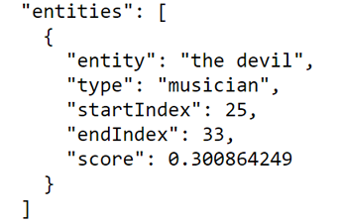

By training the model with example entities that are representative of the underlying dataset, you can increase the accuracy of your bot's language understanding.

Tip

In general, it is better for the model to err by identifying excess words in its entity recognition, e.g., identify "John Smith please" from the utterance "Call John Smith please", rather than identify too few words, e.g., identify "John" from the utterance "Call John Smith please". The search index will ignore irrelevant words such as "please" in the phrase "John Smith please".

### **LUIS and QnA Maker**

Some knowledge bots might use QnA Maker to answer basic questions in combination with LUIS to determine intents, extract entities and invoke more elaborate dialogs. For example, consider a simple IT Help Desk bot. This bot may use QnA Maker to answer basic questions about Windows or Outlook, but it might also need to facilitate scenarios like password reset, which require intent recognition and back-and-forth communication between user and bot. There are a few ways that a bot may implement a hybrid of LUIS and QnA Maker:

1. Call both QnA Maker and LUIS at the same time, and respond to the user by using information from the first one that returns a score of a specific threshold.
2. Call LUIS first, and if no intent meets a specific threshold score, i.e., "None" intent is triggered, then call QnA Maker. Alternatively, create a LUIS intent for QnA Maker, feeding your LUIS model with example QnA questions that map to "QnAIntent."
3. Call QnA Maker first, and if no answer meets a specific threshold score, then call LUIS.

The Bot Builder SDK for Node.js and the Bot Builder SDK for C# provide built-in support for LUIS and QnA Maker. This enables you to trigger dialogs or automatically answer questions using LUIS and/or QnA Maker without having to implement custom calls to either tool. For example, if LUIS has enabled you to determine intent, you could trigger a [BasicQnAMakerDialog](https://docs.botframework.com/en-us/azure-bot-service/templates/qnamaker/" \l "navtitle) to initiate the process of answering the user's question.

Tip

When implementing a combination of LUIS, QnA Maker, and/or Azure Search, test inputs with each of the tools to determine the threshold score for each of your models. LUIS, QnA Maker, and Azure Search each generate scores by using a different scoring criteria, so the scores generated across these tools are not directly comparable. Additionally, LUIS and QnA Maker normalize scores. A certain score may be considered 'good' in one LUIS model but not so in another model.

## **Sample code**

* For a sample that shows how to create a basic knowledge bot using the Bot Builder SDK for .NET, see the [Knowledge Bot sample](https://github.com/Microsoft/BotBuilder-Samples/tree/master/CSharp/sample-KnowledgeBot) in GitHub.
* For a sample that shows how to create more complex knowledge bots using the Bot Builder SDK for .NET, see the [Search-powered Bots sample](https://github.com/Microsoft/BotBuilder-Samples/tree/master/CSharp/demo-Search) in GitHub.

# Integrate your bot with a web browser

Some scenarios require more than just a bot to fulfill a requirement. A bot may need to send the user to a web browser to complete a task and then resume the conversation with the user after the task has been completed.

## **Authentication and authorization**

If a bot wants the ability to read the user's calendar in Office 365, or perhaps even create appointments on behalf of that user, the user must first authenticate with Microsoft Azure Active Directory and authorize the bot to access the user's calendar data. The bot will redirect the user to a web browser to complete the authentication and authorization tasks, and then will subsequently resume the conversation with the user.

## **Security and compliance**

Security and compliance requirements often restrict the type of information that a bot can exchange with a user. In some cases, it may be necessary for the user to send/receive data outside of the current conversation. For example, if a user wants to execute a payment using a third-party payment provider, a credit card number should not be specified within the context of the conversation. Instead, the bot will direct the user to a web browser to complete the payment process, and then will subsequently resume the conversation with the user.

This article explores the process of facilitating a user's transition from bot to web browser, and back again.

Note

Transitioning from chat to web browser and back is not ideal, as switching between applications can easily confuse a user. To provide a better experience, many channels offer built-in HTML windows that a bot can use to present applications would otherwise appear in a web browser. This technique allows the user to remain within the conversation while still accessing external resources. This approach is conceptually similar to mobile applications managing authorization flows using OAuth within embedded web views.

## **Bot to web browser, and back again**

This diagram shows the high-level flow for integration between bot and web browser.

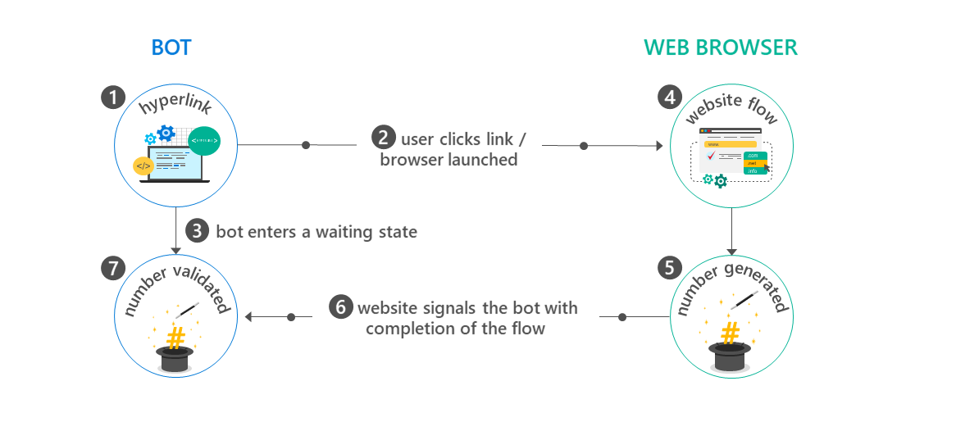

Consider each step of the flow:

1. The bot generates and displays a hyperlink that will redirect the user to a website. The hyperlink typically includes data via querystring parameters on the target URL that specify information about the context of the current conversation, such as conversation ID, channel ID, and user ID in the channel.
2. The user clicks the hyperlink and is redirected to the target URL within a web browser.
3. The bot enters a state awaiting communication from the website to indicate that the website flow is complete.

Tip

Design this flow so that the bot will not permanently remain in the 'waiting' state if the user never completes the website flow. In other words, if the user abandons the web browser and starts communicating with the bot again, the bot should acknowledge, not [ignore](https://docs.microsoft.com/en-us/bot-framework/bot-service-design-navigation#the-mysterious-bot) that input.

1. The user completes the necessary task(s) via the web browser. This could be an OAuth flow or any sequence of events required by the scenario at hand.
2. When the user completes the website flow, the website generates a '[magic number](https://docs.microsoft.com/en-us/bot-framework/bot-service-design-pattern-integrate-browser#verify-identity)' and instructs the user to copy the value and paste it back into the conversation with the bot.
3. The website [signals to the bot](https://docs.microsoft.com/en-us/bot-framework/bot-service-design-pattern-integrate-browser#website-signal-to-bot) that the user has completed the website flow. It communicates the 'magic number' to the bot and provides any other relevant data. For example, in the case of an OAuth flow, the website would provide an access token to the bot.
4. The user returns to the bot and pastes the 'magic number' into the chat. The bot validates that 'magic number' provided by the user matches the expected value, verifying that the current user is the same user who previously clicked the hyperlink to initiate the website flow.

### **Verifying user identity using the 'magic number'**

The generation of a 'magic number' during the bot-to-website flow ([step 5](https://docs.microsoft.com/en-us/bot-framework/bot-service-design-pattern-integrate-browser#generate-magic-number) above) enables the bot to subsequently verify that the user who initiated the website flow is indeed the user for whom it was intended. For example, if a bot is conducting a group chat with multiple users, any one of them could have clicked the hyperlink to initiate the website flow. Without the 'magic number' validation process, the bot has no way of knowing which user completed the flow. One user could authenticate and inject access tokens in another user's session.

Warning

This isn't just a risk within group chats. Without the 'magic number' validation process, anyone who obtains the hyperlink to launch the website flow can spoof a user's identity.

The magic number should be a random number generated using a strong cryptography library. For an example of the generation process in C#, see [this code](https://github.com/MicrosoftDX/AuthBot/blob/master/AuthBot/Controllers/OAuthCallbackController.cs#L138) within the [AuthBot](https://github.com/MicrosoftDX/AuthBot" \t "_blank) library. AuthBot enables bots that are built in Microsoft Bot Framework to implement the bot-to-website flow to authenticate a user in a website and then to subsequently use the access token that was generated from the authentication process. Since AuthBot does not make any assumptions about the channel's capabilities, such flows should function well with most channels.

Note

The need for the 'magic number' validation process should be deprecated as channels build their own embedded web views.

### **How does the website 'signal' the bot?**

When the bot [generates the hyperlink](https://docs.microsoft.com/en-us/bot-framework/bot-service-design-pattern-integrate-browser#generate-hyperlink) that the user will click to initiate the website flow, it includes information via querystring parameters in the target URL about the context of the current conversation, such as conversation ID, channel ID, and user ID in the channel. The website can subsequently use this information to read and write state variables for that user or conversation using the Bot Builder SDK or REST APIs. See [step 6](https://docs.microsoft.com/en-us/bot-framework/bot-service-design-pattern-integrate-browser#signal-to-bot) above for an example of how the website 'signals' to the bot that the website flow is complete.

## **Sample code**

As described in this article, the [AuthBot](https://github.com/microsoftdx/authbot" \t "_blank) library enables OAuth flows to be bound to bots that are built using .NET in the Microsoft Bot Framework. The [BotAuth](https://github.com/MicrosoftDX/botauth" \t "_blank) library enables OAuth flows to be bound to bots that are built using Node.js in the Microsoft Bot Framework.

# Transition conversations from bot to human

Regardless of how much artificial intelligence a bot possesses, there may still be times when it needs to hand off the conversation to a human being. The bot should recognize when it needs to hand off and provide the user with a clear, smooth transition.

## **Scenarios that require human involvement**

A wide variety of scenarios may require that a bot transition control of the conversation to a human. A few of those scenarios are triage, escalation, and supervision.

### **Triage**

A typical help desk call starts with some very basic questions that can easily be answered by a bot. As the first responder to inbound requests from users, a bot could collect the user's name, address, and description of the problem and then transition control of the conversation to an agent. Using a bot to triage incoming requests allows agents to devote their time to solving the problem instead of collecting information.

### **Escalation**

In the help desk scenario, a bot may be able to answer basic questions and resolve simple issues in addition to collecting information. For example, bots are commonly used to reset a user's password. However, if a conversation indicates that a user's issue is complex enough to require human involvement, the bot will need to escalate the issue to a human agent. To implement this type of scenario, a bot must be capable of differentiating between issues it can resolve independently and issues that must be escalated to a human. There are many ways that a bot may determine that it needs to transfer control of the conversation to a human, including:

#### **User-driven menus**

Perhaps the simplest way for a bot to handle this dilemma is to present the user with a menu of options. Tasks that the bot can handle independently appear in the menu above a link labeled "Chat with an agent." This type of implementation requires no advanced machine learning or natural language understanding. The bot simply transfers control of the conversation to a human agent when the user selects the "Chat with an agent" option.

#### **Scenario-driven**

The bot may decide whether or not to transfer control based upon whether or not it determines that it is capable of handling the scenario at hand. The bot collects some information about the user's request and then queries its internal list of capabilities to determine if it is capable of addressing that request. If the bot determines that it is capable of addressing the request, it does so. However, if the bot determines that the request is beyond the scope of issues it can resolve, it transfers control of the conversation to a human agent.

#### **Natural language**

Natural language understanding and sentiment analysis help the bot decide when to transfer control of the conversation to a human agent. This is particularly valuable when attempting to determine when the user is frustrated or wants to speak with a human agent.

The bot analyzes the content of the user's messages by using the [Text Analytics API](https://www.microsoft.com/cognitive-services/en-us/text-analytics-api) to infer sentiment or by using the [LUIS API](https://www.luis.ai/).

Tip

Natural language understanding may not always be the best method for determining when a bot should transfer conversation control to a human being. Bots, like humans, don't always guess correctly, and invalid responses will frustrate the user. If the user selects from a menu of valid choices, however, the bot will always respond appropriately to that input.

### **Supervision**

In some cases, the human agent will want to monitor the conversation instead of taking control.

For example, consider a help desk scenario where a bot is communicating with a user to diagnose computer problems. A machine learning model helps the bot determine the most likely cause of the issue. Before advising the user to take a specific course of action, the bot can privately confirm the diagnosis and remedy with the human agent and request authorization to proceed. The agent clicks a button, the bot presents the solution to the user, and the problem is solved. The bot is still performing the majority of the work, but the agent retains control the final decision.

## **Transitioning control of the conversation**

When a bot decides to transfer control of a conversation to a human, it can inform the user that she is being transferred and put the conversation into a 'waiting' state until it confirms that an agent is available.

When the bot is waiting for a human, it may automatically answer all incoming user messages with a default response such as "waiting in queue". Furthermore, you could have the bot remove the conversation from the 'waiting' state if the user sent certain messages such as "never mind" or "cancel".

You specify how agents will be assigned to waiting users when you design your bot. For example, the bot may implement a simple queue system: first in, first out. More complex logic would assign users to agents based upon geography, language, or some other factor. The bot could also present some type of UI to the agent that they can use to select a user. When an agent becomes available, she connects to the bot and joins the conversation.

Important

Even after an agent is engaged, the bot remains the behind-the-scenes facilitator of the conversation. The user and agent never communicate directly with each other; they just route messages through the bot.

## **Routing messages between user and agent**

After the agent connects to the bot, the bot begins to route messages between user and agent. Although it may appear to the user and the agent that they are chatting directly with each other, they are exchanging messages via the bot. The bot receives messages from the user and sends those messages to the agent. Likewise, it receives messages from the agent and sends those messages to the user.

Note

In more advanced scenarios, the bot can assume responsibility beyond merely routing messages between user and agent. For example, the bot may decide which response is appropriate and simply ask the agent for confirmation to proceed.

## **Sample code**

For a complete sample that shows how to hand off conversations from bot to human using the Bot Builder SDK for Node.js, see the [Bot-HandOff sample](https://github.com/palindromed/Bot-HandOff) in GitHub.

# Embed a bot in an app

Although bots most commonly exist outside of apps, they can also be integrated with apps. For example, you could embed a [knowledge bot](https://docs.microsoft.com/en-us/bot-framework/bot-service-design-pattern-knowledge-base) within an app to help users find information that might otherwise be challenging to locate within complex app structures. You could embed a bot within a help desk app to act as the first responder to incoming user requests. The bot could independently resolve simple issues and [hand off](https://docs.microsoft.com/en-us/bot-framework/bot-service-design-pattern-handoff-human) more complex issues to a human agent.

## **Integrating bot with app**

The way to integrate a bot with an app varies depending on the type of app.

### **Native mobile app**

An app that is created in native code can communicate with the Bot Framework by using the [Direct Line API](https://docs.botframework.com/en-us/restapi/directline3/#navtitle), either via REST or websockets.

### **Web-based mobile app**

A mobile app that is built by using web language and frameworks such as [Cordova](https://cordova.apache.org/) may communicate with the Bot Framework by using the same components that a [bot embedded within a website](https://docs.microsoft.com/en-us/bot-framework/bot-service-design-pattern-embed-web-site) would use, just encapsulated within a native app's shell.

### **IoT app**

An IoT app can communicate with the Bot Framework by using the [Direct Line API](https://docs.botframework.com/en-us/restapi/directline3/#navtitle). In some scenarios, it may also use [Microsoft Cognitive Services](https://www.microsoft.com/cognitive-services/) to enable capabilities such as image recognition and speech.

### **Other types of apps and games**

Other types of apps and games can communicate with the Bot Framework by using the [Direct Line API](https://docs.botframework.com/en-us/restapi/directline3/#navtitle).

## **Creating a cross-platform mobile app that runs a bot**

This example of creating a mobile app that runs a bot uses [Xamarin](https://www.xamarin.com/), a popular tool for building cross-platform mobile applications.

First, create a simple web view component and use it to host a [web chat control](https://github.com/Microsoft/BotFramework-WebChat). Then, using the Bot Framework Portal, [connect the bot](https://docs.microsoft.com/en-us/bot-framework/bot-service-manage-channels) to the Web Chat channel.

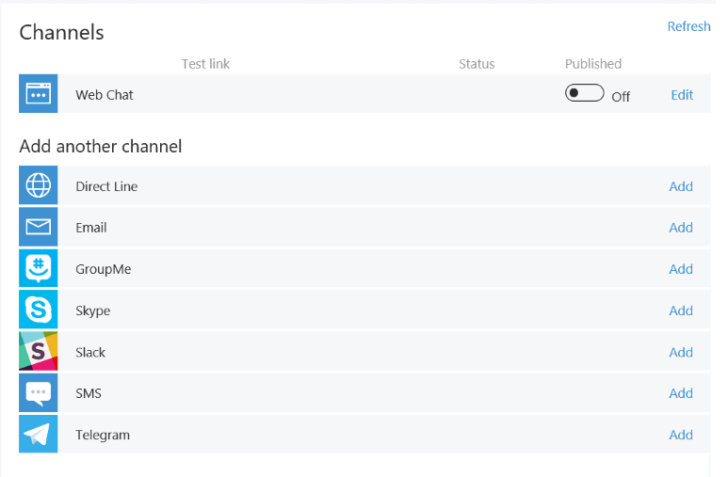

Next, specify the registered web chat URL as the source for the web view control in the Xamarin app:

C#Copy

public class WebPage : ContentPage

{

public WebPage()

{

var browser = new WebView();

browser.Source = "https://webchat.botframework.com/embed/<YOUR SECRET KEY HERE>";

this.Content = browser;

}

}

Using this process, you can create a cross-platform mobile application that renders the embedded web view with the web chat control.

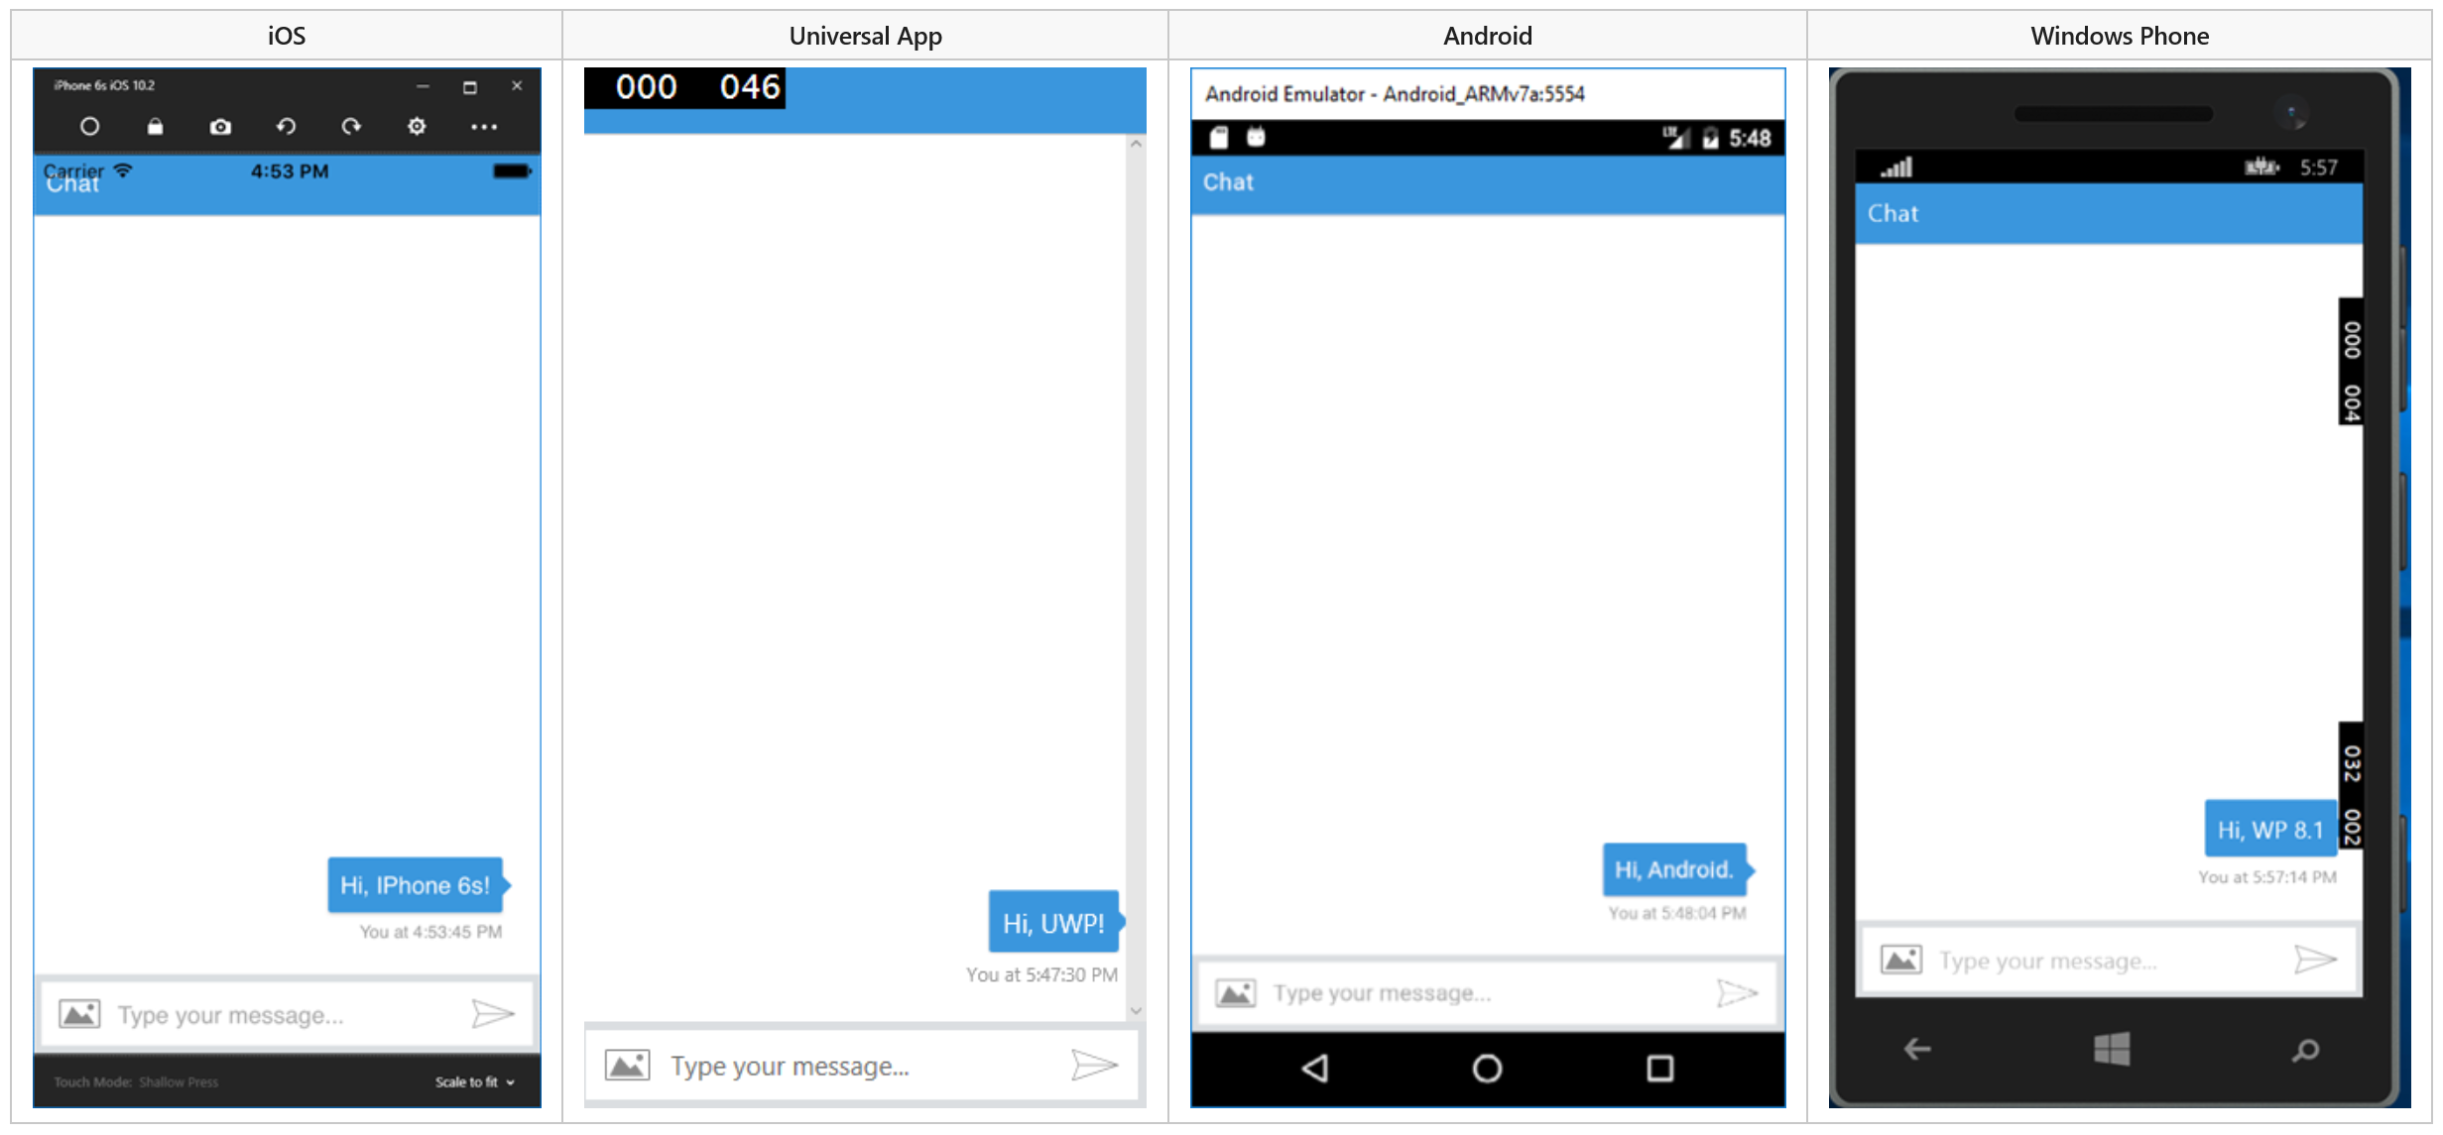

## **Sample code**

For a complete sample that shows how to create a cross-platform mobile app that runs a bot (as described in this article), see the [Bot in Apps sample](https://github.com/Microsoft/BotBuilder-Samples/tree/master/CSharp/capability-BotInApps) in GitHub.

# Embed a bot in a website

Although bots commonly exist outside of websites, they can also be embedded within a website. For example, you may embed a [knowledge bot](https://docs.microsoft.com/en-us/bot-framework/bot-service-design-pattern-knowledge-base) within a website to enable users to quickly find information that might otherwise be challenging to locate within complex website structures. Or you might embed a bot within a help desk website to act as the first responder to incoming user requests. The bot could independently resolve simple issues and [handoff](https://docs.microsoft.com/en-us/bot-framework/bot-service-design-pattern-handoff-human) more complex issues to a human agent.

This article explores integrating bots with websites and the process of using the backchannelmechanism to facilitate private communication between a web page and a bot.

Microsoft provides two different ways to integrate a bot in a website: the Skype web control and an open source web control.

## **Skype web control**

The Skype web control is essentially a Skype client in a web-enabled control. Built-in Skype authentication enables the bot to authenticate and recogize users, without requiring the developer to write any custom code. Skype will automatically recognize Microsoft Accounts used in its web client.

Because the Skype web control simply acts as a front-end for Skype, the user's Skype client automatically has access to the full context of any conversation that the web control facilitates. Even after the web browser is closed, the user may continue to interact with the bot using the Skype client.

## **Open source web control**

The [open source web chat control](https://github.com/Microsoft/BotFramework-WebChat) is based upon ReactJS and uses the [Direct Line API](https://docs.botframework.com/en-us/restapi/directline3/#navtitle) to communicate with the Bot Framework. The web chat control provides a blank canvas for implementing the web chat, giving you full control over its behaviors and the user experience that it delivers.

The backchannel mechanism enables the web page that is hosting the control to communicate directly with the bot in a manner that is entirely invisible to the user. This capability enables a number of useful scenarios:

* The web page can send relevant data to the bot (e.g., GPS location).
* The web page can advise the bot about user actions (e.g., "user just selected Option A from the dropdown").
* The web page can send the bot the auth token for a logged-in user.
* The bot can send relevant data to the web page (e.g., current value of user's portfolio).
* The bot can send "commands" to the web page (e.g., change background color).

## **Using the backchannel mechanism**

The [open source web chat control](https://github.com/Microsoft/BotFramework-WebChat) communicates with bots by using the [Direct Line API](https://docs.botframework.com/en-us/restapi/directline3/#navtitle), which allows activities to be sent back and forth between client and bot. The most common type of activity is message, but there are other types as well. For example, the activity type typingindicates that a user is typing or that the bot is working to compile a response.

You can use the backchannel mechanism to exchange information between client and bot without presenting it to the user by setting the activity type to event. The web chat control will automatically ignore any activities where type="event".

## **Sample code**

The [open source web chat control](https://github.com/Microsoft/BotFramework-WebChat) is available via GitHub. For details about how you can implement the backchannel mechanism using the open source web chat control and the Bot Builder SDK for Node.js, see [Use the backchannel mechanism](https://docs.microsoft.com/en-us/bot-framework/nodejs/bot-builder-nodejs-backchannel).

# Manage a bot

This topic explains how to manage a bot using the Azure portal.

## **Bot settings overview**

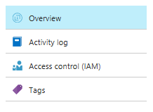

In the **Overview** blade, you can find high level information about your bot. For example, you can see your bot's **Subscription ID**, **pricing tier**, and **Messaging endpoint**.

## **Bot management**

You can find most of your bot's management options under the **BOT MANAGEMENT** section. Below is a list of options to help you manage your bot.

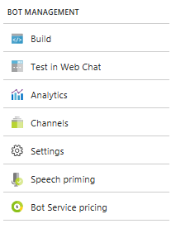

| Option | Description |
| --- | --- |
| **Build** | The Build tab provides options for making changes to your bot. This option is not available for **Registration Only Bot**. |
| **Test in Web Chat** | Use the integrated Web Chat control to help you quickly test your bot. |
| **Analytics** | If analytics is turned on for your bot, you can view the analytics data that Application Insights has collected for your bot. |
| **Channels** | Configure the channels your bot uses to communicate with users. |
| **Settings** | Manage various bot profile settings such as display name, analytics, and messaging endpoint. |
| **Speech priming** | Manage the connections between your LUIS app and the Bing Speech service.. |
| **Bot Service pricing** | Manage the pricing tier for the bot service. |

## **App service settings**

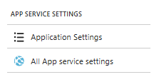

The **Application Settings** blade contains detailed information about your bot, such as the bot's environment, ID, Application Insights key, Microsoft App ID, and Microsoft App password.

### **MicrosoftAppID and MicrosoftAppPassword**

You can find the **MicrosoftAppID** and **MicrosoftAppPassword** for your bot in the **Application Settings** blade.

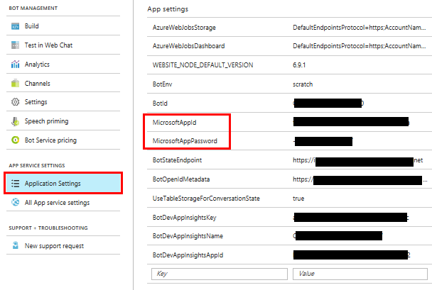

Note

The **Bot Channels Registration** bot service comes with a MicrosoftAppID but because there is no app service associated with this type of service, there is no **Application Settings** blade for you to look up the MicrosoftAppPassword. To get the password, you must go generate one. To generate the password for a **Bot Channels Registration**, see [Bot Channels Registration password](https://docs.microsoft.com/en-us/bot-framework/bot-service-quickstart-registration#bot-channels-registration-password)

# Edit a bot with online code editor

You can use the online code editor to build your bot without needing an IDE. This topic will show you how to open your bot code in the online code editor.

## **Edit bot source code in online code editor**

To edit a bot's source code in the online code editor, do the following for the specific type of type you have.

### **Web App Bot**

1. Sign into the [Azure portal](http://portal.azure.com/) and open the blade for the bot.
2. Under the **BOT MANAGEMENT** section, Click **Build**.
3. Click **Open online code editor**. This will open the bot's code in a new browser window.

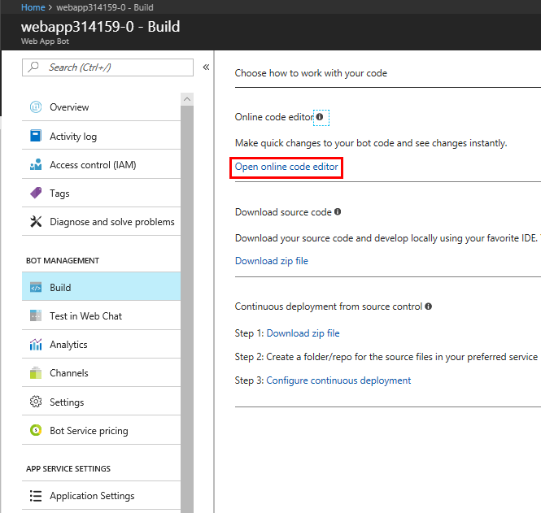

Depending on the language of the bot, the file structure under the **WWWRoot**directory will be different. For example, if you have a C# bot, your **WWWRoot** may look something like this:

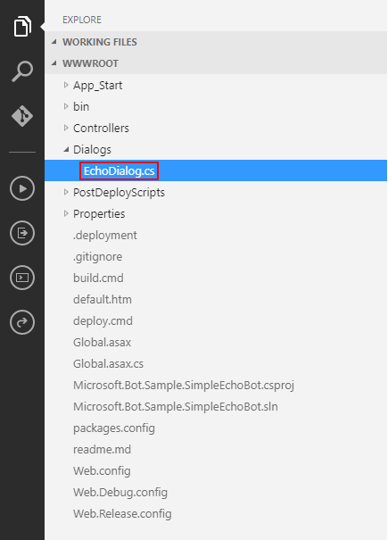

If you have a Node.js bot, your **WWWRoot** may look something like this:

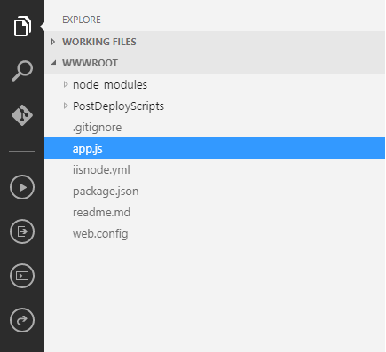

1. Make code changes. For example, for C# bots, you can start with the **Dialogs/EchoDialog.cs** file. For Node.js bots, you can start with the **App.js** file.

Note

While you can make code changes to current source files in the project, it is not possible to create new source files using the online code editor. To add new source files to the bot, you need to [download the source](https://docs.microsoft.com/en-us/bot-framework/bot-service-build-download-source-code) project, add your files and publish the changes back to Azure.

1. Save your changes. For C# bots that are on a **Consumption plan** and all Node.js bots, the bot is automatically updated once the source code is saved by clicking the **Save**button.

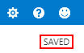

For C# bots on an **App service** plan, open the **Console** blade and send the **build.cmd**command.

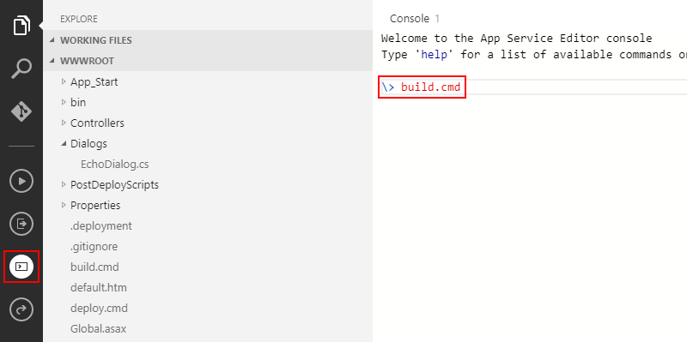

Note

If this command fails to build, try restarting your bot's app service and try building again. To restart your app service, from your bot's blade, click **All App service settings** then click the **Restart** button. 

1. Switch back to Azure portal and click **Test in Web Chat** to test out your changes. If you already have the Web Chat open for this bot, click **Start over** to see the new changes.

### **Functions Bot**

1. Sign into the [Azure portal](http://portal.azure.com/) and open the blade for the bot.
2. Under the **BOT MANAGEMENT** section, Click **Build**.
3. Click **Open this bot in Azure Functions**. This will open the bot with the [Azure Functions](http://go.microsoft.com/fwlink/?linkID=747839) UI.
4. Make code changes. For example, update the function's messages code. The screen shot below shows the Messages code for a Node.js Functions Bot.

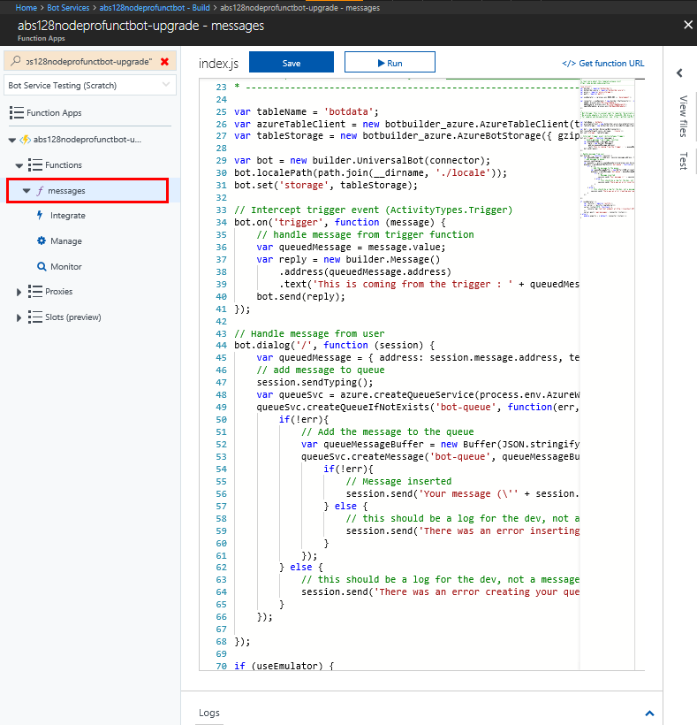

1. Save your code changes.
2. Switch back to Azure portal and click **Test in Web Chat** to test out your changes. If you already have the Web Chat open for this bot, click **Start over** to see the new changes.

# Download Bot Service source code

Bot Service allows you to download the entire source project for your bot. This allows you to work on your bot locally using an IDE of your choice. Once you are done making changes, you can publish your changes back to Azure.

This topic will show you how to download your bot's source code and publishing the changes back to Azure.

## **Download bot source code**

To develop your bot locally, do the following:

1. In the Azure portal and open the blade for the bot.
2. Under the **BOT MANAGEMENT** section, Click **Build**.
3. Click **Download zip file**.

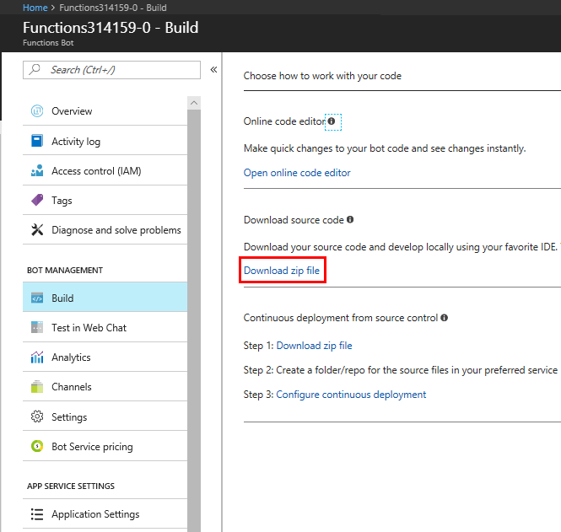

1. Extract the .zip file to a local directory.
2. Navigate to the extracted folder and open the source files in your favorite IDE.
3. Make changes to your sources. Either edit existing source files or add new ones to your project.

When you are ready, you can publish the sources back to Azure.

## **Publish Node bot source code to Azure**

To publish the sources back to Azure, run the following NPM command:

consoleCopy

npm run azure-publish

## **Publish C# bot source code to Azure**

Publishing C# code to Azure using Visual Studio is a two step process: First, you will need to configure publishing settings. Then, you can publish your changes.

To configure publishing from Visual Studio, do the following:

1. In Visual Studio, click **Solution Explorer**.
2. Right-click your project name and click **Publish...**. The **Publish** window opens.
3. Click **Create new profile**, click **Import profile**, and click **OK**.
4. Navigate to your project folder then navigate to the **PostDeployScripts** folder, and select the file that ends in **.PublishSettings**. Click **Open**.

Your project is now configured to publish changes to Azure.

Once your project is configured, you can publish your bot source code back to Azure by doing the following:

1. In Visual Studio, click **Solution Explorer**.
2. Right-click your project name and click **Publish...**.
3. Click the **Publish** button to publish your changes to Azure.

# Set up continuous deployment

Continuous deployment allows you to develop your bot locally. Continuous deployment is useful if your bot is checked into a source control like **GitHub** or **Visual Studio Team Services**. As you check your changes back into your source repository, your changes will automatically be deployed to Azure.

Note

Once continuous deployment is set up, the [online code editor](https://docs.microsoft.com/en-us/bot-framework/bot-service-build-online-code-editor) becomes READ ONLY.

This topic will show you how to set up continuous deployment for **GitHub** and **Visual Studio Team Services**.

## **Continuous deployment using GitHub**

To set up continuous deployment using GitHub, do the following:

1. [Fork](https://help.github.com/articles/fork-a-repo/) the GitHub repository that contains the code you want to deploy to Azure.
2. From the Azure portal, go to your bot's **Build** blade and click **Configure continuous deployment**.
3. Click **Setup**.



1. Click **Choose source** and choose **GitHub**.

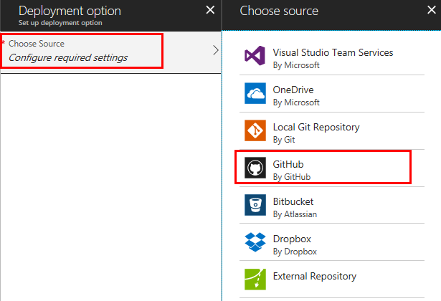

1. Click **Authorization** then click the **Authorize** button and follow the prompts to give Azure authorization to access your GitHub account.

Your continuous deployment with GitHub setup is complete. Whenever you commit, your changes will automatically be deployed to Azure.

## **Continuous deployment using Visual Studio**

1. From your bot's **Build** blade, click **Configure continuous deployment**.
2. Click **Setup**.



1. Click **Choose source** and choose **Visual Studio Team Services**.

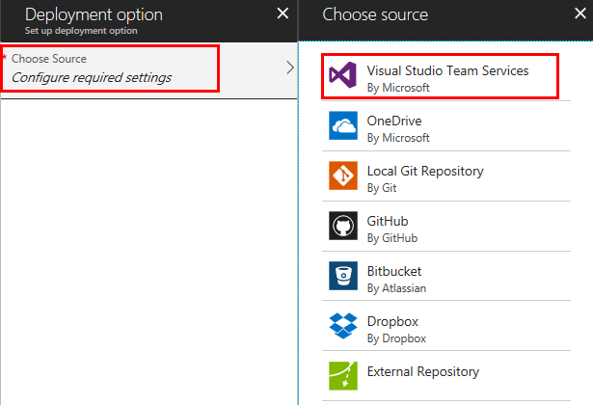

1. Click **Choose your account** and choose an account.
2. Click **Choose a project** and choose a project.
3. click **Choose Branch** and choose a branch to branch.
4. Click **OK** to complete the setup process.

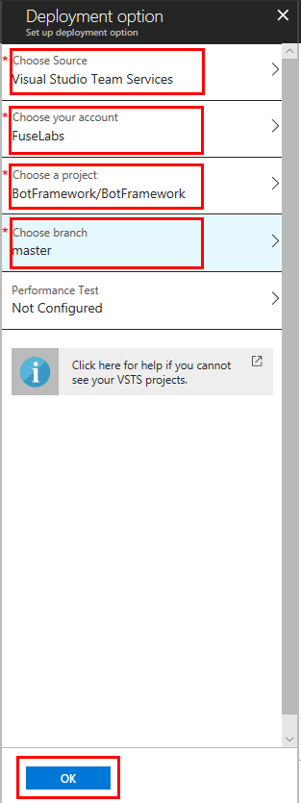

Your continuous deployment with Visual Studio Team Services setup is complete. Whenever you commit, your changes will automatically be deployed to Azure.

## **Disable continuous deployment**

While your bot is configured for continuous deployment, you may not use the online code editor to make changes to your bot. If you want to use the online code editor, you can temporarily disable continuous deployment.

To disable (or re-enable) continuous deployment, do the following:

1. From your bot's **Build** blade, click **Configure continuous deployment**.
2. Click **Disconnect** to disable continuous deployment. To re-enable continuous deployment, repeat these steps.

# Test in Web Chat

Bot Service includes the [Web Chat control](https://docs.microsoft.com/en-us/bot-framework/bot-service-channel-connect-webchat) to help you conveniently test your bot.

## **Test a bot in the Azure Portal with Web Chat**

Sign into the [Azure portal](https://portal.azure.com/) and open the blade for the bot. In the Bot Management section, click **Test in Web Chat**. Bot Service will load the Web Chat control and connect to your bot.

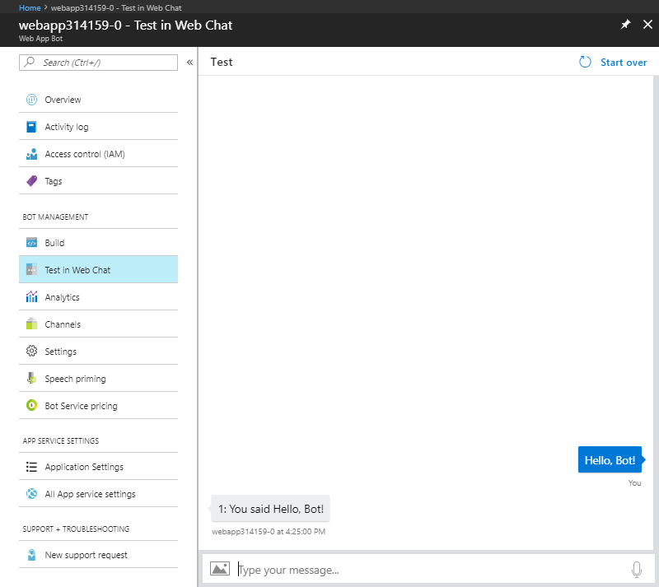

You can enter text to chat with your bot. If your bot supports speech, you can click the microphone button to talk to your bot. If your bot supports attachments, you can upload an attachment, such as an image. Learn how to add features to your bot with the [Bot Builder SDK](https://docs.microsoft.com/en-us/bot-framework/bot-builder-overview-getstarted).

Note

If the Web Chat control is not fully loaded after a few minutes, try refreshing the page.

# Bot analytics

Analytics is an extension of [Application Insights](https://docs.microsoft.com/en-us/azure/application-insights/app-insights-analytics). Application Insights provides **service-level** and instrumentation data like traffic, latency, and integrations. Analytics provides **conversation-level**reporting on user, message, and channel data.

## **View analytics for a bot**

To access Analytics, open the bot in the developer portal and click **Analytics**.

Too much data? [Enable and configure sampling](https://docs.microsoft.com/en-us/azure/application-insights/app-insights-sampling) to reduce telemetry traffic and storage while maintaining statistically correct analysis.

### **Specify channel**

Choose which channels appear in the graphs below. Note that if a bot is not enabled on a channel, there will be no data from that channel.

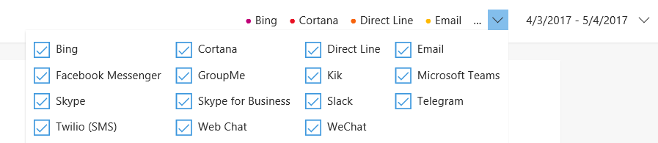

* Check the check box to include a channel in the chart.
* Clear the check box to remove a channel from the chart.

### **Specify time period**

Analysis is available for the past 90 days only. Data collection began when Application Insights was enabled.

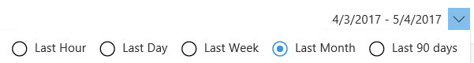

Click the drop-down menu and then click the amount of time the graphs should display. Note that changing the overall time frame will cause the time increment (X-axis) on the graphs to change accordingly.

### **Grand totals**

The total number of active users and messages sent and received during the specified time frame. Dashes -- indicate no activity.

### **Retention**

Retention tracks how many users who sent one message came back later and sent another one. The chart is a rolling 10-day window; the results are not affected by changing the time frame.

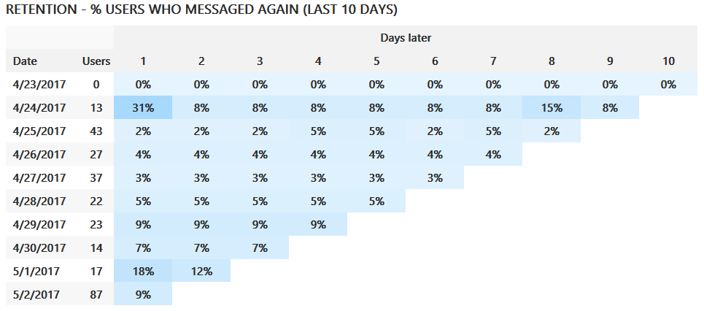

Note that the most recent possible date is two days ago; a user sent messages the day before yesterday and then returned yesterday.

### **User**

The Users graph tracks how many users accessed the bot using each channel during the specified time frame.

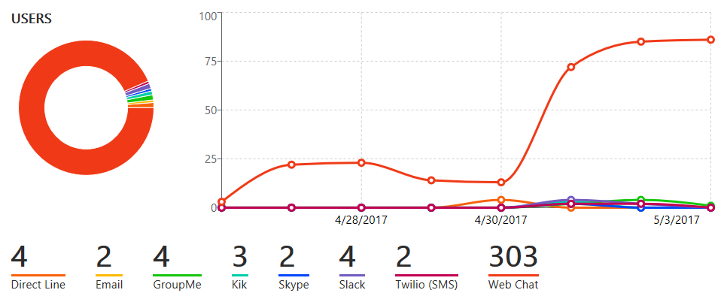

* The percentage chart shows what percentage of users used each channel.
* The line graph indicates how many users were accessing the bot at a certain time.
* The legend for the line graph indicates which color represents which channel and the includes the total number of users during the specified time period.

### **Messages**

The Message graph tracks how many messages were sent and received using which channel during the specified time frame.

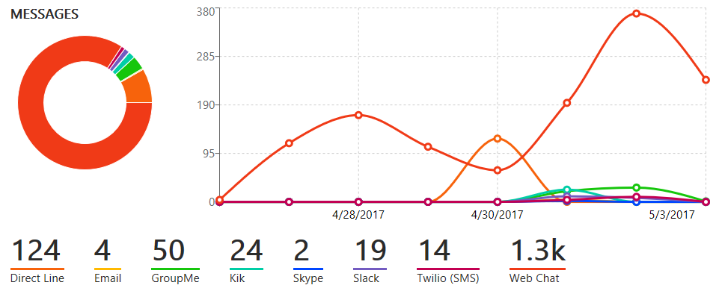

* The percentage chart shows what percentage of messages were communicated over each channel.
* The line graph indicates how many messages were sent and received over the specified time frame.
* The legend for the line graph indicates which line color represents each channel and the total number of messages sent and received on that channel during the specified time period.

## **Enable analytics**

Analytics are not available until Application Insights has been enabled and configured. Application Insights will begin collecting data as soon as it is enabled. For example, if Application Insights was enabled a week ago for a six-month-old bot, it will have collected one week of data.

Note

Analytics requires both an Azure subscription and Application Insights [resource](https://docs.microsoft.com/en-us/azure/application-insights/app-insights-create-new-resource). To access Application Insights, open the bot in the [Bot Framework Portal](https://dev.botframework.com/) and click **Settings**.

1. Create an Application Insights [resource](https://docs.microsoft.com/en-us/azure/application-insights/app-insights-create-new-resource).
2. Open the bot in the dashboard. Click **Settings** and scroll down to the **Analytics** section.
3. Enter the information to connect the bot to Application Insights. All fields are required.

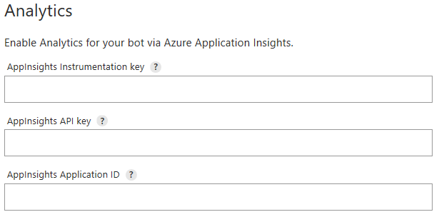

### **AppInsights Instrumentation Key**

To find this value, open Application Insights and navigate to **Configure** > **Properties**.

### **AppInsights API key**

Provide an Azure App Insights API key. Learn how to [generate a new API key](https://dev.applicationinsights.io/documentation/Authorization/API-key-and-App-ID). Only **Read**permission is required.

### **AppInsights Application ID**

To find this value, open Application Insights and navigate to **Configure** > **API Access**.

For more information on how to locate these values, see [Application Insights keys](https://docs.microsoft.com/en-us/bot-framework/bot-service-resources-app-insights-keys).

# Connect a bot to channels

A channel is the connection between the Bot Framework and communication apps. You configure a bot to connect to the channels you want it to be available on. For example, a bot connected to the Skype channel can be added to a contact list and people can interact with it in Skype.

The channels include many popular services, such as [Cortana](https://docs.microsoft.com/en-us/bot-framework/bot-service-channel-connect-cortana), [Facebook Messenger](https://docs.microsoft.com/en-us/bot-framework/bot-service-channel-connect-facebook), [Kik](https://docs.microsoft.com/en-us/bot-framework/bot-service-channel-connect-kik), and [Slack](https://docs.microsoft.com/en-us/bot-framework/bot-service-channel-connect-slack), as well as several others. [Skype](https://dev.skype.com/bots) and Web Chat are pre-configured for you.

Connecting to channels is quick and easy in the [Azure Portal](https://portal.azure.com/).

## **Get started**

For most channels, you must provide channel configuration information to run your bot on the channel. Most channels require that your bot have an account on the channel, and others, like Facebook Messenger, require your bot to have an application registered with the channel also.

To configure your bot to connect to a channel, complete the following steps:

1. Sign in to the [Azure Portal](https://portal.azure.com/).
2. Select the bot that you want to configure.
3. In the Bot Service blade, click **Channels** under **Bot Management**.
4. Click the icon of the channel you want to add to your bot.

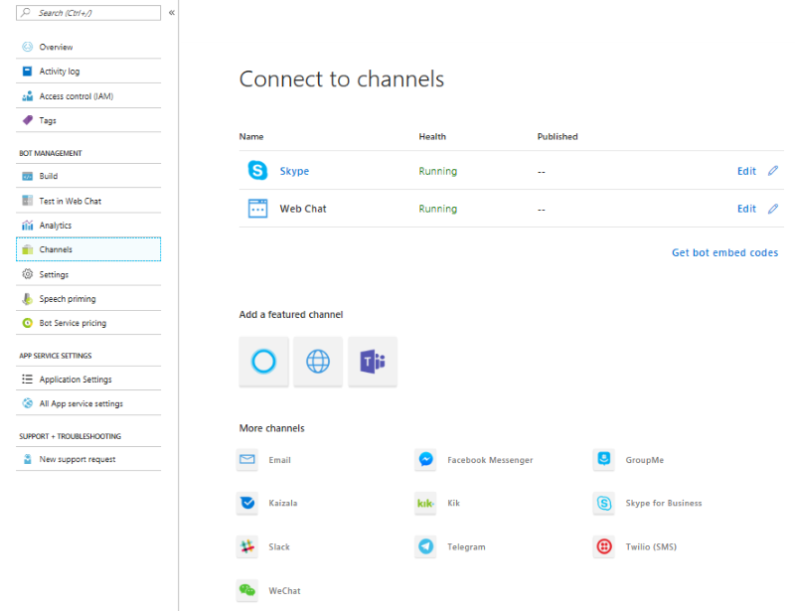

After you've configured the channel, users on that channel can start using your bot.

## **Publish a bot**

The publishing process is different for each channel.

### **Cortana**

Bots are published to Cortana from the [dashboard](https://aka.ms/cortana-publish) and are used to power Cortana skills. Publishing a bot submits it for review. Cortana skills can be deployed for your own use, deployed to a small group, or published to the world.

### **Skype**

Bots are published to Skype from the [configuration page](https://docs.microsoft.com/en-us/bot-framework/bot-service-channel-connect-skypeforbusiness). Publishing a bot submits it for review. Before review, the bot is limited to 100 contacts. Approved bots do not have limited contacts and you may opt to have the bot included in the Skype bot directory.

### **Skype for Business**

Skype for Business bots are registered with a [Skype for Business Online tenant](https://msdn.microsoft.com/en-us/skype/Skype-For-Business-Bot-Framework/docs/overview) by a Tenant Administrator.

Tip

To view the status of a review, open the bot in the [Bot Framework Portal](https://dev.botframework.com/) and click **Channels**. If the bot is not approved, the result will link to the reason why. After making the required changes, resubmit the bot for review.

# Connect a bot to Cortana

Cortana is a speech-enabled channel that can send and receive voice messages in addition to textual conversation. A bot intended to connect to Cortana should be designed for speech as well as text. A Cortana skill is a bot that can be invoked using a Cortana client. Publishing a bot adds the bot to the list of available skills.

To add the Cortana channel, open the bot in the [Azure Portal](https://portal.azure.com/), click the **Channels** blade, and then click **Cortana**.

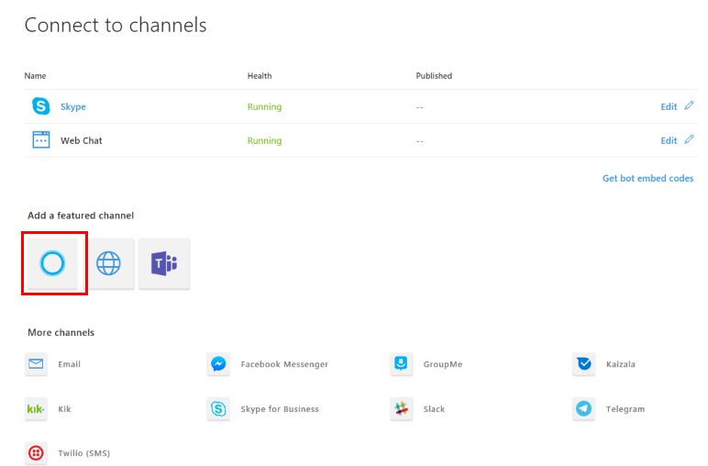

## **General bot information**

All fields marked with an asterisk (\*) are required. Bots must be published on the Bot Framework before they can be connected to Cortana.

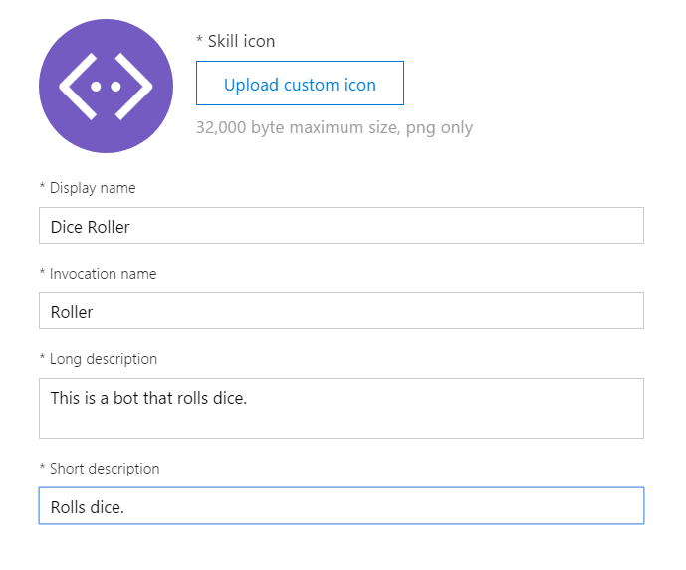

### **Skill Icon**

Select a custom icon to represent this bot. This icon is displayed in the Cortana canvas when this skill is invoked and anywhere skills are discoverable, such as the Microsoft store. The image must be a PNG, 60 x 60 pixels, and no larger than 30kb.

### **Display Name**

The name of this skill as displayed to the user at the top of Cortana's visual UI.

### **Invocation Name**

The name that Cortana will recognize and use to invoke this skill when spoken aloud by the user. See the [Invocation Name Guidelines](https://aka.ms/cortana-invocation-guidelines) for more information on how to choose this phrase.

### **Skill description**

Describe the skill. This is used where bots are discoverable, like the Microsoft store.

### **Short description**

This summary will be used to describe the skill in Cortana’s Notebook.

Note

For basic skills, this is all that is required. Click **Connect to Cortana** to complete the connection. For more advanced skills, add a connected account or configure access to user profile and contextual information.

## **Manage user identity**

The default value is Disabled. If Enabled, the user will be required to log in before using this skill. Cortana can manage this skill's user identity and tokens across devices if an OAuth2 identity provider is added as a [connected service](https://aka.ms/CortanaSkillsBotConnectedAccount).

Note

Only **Auth Code Grant** authentication is supported. **Implicit Grant** is currently not supported.

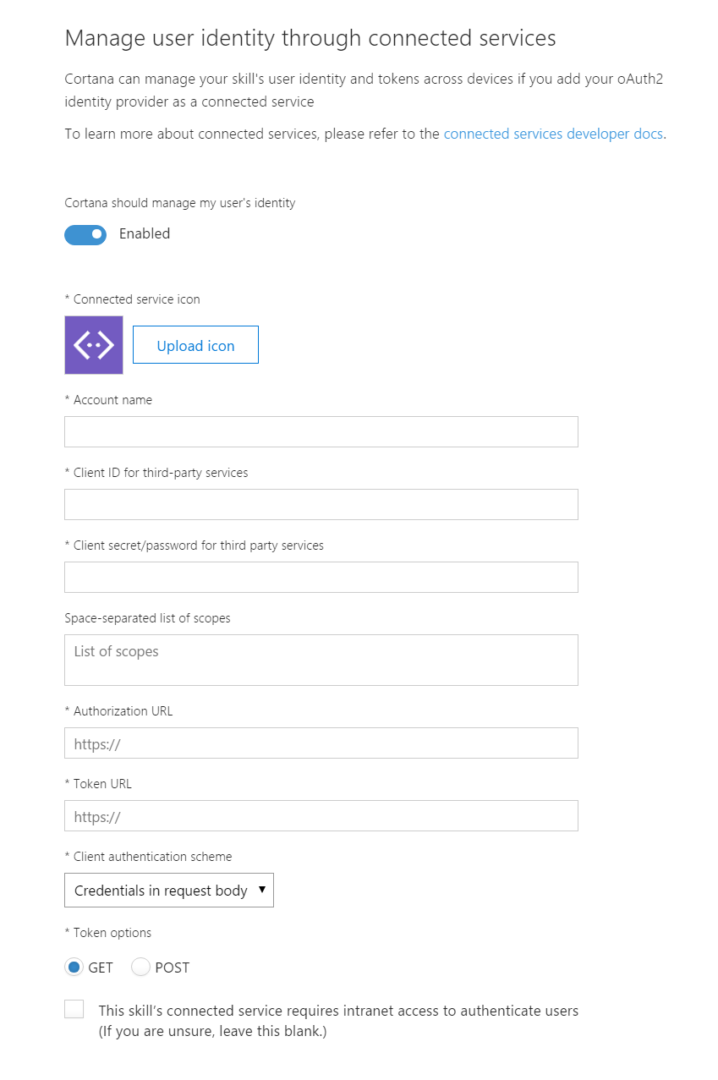

| Field | Description |
| --- | --- |
| Icon | The icon to display when the sign-in form is displayed. |
| Account Name | The name to be shown when the sign-in form is displayed. |
| Client ID for third-party services | The client id that Cortana needs as part of the OAuth flow. |
| Client secret/password for third party services | The client secret Cortana needs as part of the OAuth flow. |
| List of scopes | A list of scopes Cortana needs as part of the skill execution flow. |
| Authorization URL | The URI Cortana will call to authorize the user. |
| Token URL | The URI Cortana will call to fetch tokens. |
| Client authentication scheme | The mechanism by which Cortana will pass a bearer token. |
| Token option | How Cortana should obtain tokens. If unsure, select POST. |
| Intranet toggle | Select if this skill’s connected service requires intranet access to authenticate users. If unsure, leave this blank.) |

## **Request user profile data**

Cortana provides access to several different types of user profile information, which is useful in customizing the bot for different users.

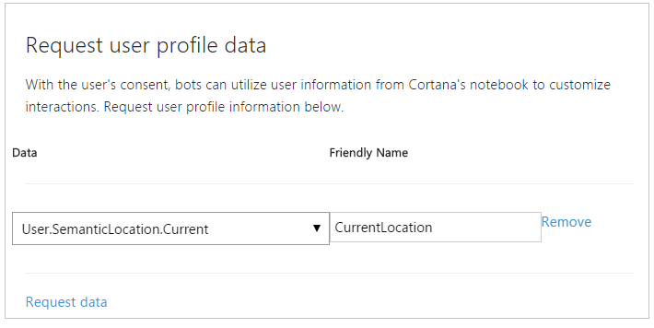

1. Click **Add a user profile request**.
2. Click **Select Data** and then select the user profile information from the drop-down list.
3. Add a **Friendly name** to identify this information in the UserInfo [entity](https://aka.ms/lgvcto).
4. Click **Remove** to remove this request for data or click **Add a user profile request** again to define another request.

Click **Save**. The bot will be deployed automatically as a Cortana skill.

## **Enable speech recognition priming**

If your bot uses a Language Understanding (LUIS) app, register the LUIS application ID.

Click the **Settings** tab and then under **Configuration**, enter the LUIS application ID in the **Speech recognition priming with LUIS** text box. This helps your bot recognize spoken utterances that are defined in your LUIS model. 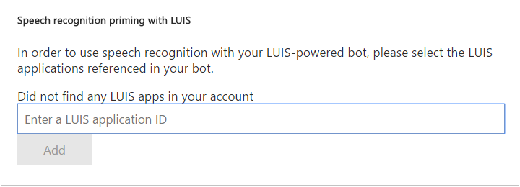

# Connect a bot to Skype for Business

Skype for Business Online keeps you connected with co-workers and business partners through instant messaging, phone, and video calls. Extend this functionality by building bots that users can discover and interact with through the Skype for Business interface.

Note

The Skype for Business Bot Framework channel is currently supported for Skype for Business Online. Skype for Business Server 2015 is not supported.

## **Enable the channel**

Open the bot in the [Azure Portal](https://portal.azure.com/), click the **Channels** blade, and then click **Skype for Business**. The bot is now enabled.

Connecting the bot with Skype for Business Online is performed by a **Tenant Administrator** of that Skype for Business tenant.

# Connect a bot to Direct Line

You can enable your own client application to communicate with your bot by using the Direct Line channel.

## **Add the Direct Line channel**

To add the Direct Line channel, open the bot in the [Azure Portal](https://portal.azure.com/), click the **Channels** blade, and then click **Direct Line**.

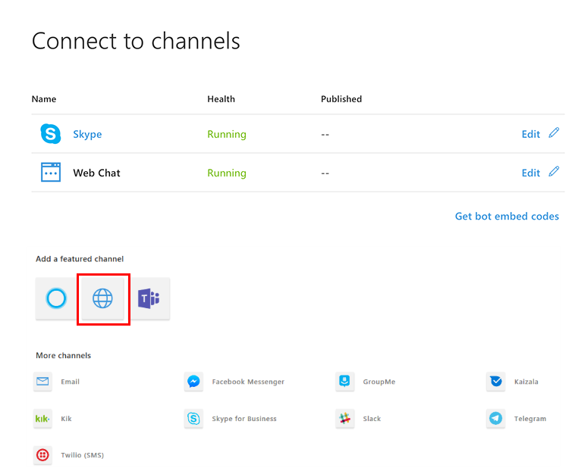

## **Add new site**

Next, add a new site that represents the client application that you want to connect to your bot. Click **Add new site**, enter a name for your site, and click **Done**.

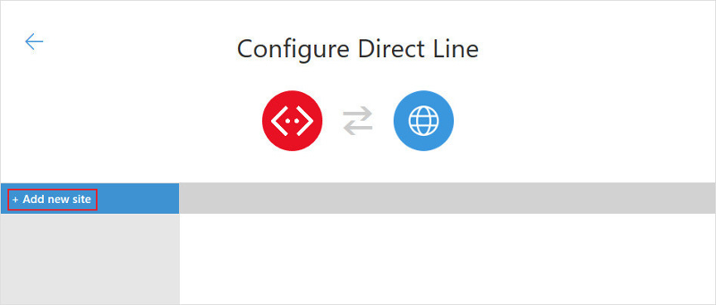

## **Manage secret keys**

When your site is created, the Bot Framework generates secret keys that your client application can use to [authenticate](https://docs.microsoft.com/en-us/bot-framework/rest-api/bot-framework-rest-direct-line-3-0-authentication) the Direct Line API requests that it issues to communicate with your bot. To view a key in plain text, click **Show** for the corresponding key.

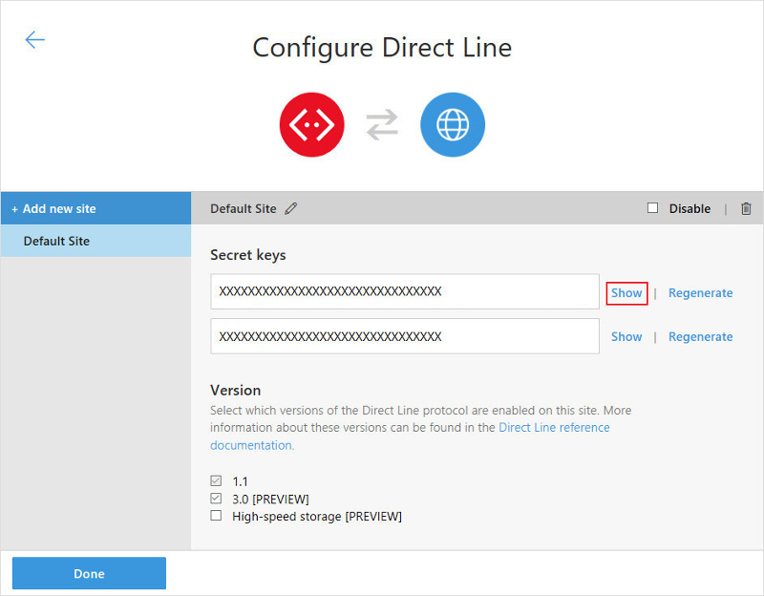

Copy and securely store the key that is shown. Then use the key to [authenticate](https://docs.microsoft.com/en-us/bot-framework/rest-api/bot-framework-rest-direct-line-3-0-authentication) the Direct Line API requests that your client issues to communicate with your bot, or alternatively, use the Direct Line API to [exchange the key for a token](https://docs.microsoft.com/en-us/bot-framework/rest-api/bot-framework-rest-direct-line-3-0-authentication#generate-token) that your client can use to authenticate its subsequent requests within the scope of a single conversation.

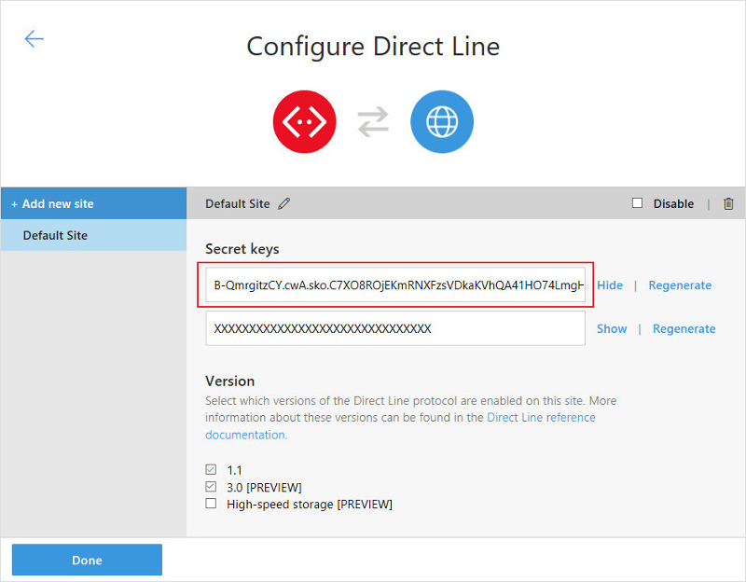

## **Configure settings**

Finally, configure settings for the site.

* Select the Direct Line protocol version that your client application will use to communicate with your bot. > [!TIP] > If you are creating a new connection between your client application and bot, use Direct Line API 3.0.

When finished, click **Done** to save the site configuration. You can repeat this process, beginning with [Add new site](https://docs.microsoft.com/en-us/bot-framework/bot-service-channel-connect-directline#add-new-site), for each client application that you want to connect to your bot.

# Develop bots for Microsoft Teams

Build and connect intelligent bots to interact with Microsoft Teams users naturally through chat. Or provide a simple commands-based bot, to be used as your "command-line" interface for your broader Teams app experience. You can make a notification-only bot, which can push information relevant to your users directly to them in a channel or direct message. You can even bring your existing Bot Framework–based bot and add Teams-specific support to make your experience shine.

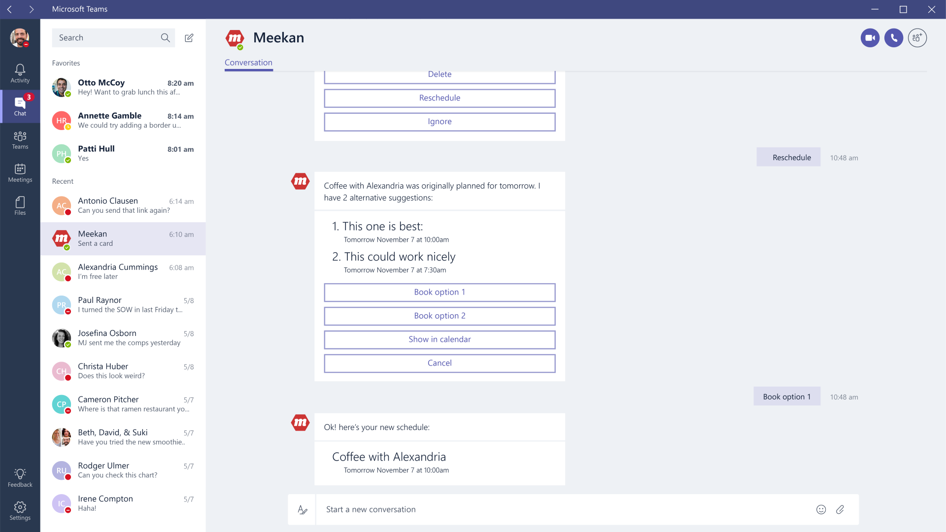

Tip

If you are just looking for a way to simply extend your team by integrating with custom tools and services in a secure manner, check out our [custom bots](https://docs.microsoft.com/en-us/microsoftteams/platform/concepts/custom-bot) feature. Be aware, though, that custom bots simply leverage your existing web services—they can't access non-messaging APIs, perform asynchronous posting, or add button actions to cards.

## **What you need to know: Bots**

Other than its hexagonal avatar icon, a bot appears just like any other team member you interact with, in a channel or in one-on-one conversations. It is always online and does not have a mood message.

Bots in Teams can surface in a one-on-one context ("personal scope"), as a member of a team ("team scope"), or both. For the latter, they take part in a conversation only when you @mention them. For the former, you can address them via the conversation interface or access them in the apps personal experience from the app bar flyout.

With Microsoft Teams apps, you can make the bot the star of your experience, or just a helper. Bots are distributed as part of your broader app package, which can include other capabilities such as tabs or messaging extensions.

If your bot is the star, be sure to take advantage of the [tabs](https://docs.microsoft.com/en-us/microsoftteams/platform/concepts/tabs/tabs-overview) capability as well. Use this rich web view to surface accompanying experiences and information that helps your users best interact with your service.

Microsoft Teams supports much of the [Microsoft Bot Framework](https://dev.botframework.com/) functionality. (If you already have a bot that's based on the Bot Framework, you can easily adapt it to work in Microsoft Teams.) We recommend you use either C# or TypeScript to take advantage of our SDKs.

We want to make development of Microsoft Teams apps as easy as possible, so we build and maintain extensions to the Bot Builder SDK. These packages extend the basic Bot Builder classes and methods with the following:

* Using specialized card types like the Office 365 Connector card
* Consuming and setting Teams-specific channel data on activities
* Processing messaging extension requests
* Handling rate limiting

The SDK extensions install dependencies, including the Bot Builder SDK.

* **.NET** To use the Microsoft Teams extensions for the Bot Builder SDK for .NET, install the [Microsoft.Bot.Connector.Teams](https://www.nuget.org/packages/Microsoft.Bot.Connector.Teams) NuGet package in your Visual Studio project.
* **Node.js** To use the Microsoft Teams extensions for the Bot Builder SDK for Node.js, add the [botbuilder-teams](https://www.npmjs.com/package/botbuilder-teams) npm package.
* **Source code** You can find the full source code for the extensions in the [BotBuilder-MicrosoftTeams](https://github.com/OfficeDev/BotBuilder-MicrosoftTeams) repo on Github.

Important

You can develop Teams apps in any other web-programming technology and call the [Bot Framework REST APIs](https://docs.microsoft.com/en-us/bot-framework/rest-api/bot-framework-rest-overview) directly, but you must perform all token handling yourself.

Follow these steps to build a great Teams bot:

* [Design a great bot](https://docs.microsoft.com/en-us/microsoftteams/platform/get-started/design#designing-a-great-bot): Microsoft Teams is the place for group and team collaboration. Consider what functionality your bot can bring to this collaboration environment, via 1:1 conversations or as part of a channel conversation. A great bot on Teams will also find ways to leverage the unique tabs feature, via a [configurable tab](https://docs.microsoft.com/en-us/microsoftteams/platform/concepts/tabs/tabs-overview) or a [static tab](https://docs.microsoft.com/en-us/microsoftteams/platform/concepts/tabs/tabs-static).
* [Create and register your bot in the Bot Framework](https://docs.microsoft.com/en-us/microsoftteams/platform/concepts/bots/bots-create): Take advantage of the great tools, documentation, and community provided by the Bot Framework team.
* [Develop your bot](https://docs.microsoft.com/en-us/microsoftteams/platform/concepts/bots/bots-conversations): Add basic conversation flow and leverage channel-specific functionality. If you develop in .NET or Node.js, use our [extensions for the Bot Builder SDK](https://docs.microsoft.com/en-us/microsoftteams/platform/get-started/code#microsoft-teams-extensions-for-the-bot-builder-sdk) to simplify your work.
* [Test your bot](https://docs.microsoft.com/en-us/microsoftteams/platform/concepts/bots/bots-test): Add your bot for 1:1 or team conversations to see it in action.
* [Publish your bot](https://docs.microsoft.com/en-us/microsoftteams/platform/publishing/apps-publish): Create your Teams package, add other capabilities, and submit it to the Office Store.

## **What you need to know: Custom bots**

Custom bots allow you to create a simple bot for basic interaction, like kicking off a workflow or other simple commands you may need. These custom bots live only in the team in which you create them and are intended for simple processes specific to your company's workflow. See [Custom bots](https://docs.microsoft.com/en-us/microsoftteams/platform/concepts/custom-bot) for more information.

# Connect a bot to Web Chat

When you [create a bot](https://docs.microsoft.com/en-us/bot-framework/bot-service-quickstart) with Bot Service, the Web Chat channel is automatically configured for you. The Web Chat channel includes the web chat control, which provides the ability for users to interact with your bot directly in a web page.

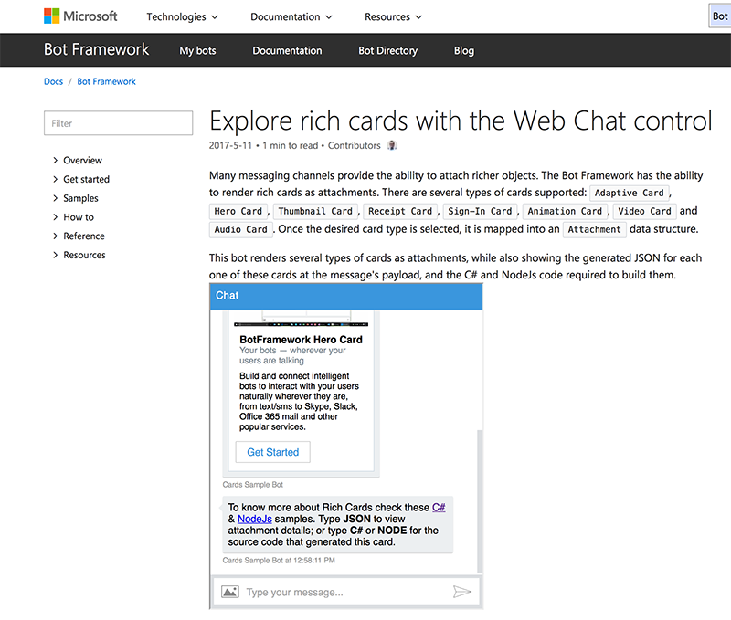

The Web Chat channel in the Bot Framework Portal contains everything you need to embed the web chat control in a web page. All you have to do to use the web chat control is get your bot's secret key and embed the control in a web page.

Tip

To see how various Bot Framework features look and work on this channel, [use the Channel Inspector](https://docs.microsoft.com/en-us/bot-framework/bot-service-channel-inspector).

## **Get your bot secret key**

1. Open your bot in the [Azure Portal](http://portal.azure.com/) and click **Channels** blade.
2. Click **Edit** for the **Web Chat** channel.  
   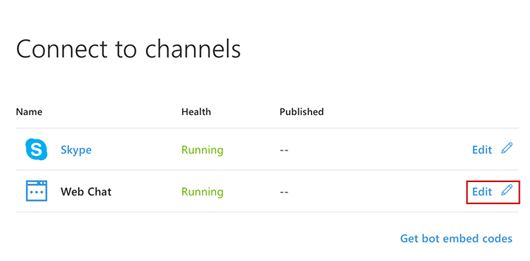
3. Under **Secret keys**, click **Show** for the first key.  
   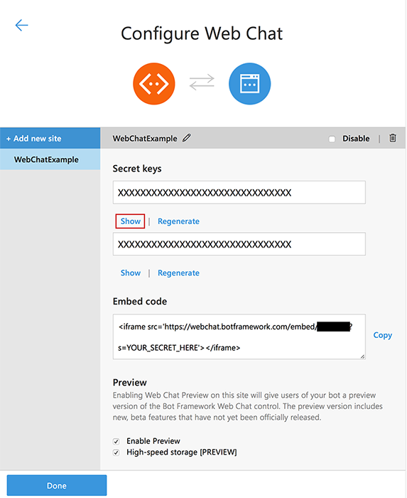
4. Copy the **Secret key** and the **Embed code**.
5. Click **Done**.

## **Embed the web chat control in your website**

You can embed the web chat control in your website by using one of two options.

### **Option 1 - Keep your secret hidden, exchange your secret for a token, and generate the embed**

Use this option if you can execute a server-to-server request to exchange your web chat secret for a temporary token, and if you want to make it difficult for other developers to embed your bot in their websites. Although using this option will not absolutely prevent other developers from embedding your bot in their websites, it does make it difficult for them to do so.

To exchange your secret for a token and generate the embed:

1. Issue a **GET** request to https://webchat.botframework.com/api/tokens and pass your web chat secret via the Authorization header. The Authorization header uses the BotConnector scheme and includes your secret, as shown in the example request below.
2. The response to your **GET** request will contain the token (surrounded with quotation marks) that can be used to start a conversation by rendering the web chat control within an **iframe**. A token is valid for one conversation only; to start another conversation, you must generate a new token.
3. Within the iframe **Embed code** that you copied from the Web Chat channel within the Bot Framework Portal (as described in [Step 1](https://docs.microsoft.com/en-us/bot-framework/bot-service-channel-connect-webchat#step-1) above), change the s= parameter to t=and replace "YOUR\_SECRET\_HERE" with your token.

Note

Tokens will automatically be renewed before they expire.

##### **Example request**

requestCopy

GET https://webchat.botframework.com/api/tokens

Authorization: BotConnector YOUR\_SECRET\_HERE

##### **Example response**

responseCopy

"IIbSpLnn8sA.dBB.MQBhAFMAZwBXAHoANgBQAGcAZABKAEcAMwB2ADQASABjAFMAegBuAHYANwA.bbguxyOv0gE.cccJjH-TFDs.ruXQyivVZIcgvosGaFs\_4jRj1AyPnDt1wk1HMBb5Fuw"

##### **Example iframe (using token)**

HTMLCopy

<iframe src="https://webchat.botframework.com/embed/YOUR\_BOT\_ID?t=YOUR\_TOKEN\_HERE"></iframe>

### **Option 2 - Embed the web chat control in your website using the secret**

Use this option if you want to allow other developers to easily embed your bot into their websites.

Warning

If you use this option, other developers can embed your bot into their websites by simply copying your embed code.

To embed your bot in your website by specifying the secret within the iframe tag:

1. Copy the iframe **Embed code** from the Web Chat channel within the Bot Framework Portal (as described in [Step 1](https://docs.microsoft.com/en-us/bot-framework/bot-service-channel-connect-webchat#step-1) above).
2. Within that **Embed code**, replace "YOUR\_SECRET\_HERE" with the **Secret key** value that you copied from the same page.

##### **Example iframe (using secret)**

HTMLCopy

<iframe src="https://webchat.botframework.com/embed/YOUR\_BOT\_ID?s=YOUR\_SECRET\_HERE"></iframe>

## **Style the web chat control**

You may change the size of the web chat control by using the style attribute of the iframe to specify height and width.

HTMLCopy

<iframe style="height:480px; width:402px" src="... SEE ABOVE ..."></iframe>

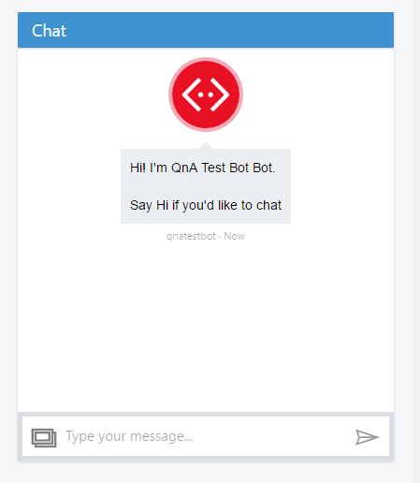

You can enable a voice interface in the Web Chat control. Users interact with the voice interface by using the microphone in the Web Chat control.

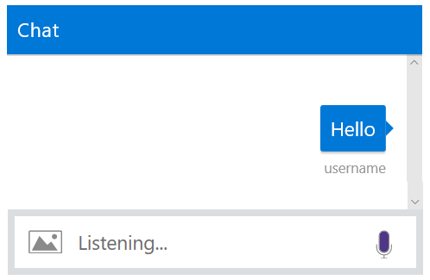

If the user types instead of speaking a response, Web Chat turns off the speech functionality and the bot gives only a textual response instead of speaking out loud. To re-enable the spoken response, the user can use the microphone to respond to the bot the next time. If the microphone is accepting input, it appears dark or filled-in. If it's grayed out, the user clicks on it to enable it.

## **Prerequisites**

Before you run the sample, you need to have a Direct Line secret or token for the bot that you want to run using the Web Chat control.

* See [Connect a bot to Direct Line](https://docs.microsoft.com/en-us/bot-framework/bot-service-channel-connect-directline) for information on getting a Direct Line secret associated with your bot.
* See [Generate a Direct Line token](https://docs.microsoft.com/en-us/bot-framework/rest-api/bot-framework-rest-direct-line-3-0-authentication) for information on exchanging the secret for a token.

## **Customizing Web Chat for speech**

To enable the speech functionality in Web Chat, you need to customize the JavaScript code that invokes the Web Chat control. You can try out voice-enabled Web Chat locally using the following steps.

1. Download the [sample index.html](https://aka.ms/web-chat-speech-sample).
2. Edit the code in index.html according to the type of speech support you want to add. The types of speech implementations are described in [Enable speech services](https://docs.microsoft.com/en-us/bot-framework/bot-service-channel-connect-webchat-speech#enable-speech-services).
3. Start a web server. One way to do so is to use npm http-server at a Node.js command prompt.
   * To install http-server globally so it can be run from the command line, run this command:

Copy

npm install http-server- -g

* + To start a web server using port 8000, from the directory that contains index.html, run this command:

Copy

http-server -p 8000

1. Aim your browser at http://localhost:8000/samples?parameters. For example, http://localhost:8000/samples?s=YOURDIRECTLINESECRET invokes the bot using a Direct Line secret. The parameters that can be set in the query string are described in the following table:

| Parameter | Description |
| --- | --- |
| s | Direct Line secret. See [Connect a bot to Direct Line](https://docs.microsoft.com/en-us/bot-framework/bot-service-channel-connect-directline) for information on getting a Direct Line secret. |
| t | Direct Line token. See [Generate a Direct Line token](https://docs.microsoft.com/en-us/bot-framework/rest-api/bot-framework-rest-direct-line-3-0-authentication) for info on how to generate this token. |
| domain | Optional. The URL of an alternate Direct Line endpoint. |
| webSocket | Optional. Set to 'true' to use WebSocket to receive messages. Default is false. |
| userid | Optional. The ID of the bot user. |
| username | Optional. The user name of the bot's user. |
| botid | Optional. ID of the bot. |
| botname | Optional. Name of the bot. |

## **Enable speech services**

The customization allows you to add speech functionality in any of the following ways:

* **Browser-provided speech** - Use speech functionality built into the web browser. At this time, this functionality is only available on the Chrome browser.
* **Use Bing Speech service** - You can use the Bing Speech service to provide speech recognition and synthesis. This way of access speech functionality is supported by a variety of browsers. In this case, the processing is done on a server instead of on the browser.
* **Create a custom speech service** - You can create your own custom speech recognition and voice synthesis components.

### **Browser-provided speech**

The following code instantiates speech recognizer and speech synthesis components that come with the browser. This method of adding speech is not supported by all browsers.

Note

Google Chrome supports the browser speech recognizer. However, Chrome may block the microphone in the following cases:

* If the URL of the page that contains Web Chat begins with http:// instead of https://.
* If the URL is a local file using the file:// protocol instead of http://localhost:8000.

JavaScriptCopy

const speechOptions = {

speechRecognizer: new BotChat.Speech.BrowserSpeechRecognizer(),

speechSynthesizer: new BotChat.Speech.BrowserSpeechSynthesizer()

};

### **Bing Speech service**

The following code instantiates speech recognizer and speech synthesis components that use the Bing Speech service. The recognition and generation of speech is performed on the server. This mechanism is supported in multiple browsers.

Tip

You can use speech recognition priming to improve your bot's speech recognition accuracy if you use the Bing Speech service. For more information, check out the [Speech Support in Bot Framework](https://blog.botframework.com/2017/06/26/Speech-To-Text) blog post.

JavaScriptCopy

const speechOptions = {

speechRecognizer: new CognitiveServices.SpeechRecognizer({ subscriptionKey: 'YOUR\_COGNITIVE\_SPEECH\_API\_KEY' }),

speechSynthesizer: new CognitiveServices.SpeechSynthesizer({

gender: CognitiveServices.SynthesisGender.Female,

subscriptionKey: 'YOUR\_COGNITIVE\_SPEECH\_API\_KEY',

voiceName: 'Microsoft Server Speech Text to Speech Voice (en-US, JessaRUS)'

})

};

#### **Use the Bing Speech service with a token**

You also have the option to enable Cognitive Services speech recognition using a token. The token is generated in a secure back end using your API key.

The following example code shows how the token fetch is done from a secure back end to avoid exposing the API key.

JavaScriptCopy

function getToken() {

// This call would be to your backend, or to retrieve a token that was served as part of the original page.

return fetch(

'https://api.cognitive.microsoft.com/sts/v1.0/issueToken',

{

headers: {

'Ocp-Apim-Subscription-Key': 'YOUR\_COGNITIVE\_SPEECH\_API\_KEY'

},

method: 'POST'

}

).then(res => res.text());

}

const speechOptions = {

speechRecognizer: new CognitiveServices.SpeechRecognizer({

fetchCallback: (authFetchEventId) => getToken(),

fetchOnExpiryCallback: (authFetchEventId) => getToken()

}),

speechSynthesizer: new BotChat.Speech.BrowserSpeechSynthesizer()

};

### **Custom Speech service**

You can also provide your own custom speech recognition that implements ISpeechRecognizer or speech synthesis that implements ISpeechSynthesis.

JavaScriptCopy

const speechOptions = {

speechRecognizer: new YourOwnSpeechRecognizer(),

speechSynthesizer: new YourOwnSpeechSynthesizer()

};

### **Pass the speech options to Web Chat**

The following code passes the speech options to the Web Chat control:

JavaScriptCopy

BotChat.App({

bot: bot,

locale: params['locale'],

resize: 'detect',

// sendTyping: true, // defaults to false. set to true to send 'typing' activities to bot (and other users) when user is typing

speechOptions: speechOptions,

user: user,

directLine: {

domain: params['domain'],

secret: params['s'],

token: params['t'],

webSocket: params['webSocket'] && params['webSocket'] === 'true' // defaults to true

}

}, document.getElementById('BotChatGoesHere'));

## **Next steps**

Now that you can enable voice interaction with Web Chat, learn how your bot constructs spoken messages and adjusts the state of the microphone:

* [Add speech to messages (C#)](https://docs.microsoft.com/en-us/bot-framework/dotnet/bot-builder-dotnet-text-to-speech)
* [Add speech to messages (Node.js)](https://docs.microsoft.com/en-us/bot-framework/nodejs/bot-builder-nodejs-text-to-speech)

# Connect a bot to Office 365 email

Bots can communicate with users via Office 365 email in addition to other [channels](https://docs.microsoft.com/en-us/bot-framework/bot-service-manage-channels). When a bot is configured to access an email account, it receives a message when a new email arrives. The bot can then respond as indicated by its business logic. For example, the bot could send an email reply acknowledging an email was received with the message, "Hi! Thanks for your order! We will begin processing it immediately."

Warning

It is a violation of the Bot Framework [Code of Conduct](https://www.botframework.com/Content/Microsoft-Bot-Framework-Preview-Online-Services-Agreement.htm) to create "spambots", including bots that send unwanted or unsolicited bulk email.

## **Configure email credentials**

You can connect a bot to the Email channel by entering Office 365 credentials in the Email channel configuration.

To add the Email channel, open the bot in the [Azure Portal](https://portal.azure.com/), click the **Channels** blade, and then click **Email**. Enter your valid email credentials and click **Save**.

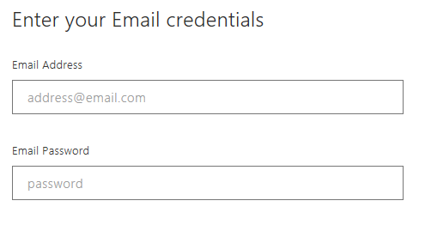

The Email channel currently works with Office 365 only. Other email services are not currently supported.

## **Customize emails**

The Email channel supports sending custom properties to create more advanced, customized emails using the channelData property.

| Property | Description |
| --- | --- |
| HtmlBody | The HTML to use for the body of the message. |
| Subject | The subject to use for the message. |
| Importance | The importance flag to use for the message.(Low/Normal/High) |

The following example message shows a JSON file that includes the channelData properties.

JSONCopy

{

"type": "message",

"locale": "en-Us",

"channelID":"email",

"from": { "id":"mybot@mydomain.com", "name":"My bot"},

"recipient": { "id":"joe@otherdomain.com", "name":"Joe Doe"},

"conversation": { "id":"123123123123", "topic":"awesome chat" },

"channelData":

{

"htmlBody" : "<html><body style = /"font-family: Calibri; font-size: 11pt;/" >This is more than awesome</body></html>",

"subject":"Super awesome message subject",

"importance":"high"

}

}

For more information about using channelData, see the [Node.js](https://github.com/Microsoft/BotBuilder-Samples/tree/master/Node/core-ChannelData) sample or [.NET](https://docs.microsoft.com/en-us/bot-framework/dotnet/bot-builder-dotnet-channeldata) documentation.

# Connect a bot to GroupMe

You can configure a bot to communicate with people using the GroupMe group messaging app.

Tip

To see how various Bot Framework features look and work on this channel, [use the Channel Inspector](https://docs.microsoft.com/en-us/bot-framework/bot-service-channel-inspector).

## **Sign up for a GroupMe account**

If you don't have a GroupMe account, [sign up for a new account](https://web.groupme.com/signup).

## **Create a GroupMe application**

[Create a GroupMe application](https://dev.groupme.com/applications/new) for your bot.

Use this callback URL: https://groupme.botframework.com/Home/Login

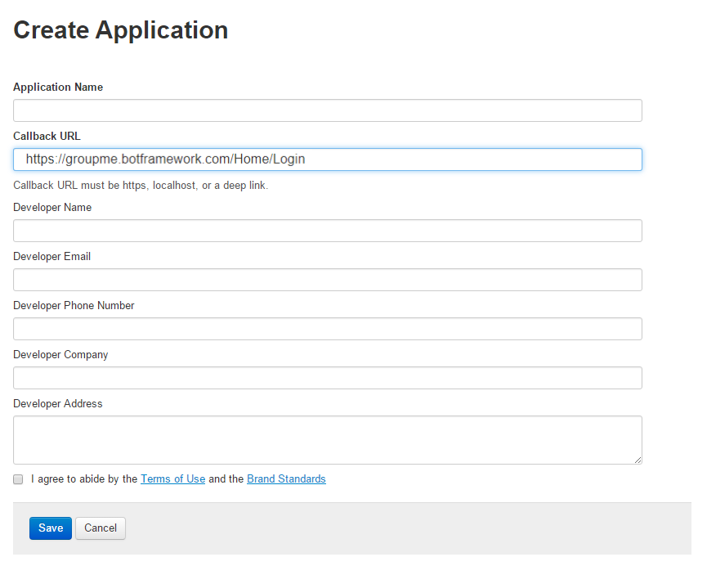

## **Gather credentials**

1. In the **Redirect URL** field, copy the value after **client\_id=**.
2. Copy the **Access Token** value.

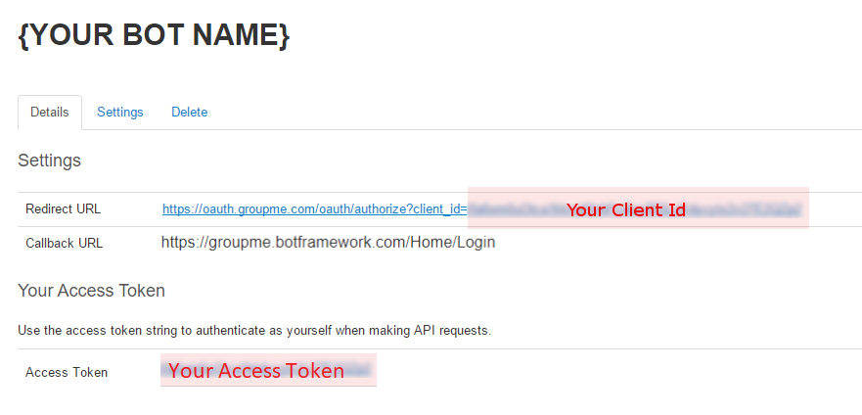

## **Submit credentials**

1. On dev.botframework.com, paste the **client\_id** value you just copied into the **Client ID**field.
2. Paste the **Access Token** value into the **Access Token** field.
3. Click **Save**.

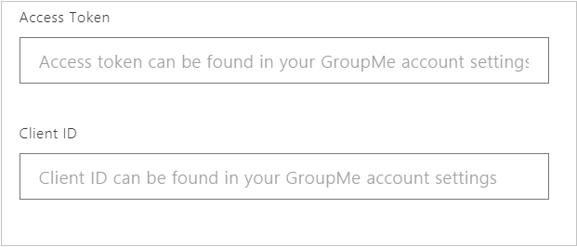

# Connect a bot to Facebook Messenger

To learn more about developing for Facebook Messenger, see the [Messenger platform documentation](https://developers.facebook.com/docs/messenger-platform). You may wish to review Facebook's [pre-launch guidelines](https://developers.facebook.com/docs/messenger-platform/product-overview/launch#app_public), [quick start](https://developers.facebook.com/docs/messenger-platform/guides/quick-start), and [setup guide](https://developers.facebook.com/docs/messenger-platform/guides/setup).

To configure a bot to communicate using Facebook Messenger, enable Facebook Messenger on a Facebook page and then connect the bot to the app.

Tip

To see how various Bot Framework features look and work on this channel, [use the Channel Inspector](https://docs.microsoft.com/en-us/bot-framework/bot-service-channel-inspector).

Note

The Facebook UI may appear slightly different depending on which version you are using.

## **Copy the Page ID**

The bot is accessed through a Facebook Page. [Create a new Facebook Page](https://www.facebook.com/bookmarks/pages) or go to an existing Page.

* Open the Facebook Page's **About** page and then copy and save the **Page ID**.

## **Create a Facebook app**

[Create a new Facebook App](https://developers.facebook.com/quickstarts/?platform=web) on the Page and generate an App ID and App Secret for it.

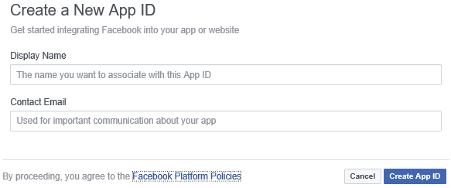

* Copy and save the **App ID** and the **App Secret**.

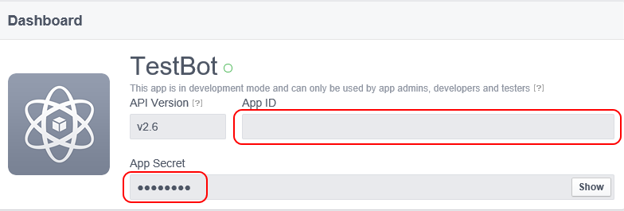

Set the "Allow API Access to App Settings" slider to "Yes".

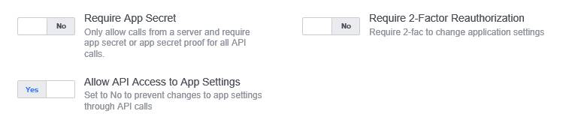

## **Enable messenger**

Enable Facebook Messenger in the new Facebook App.

* On the **Product Setup** page of the app, click **Get Started** and then click **Get Started** again.

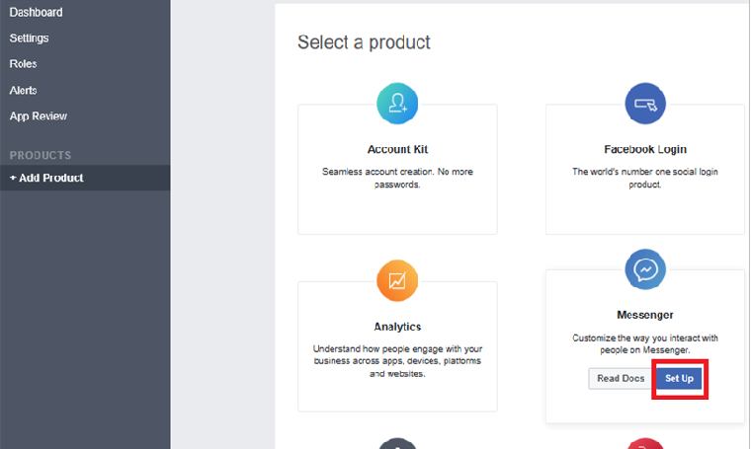

## **Generate a Page Access Token**

In the **Token Generation** panel of the Messenger section, select the target Page. A Page Access Token will be generated.

* Copy and save the **Page Access Token**.

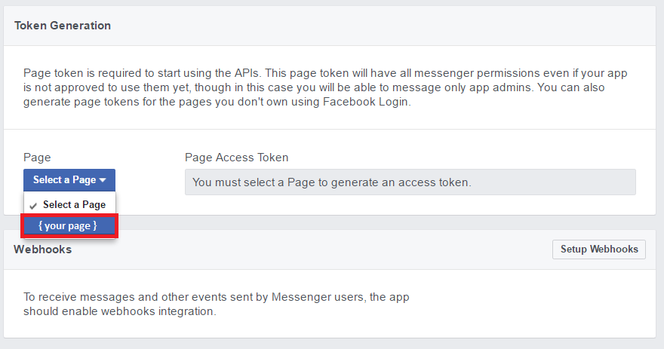

## **Enable webhooks**

Click **Set up Webhooks** to forward messaging events from Facebook Messenger to the bot.

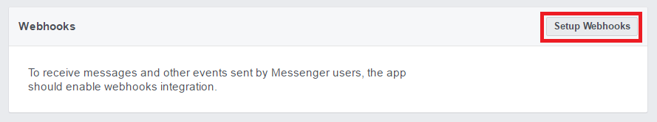

## **Provide webhook callback URL and verify token**

Return to the [Bot Framework Portal](https://dev.botframework.com/). Open the bot, click the **Channels** tab, and then click **Facebook Messenger**.

* Copy the **Callback URL** and **Verify Token** values from the portal.

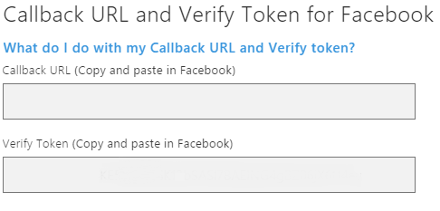

1. Return to Facebook Messenger and paste the **Callback URL** and **Verify Token** values.
2. Under **Subscription Fields**, select message\_deliveries, messages, messaging\_options, and messaging\_postbacks.
3. Click **Verify and Save**.

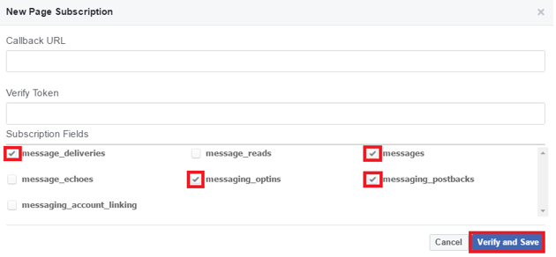

## **Provide Facebook credentials**

On the Bot Framework Portal, paste the **Page ID**, **App ID**, **App Secret**, and **Page Access Token**values copied from Facebook Messenger previously.

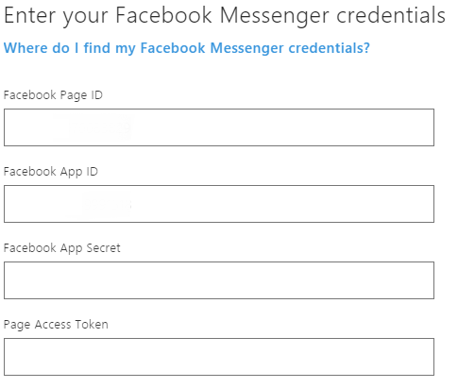

## **Submit for review**

Facebook requires a Privacy Policy URL and Terms of Service URL on its basic app settings page. The [Code of Conduct](https://aka.ms/bf-conduct) page contains third party resource links to help create a privacy policy. The [Terms of Use](https://aka.ms/bf-terms) page contains sample terms to help create an appropriate Terms of Service document.

After the bot is finished, Facebook has its own [review process](https://developers.facebook.com/docs/messenger-platform/app-review) for apps that are published to Messenger. The bot will be tested to ensure it is compliant with Facebook's [Platform Policies](https://developers.facebook.com/docs/messenger-platform/policy-overview).

## **Make the App public and publish the Page**

Note

Until an app is published, it is in [Development Mode](https://developers.facebook.com/docs/apps/managing-development-cycle). Plugin and API functionality will only work for admins, developers, and testers.

After the review is successful, in the App Dashboard under App Review, set the app to Public. Ensure that the Facebook Page associated with this bot is published. Status appears in Pages settings.

# Connect a bot to Kik

You can configure your bot to communicate with people using the Kik messaging app.

Tip

To see how various Bot Framework features look and work on this channel, [use the Channel Inspector](https://docs.microsoft.com/en-us/bot-framework/bot-service-channel-inspector).

## **Install Kik on your phone**

If you don't have Kik installed on your phone, you can install it via your phone's app store or at [the Kik website](https://www.kik.com/)

## **Log into the dev portal with your mobile phone**

[Log into the Kik portal](https://dev.kik.com/) on your mobile phone.

## **Follow the bot setup process**

Give the bot a name.

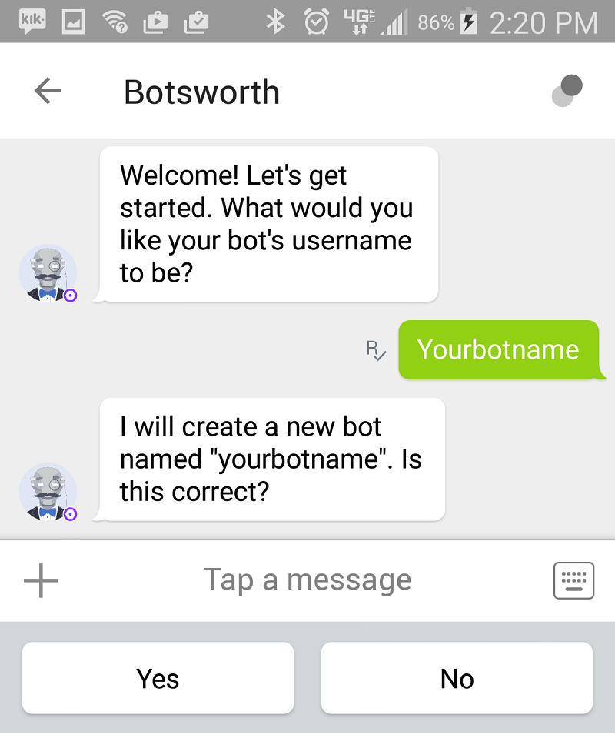

## **Gather credentials**

On the Configuration tab, copy the **Name** and **API key**.

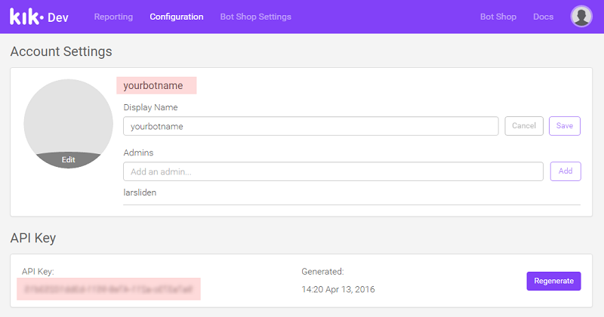

## **Submit credentials**

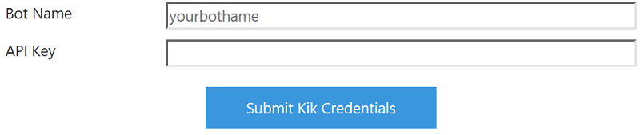

Click **Submit Kik Credentials**.

## **Enable the bot**

Check **Enable this bot on Kik**. Then click **I'm done configuring Kik**.

When you have completed these steps, your bot will be successfully configured to communicate with users in Kik.

# Connect a bot to Slack

You can configure your bot to communicate with people using the Slack messaging app.

## **Create a Slack Application for your bot**

Log into Slack and [create a Slack application](https://api.slack.com/applications/new).



## **Create an app and assign a Development Slack team**

Enter an App Name and select a Development Slack Team. If you are not already a member of a Development Slack Team, [create or join one](https://slack.com/).

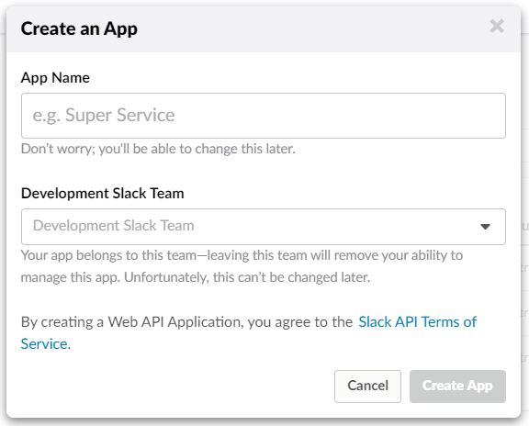

Click **Create App**. Slack will create your app and generate a Client ID and Client Secret.

## **Add a new Redirect URL**

Next you will add a new Redirect URL.

1. Select the **OAuth & Permissions** tab.
2. Click **Add a new Redirect URL**.
3. Enter [https://slack.botframework.com](https://slack.botframework.com/).
4. Click **Add**.
5. Click **Save URLs**.

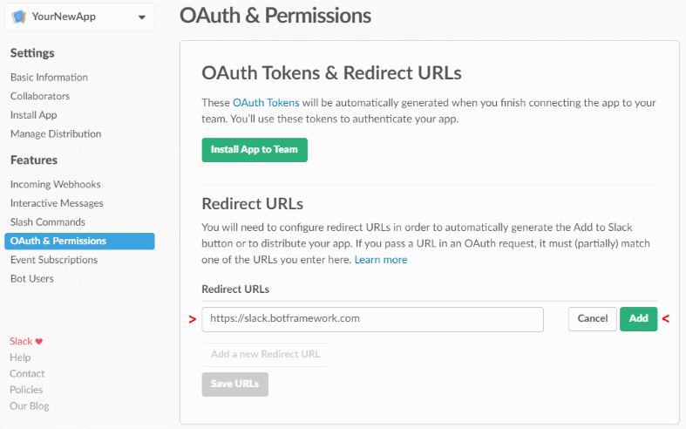

## **Create a Slack Bot User**

Adding a Bot User allows you to assign a username for your bot and choose whether it is always shown as online.

1. Select the **Bot Users** tab.
2. Click **Add a Bot User**.

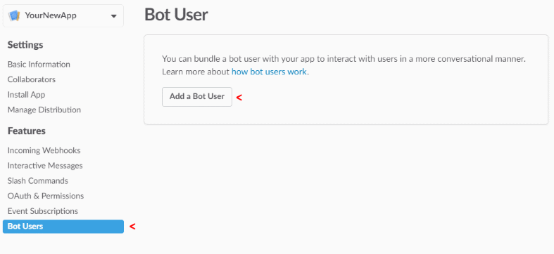

Click **Add Bot User** to validate your settings, click **Always Show My Bot as Online** to **On**, and then click **Save Changes**.

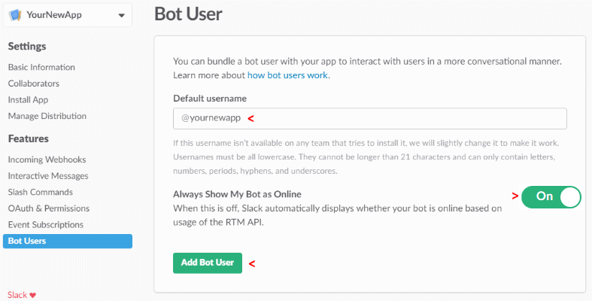

## **Subscribe to Bot Events**

Follow these steps to subscribe to six particular bot events. By subscribing to bot events, your app will be notified of user activities at the URL you specify.

Tip

Your bot handle is a property of your bot. To find a bot's handle, visit <https://dev.botframework.com/bots>, choose a bot, and click **SETTINGS**.

1. Select the **Event Subscriptions** tab.
2. Click **Enable Events** to **On**.
3. In **Request URL**, enter this URL, but replace {YourBotHandle} with your bot handle.https://slack.botframework.com/api/Events/{YourBotHandle}
4. In **Subscribe to Bot Events**, click **Add Bot User Event**.
5. In the list of events, click Add **Bot User Event** and select these six event types:
   * member\_joined\_channel
   * member\_left\_channel
   * message.channels
   * message.groups
   * message.im
   * message.mpim
6. Click **Save Changes**.

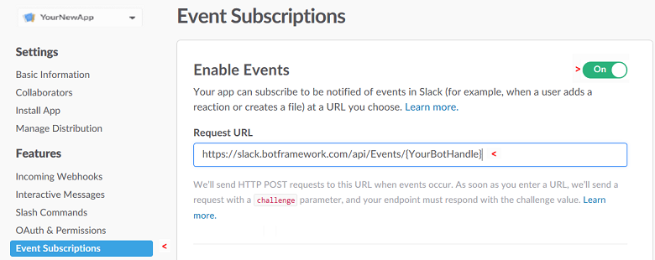

## **Add and Configure Interactive Messages (optional)**

If your bot will use Slack-specific functionality such as buttons, follow these steps:

1. Select the **Interactive Components** tab and click **Enable Interactive Components**.
2. Enter https://slack.botframework.com/api/Actions as the **Request URL**.
3. Click the **Enable Interactive Messages** button, and then click the **Save changes** button.

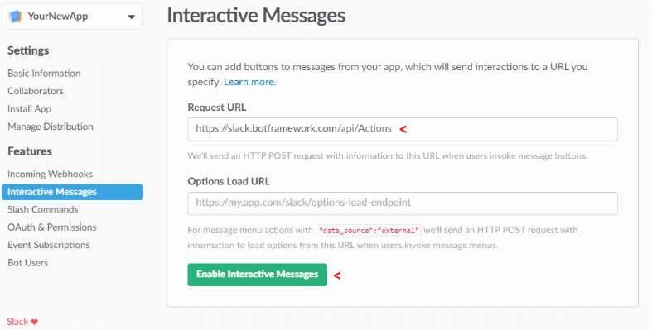

## **Gather credentials**

Select the **Basic Information** tab and scroll to the **App Credentials** section. The Client ID, Client Secret, and Verification Token required for configuration of your Slack bot are displayed.

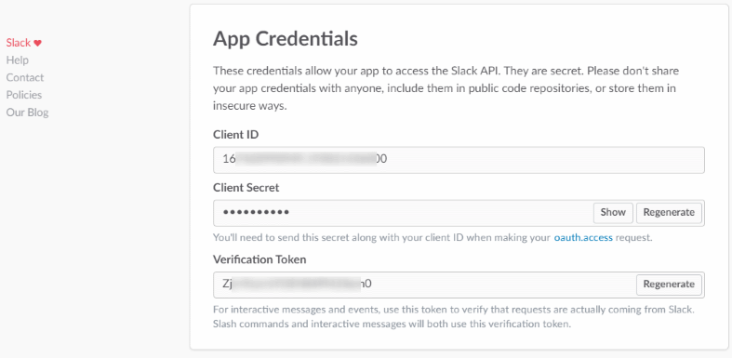

## **Submit credentials**

In a separate browser window, return to the Bot Framework site at https://dev.botframework.com/.

1. Select **My bots** and choose the Bot that you want to connect to Slack.
2. In the **Add a channel** section, click the Slack icon.
3. In the **Enter your Slack credentials** section, paste the App Credentials from the Slack website into the appropriate fields.
4. The **Landing Page URL** is optional. You may omit or change it.
5. Click **Save**.

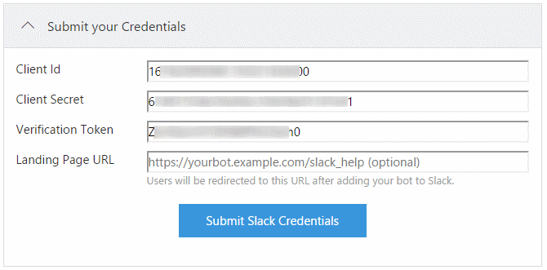

Follow the instructions to authorize your Slack app's access to your Development Slack Team.

## **Enable the bot**

On the Configure Slack page, confirm the slider by the Save button is set to **Enabled**. Your bot is configured to communicate with users in Slack.

## **Create an Add to Slack button**

Slack provides HTML you can use to help Slack users find your bot in the Add the Slack buttonsection of [this page](https://api.slack.com/docs/slack-button). To use this HTML with your bot, replace the href value (begins with https://) with the URL found your bot's Slack channel settings. Follow these steps to get the replacement URL.

1. On <https://dev.botframework.com/bots>, click your bot.
2. Click **CHANNELS**, right-click the entry named **Slack**, and click **Copy link**. This URL is now in your clipboard.
3. Paste this URL from your clipboard into the HTML provided for the Slack button. This URL replaces the href value provided by Slack for this bot.

Authorized users can click the **Add to Slack** button provided by this modified HTML to reach your bot on Slack.

# Connect a bot to Telegram

You can configure your bot to communicate with people using the Telegram messaging app.

Tip

To see how various Bot Framework features look and work on this channel, [use the Channel Inspector](https://docs.microsoft.com/en-us/bot-framework/bot-service-channel-inspector).

## **Visit the Bot Father to create a new Telegram bot**

[Create a new Telegram bot](https://telegram.me/botfather) using the Bot Father.

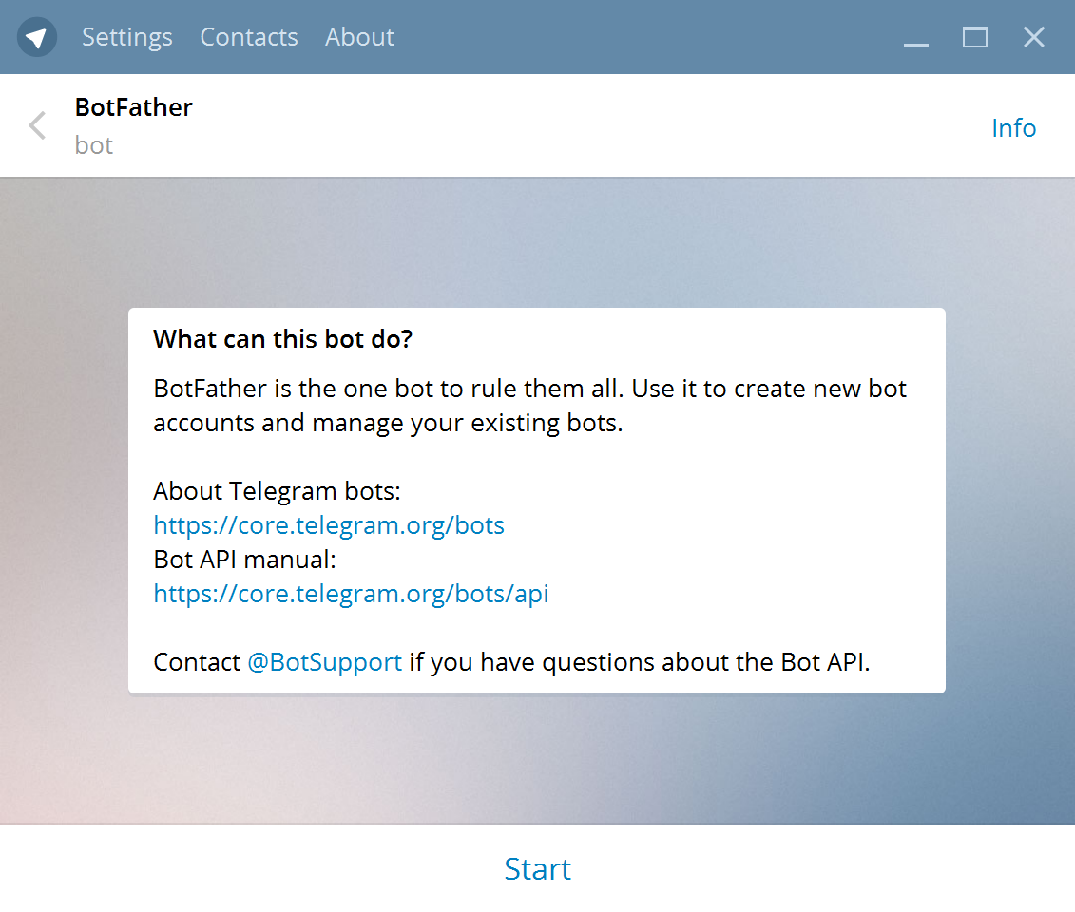

## **Create a new Telegram bot**

To create a new Telegram bot, send command /newbot.

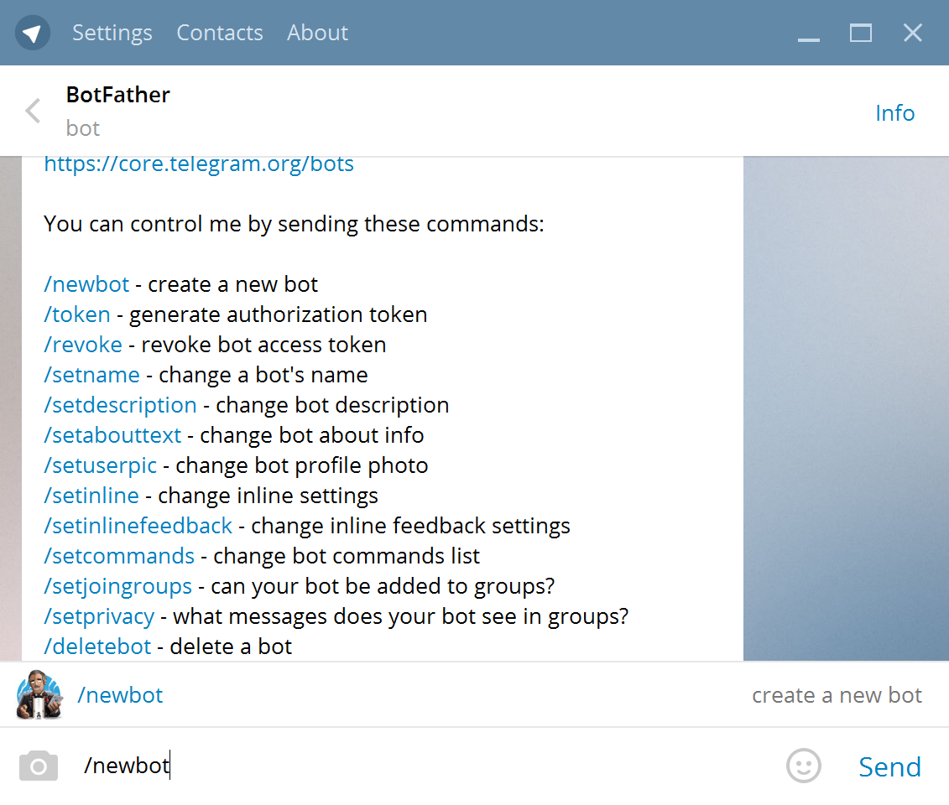

### **Specify a friendly name**

Give the Telegram bot a friendly name.

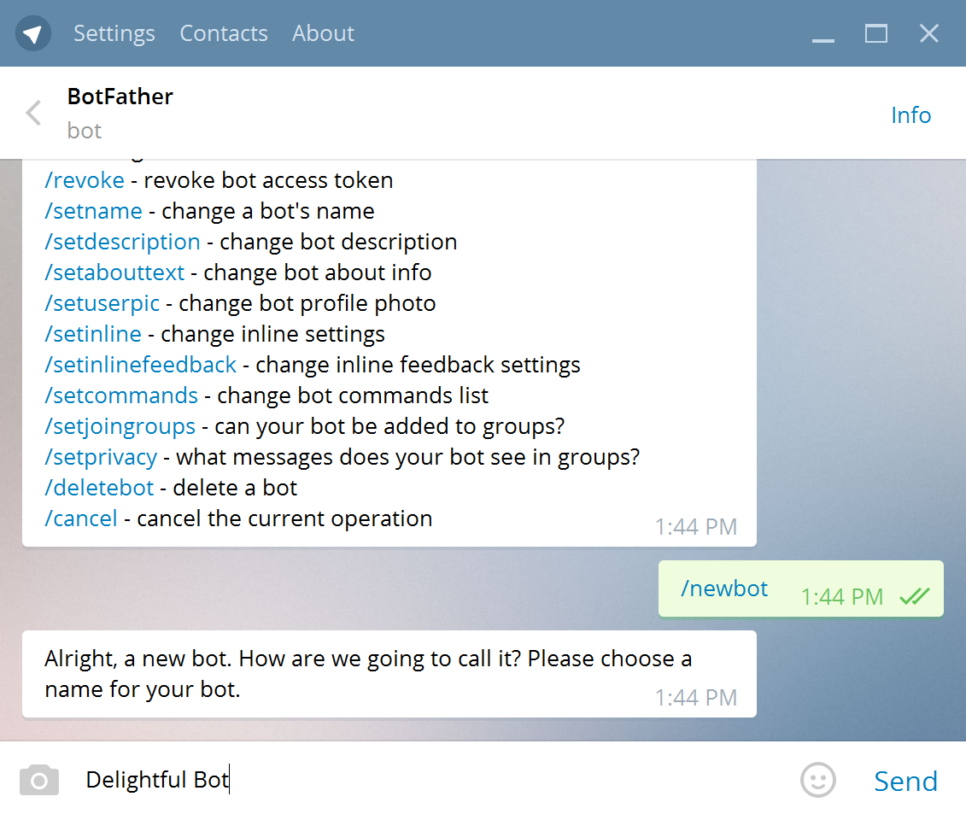

### **Specify a username**

Give the Telegram bot a unique username.

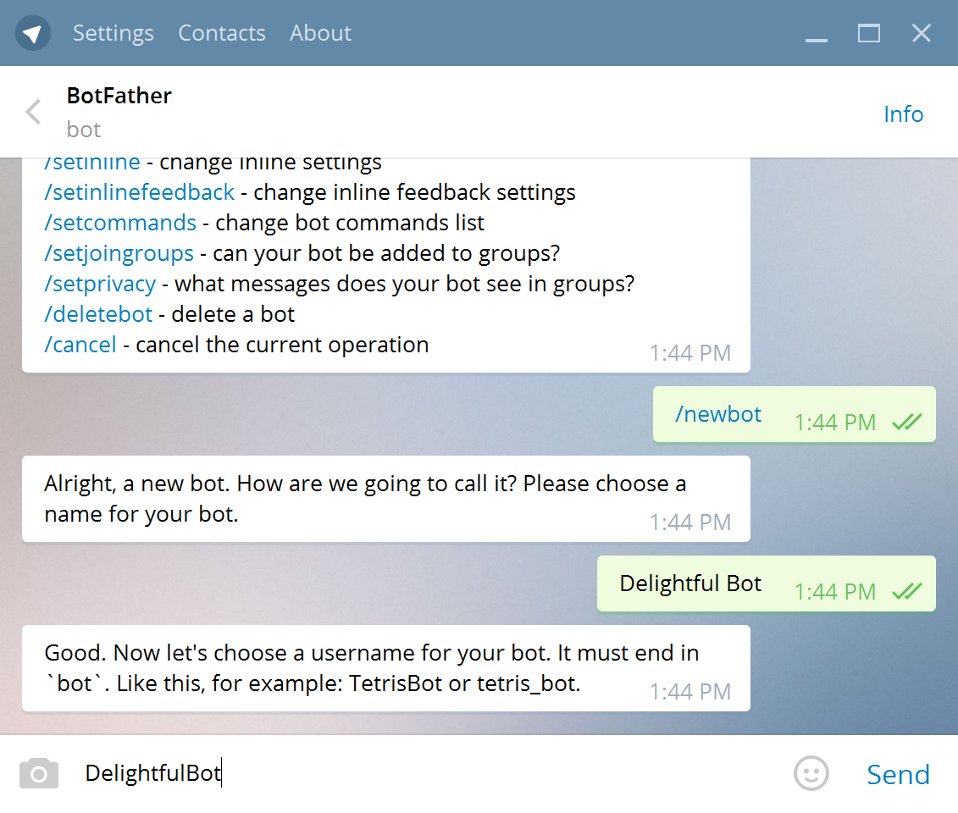

### **Copy the access token**

Copy the Telegram bot's access token.

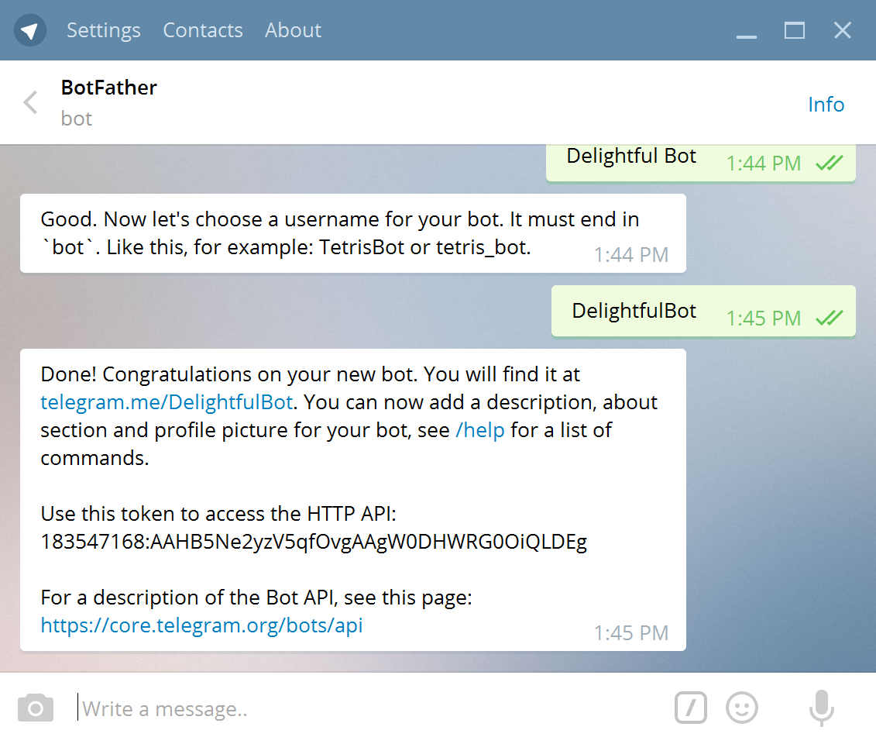

## **Enter the Telegram bot's access token**

Paste the token you copied previously into the **Access Token** field and click **Submit**.

## **Enable the bot**

Check **Enable this bot on Telegram**. Then click **I'm done configuring Telegram**.

When you have completed these steps, your bot will be successfully configured to communicate with users in Telegram.

# Connect a bot to Twilio

You can configure your bot to communicate with people using the Twilio cloud communication platform.

## **Log in to or create a Twilio account for sending and receiving SMS messages**

If you don't have a Twilio account, [create a new account](https://www.twilio.com/try-twilio)

## **Create a TwiML Application**

[Create a TwiML application](https://www.twilio.com/user/account/messaging/dev-tools/twiml-apps/add)

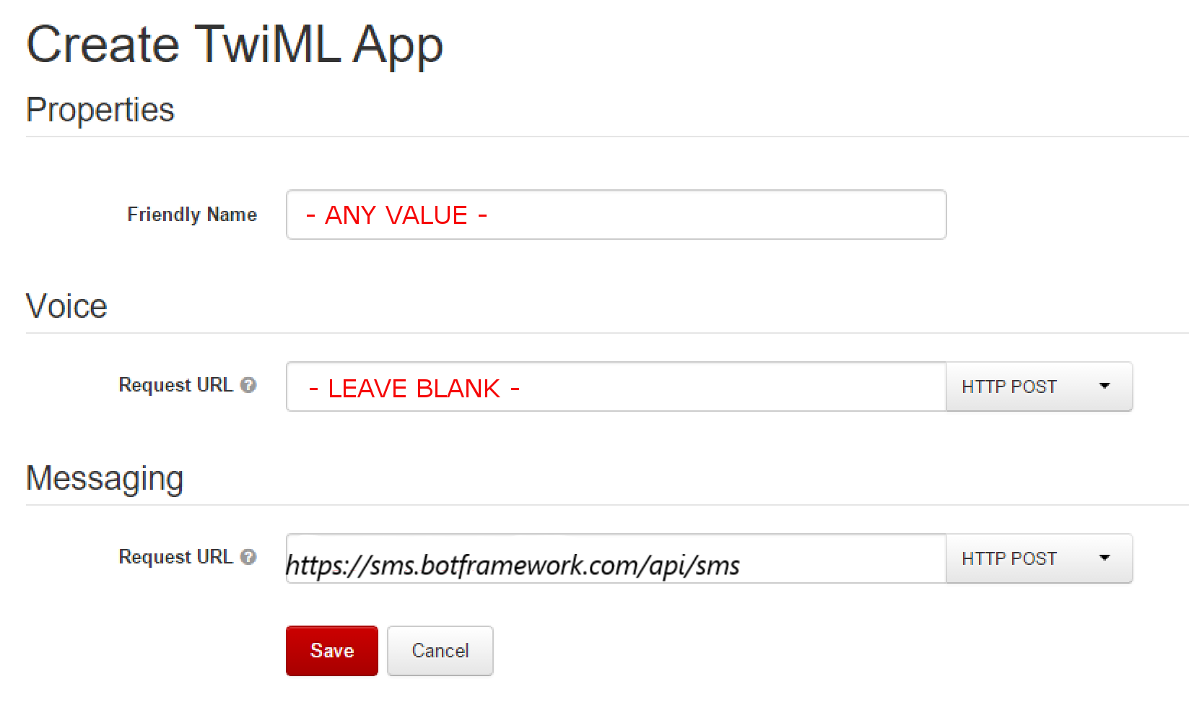

Under Messaging, the Request URL should be [**https://sms.botframework.com/api/sms**](https://sms.botframework.com/api/sms).

## **Select or add a phone number**

[Select or add a phone number](https://www.twilio.com/user/account/phone-numbers/incoming). Click the number to add it to the TwiML application you created.

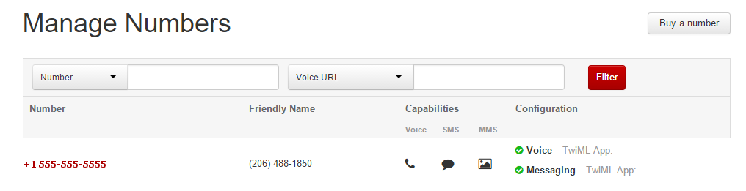

## **Specify application to use for Messaging**

In the **Messaging** section, set the **TwiML App** to the name of the TwiML App you just created. Copy the **Phone Number** value for later use.

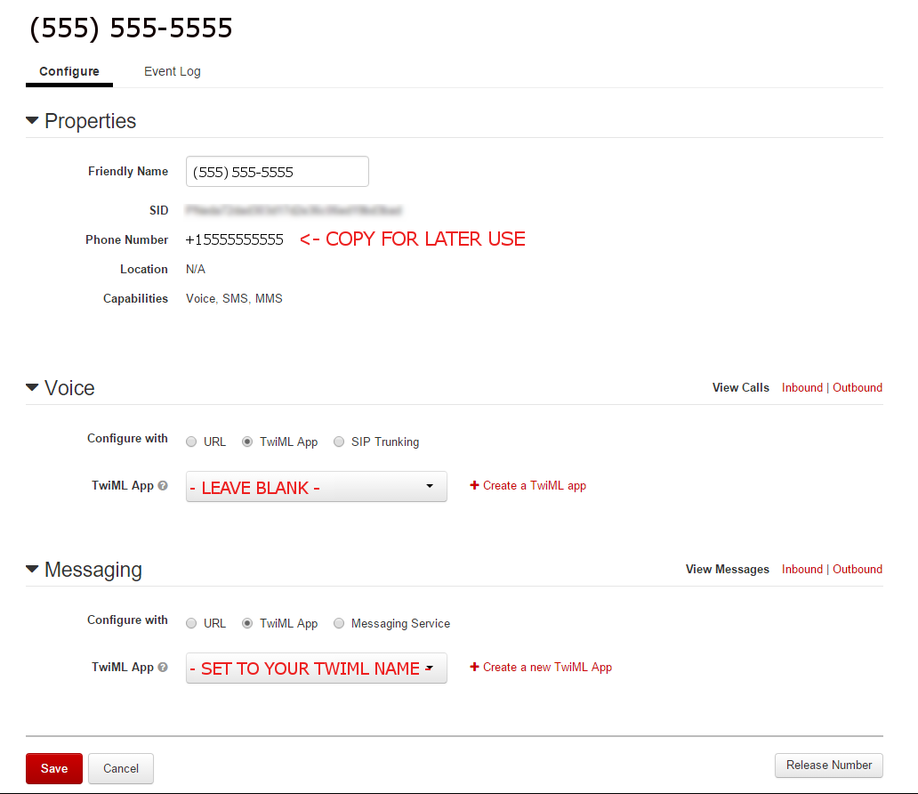

## **Gather credentials**

[Gather credentials](https://www.twilio.com/user/account/settings) and then click the "eye" icon to see the Auth Token.

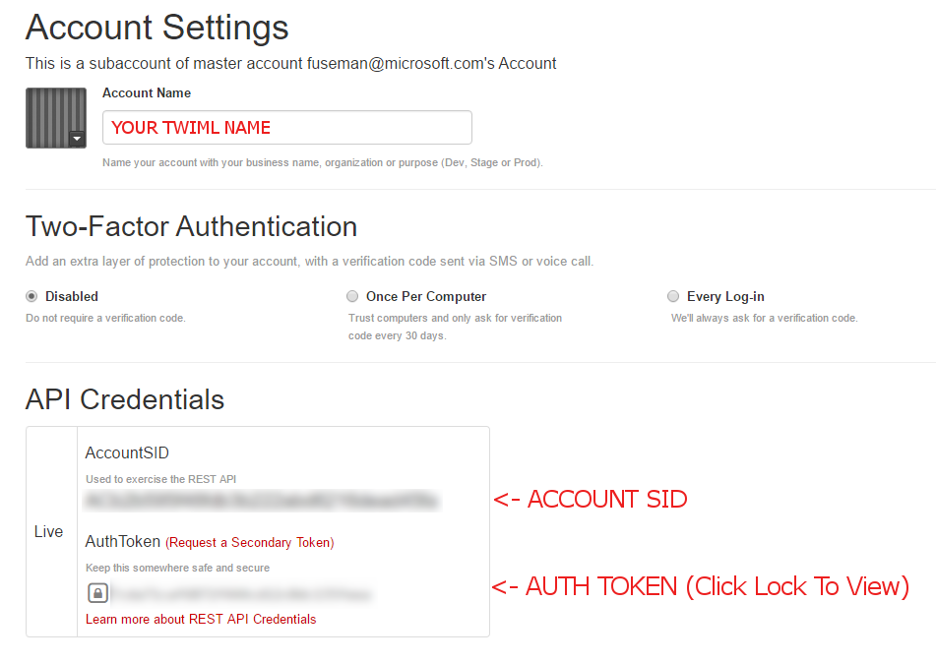

## **Submit credentials**

Enter the phone number, accountSID, and Auth Token you copied earlier and click **Submit Twilio Credentials**.

## **Enable the bot**

Check **Enable this bot on SMS**. Then click **I'm done configuring SMS**.

When you have completed these steps, your bot will be successfully configured to communicate with users using Twilio.

# Preview bot features with the Channel Inspector

The Bot Framework enables you to create bots with a variety of features such as text, buttons, images, rich cards displayed in carousel or list format, and more. However, each channel ultimately controls how features are rendered by its messaging clients.

Even when a feature is supported by multiple channels, each channel may render the feature in a slightly different way. In cases where a message contains feature(s) that a channel does not natively support, the channel may attempt to down-render message contents as text or as a static image, which can significantly impact the message's appearance on the client. In some cases, a channel may not support a particular feature at all. For example, GroupMe clients cannot display a typing indicator.

## **The Channel Inspector**

The [Channel Inspector](https://docs.botframework.com/en-us/bot-service-channel-inspector/channels/Skype/) is created to give you a preview on how various Bot Framework features look and work on different channels. By understanding how features are rendered by various channels, you'll be able to design your bot to deliver an exceptional user experience on the channels where it communicates. The Channel Inspector also provides a great way to learn about and visually explore Bot Framework features.1

Note

Rich cards are a developing standard for bot information exchange to ensure consistent display across multiple channels. See the [.NET](https://docs.microsoft.com/en-us/bot-framework/dotnet/bot-builder-dotnet-add-rich-card-attachments) or [Node.js](https://docs.microsoft.com/en-us/bot-framework/nodejs/bot-builder-nodejs-send-rich-cards) documentation for more information about rich cards.

## **Text formatting**

Text formatting can enhance your text messages visually. Besides **plain** text, your bot can send text messages using **markdown** or **xml** formatting to channels that support them. The following tables list some of the most commonly used text formatting in **markdown** and **xml**. Each channel may support fewer or more text formatting then what is listed here. You can check the [Channel Inspector](https://docs.botframework.com/en-us/bot-service-channel-inspector/channels/Skype/) to see if a feature you want to use is supported on a channel that you target.

### **Markdown text format**

These styles may be supported when textFormat is set to **markdown**:

| Style | Markdown | Example |
| --- | --- | --- |
| bold | \*\*text\*\* | **text** |
| italic | \*text\* | text |
| header (1-5) | # H1 | # H1 |
| strikethrough | ~~text~~ |  |
| horizontal rule | ---- | ---- |
| unordered list | \* text | * text |
| ordered list | 1. text | 1. text |
| preformatted text | `text` | text |
| blockquote | > text | text |
| hyperlink | [bing]([http://www.bing.com](http://www.bing.com/)) | [bing](http://www.bing.com/) |
| image link | ![duck](<http://aka.ms/Fo983c>) | duck |

Note

HTML tags in **Markdown** are not supported in Microsoft Bot Framework Web Chat channels. If you need to use HTML tags in your **Markdown**, you can render them in a [Direct Line](https://docs.microsoft.com/en-us/bot-framework/bot-service-channel-connect-directline) channel that supports them. Alternatively, you can use the HTML tags below by setting the textFormat to **xml** and connect your bot to Skype channel.

### **XML text format**

These styles may be supported when textFormat is set to **xml**:

| Style | XML | Example |
| --- | --- | --- |
| bold | <b>text</b> | **text** |
| italic | <i>text</i> | text |
| underline | <u>text</u> | text |
| strikethrough | <s>text</s> | ~~text~~ |
| hyperlink | <a href="http://www.bing.com">bing</a> | [bing](http://www.bing.com/) |
| paragraph | <p>text</p> | text |
| line break | <br/> | line 1  line 2 |
| horizontal rule | <hr/> |  |
| header (1-4) | <h1>text</h1> | Heading 1 |
| code | <code>code block</code> | code block |
| image | <img src="<http://aka.ms/Fo983c>" alt="Duck"> | Duck |

Note

The textFormat **xml** is supported only by the Skype channel.

## **Preview features across various channels**

To see how a channel renders a particular feature, go to the [Channel Inspector](https://docs.botframework.com/en-us/bot-service-channel-inspector/channels/Skype/), select the channel from **Channel** list and the feature from the **Feature** list. For example, to see how Skype renders a Hero Card, set **Channel** to Skype and **Feature** to HeroCard.

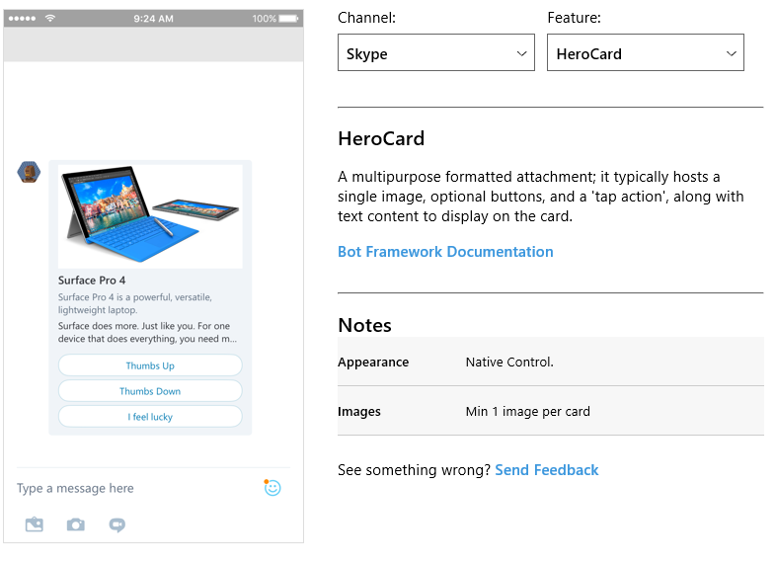

The Channel Inspector shows a preview of the selected feature as it will be rendered by the specified channel. The **Notes** section conveys important information about message limitations and/or display changes. For example, some types of rich cards support only one image and some features may be down-rendered on certain channels.

Note

The Channel Inspector currently supports these channels:

* Cortana
* Email
* Facebook
* GroupMe
* Kik
* Skype
* Skype for Business
* Slack
* SMS
* Microsoft Teams
* Telegram
* WeChat
* Web Chat

Additional channels may be added in the future.

## **Features that can be previewed**

The Channel Inspector currently allows you to preview the following features.

| Feature | Description |
| --- | --- |
| Adaptive Cards | A card that can contain any combination of text, speech, images, buttons, and input fields. |
| Buttons | Buttons that the user can click. Buttons appear on the conversation canvas with the message they belong to. |
| Carousel | A compact, scrollable horizontal list of cards. For a vertical layout, use List. |
| ChannelData | A way to pass metadata to access channel-specific functionality beyond cards, text, and attachments. |
| Codesample | A multi-line, pre-formatted block of text designed to display computer code. |
| DirectMessage | A message sent to a single member of a group conversation. |
| Document | Send and receive non-media attachments. |
| Emoji | Display supported emoji. |
| GroupChat | Bot sends messages to participate in group conversations. |
| HeroCard | A formatted attachment typically containing a single large image, a tap action, and buttons (optional), along with descriptive text content. |
| Images | Display of image attachments. |
| List Layout | A vertical list of cards. For a horizontal, scrollable layout, use Carousel. |
| Location | Share the user's physical location with the bot. |
| Markdown | Renders text formatted with Markdown. |
| Members | Shares the list of members in the conversation with the bot during a group chat. |
| Receipt Card | Display a receipt to the user. |
| Signin Card | Request the user to enter authentication credentials. |
| Suggested Actions | Actions presented as buttons that the user can tap to provide input. |
| Thumbnail Card | A formatted attachment containing a single small image (thumbnail), a tap action, and buttons (optional), along with descriptive text content. |
| Typing | Displays a typing indicator. This is helpful to inform the user that the bot is still functioning, but performing some action in the background. |
| Video | Displays video attachments and play controls. |

# Configure bot settings

The bot settings, such as Display name, Icon, and Application Insights, can be viewed and modified on its **Settings** blade.

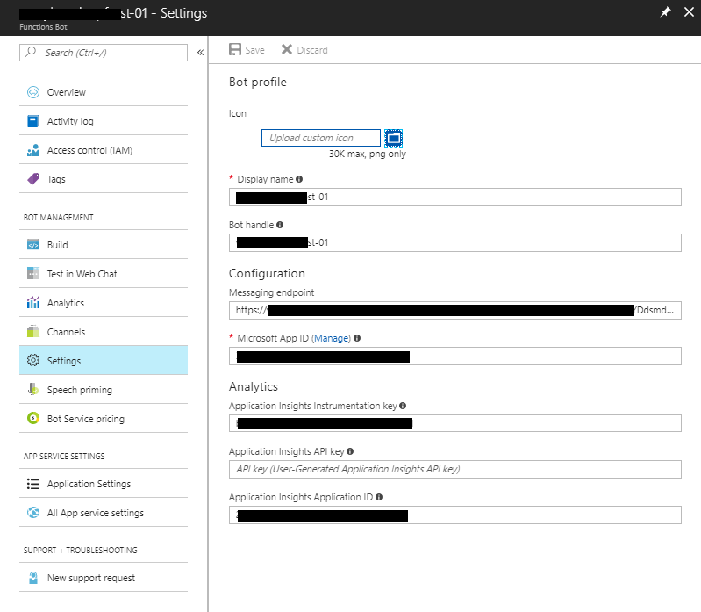

Below is the list of fields on the **Settings** blade:

| Field | Description |
| --- | --- |
| Icon | A custom icon to visually identify your bot in channels and as the icon for Skype, Web Chat, and other services. This icon must be in PNG format, and no larger than 30K in size. This value can be changed at any time. |
| Display name | The name of your bot in channels and directories. This value can be changed at any time. 35 character limit. |
| Bot handle | Unique idenifier for your bot. This value cannot be changed after creating your bot with the Bot Service. |
| Messaging endpoint | The endpoint to communicate with your bot. |
| Microsoft App ID | Unique identifier for your bot. This value cannot be changed. You can generate a new password by clicking on the **Manage** link. |
| Application Insights Instrumentation key | Unique key for bot telemetry. Copy your Azure Application Insights Key to this field if you want to receive bot telemetry for this bot. This value is optional. Bots created in the Azure Portal will have this key generated for them. For more details on this field, see [Application Insights keys](https://docs.microsoft.com/en-us/bot-framework/bot-service-resources-app-insights-keys). |
| Application Insights API key | Unique key for bot analytics. Copy your Azure Application Insights API Key to this field if you want to view analytics about your bot in the Dashboard. This value is optional. For more details on this field, see [Application Insights keys](https://docs.microsoft.com/en-us/bot-framework/bot-service-resources-app-insights-keys). |
| Application Insights Application ID | Unique key for bot analytics. Copy your Azure Insights Application ID Key to this field if you want to view analytics about your bot in the Dashboard. This value is optional. Bots created in the Azure Portal will have this key generated for them. For more details on this field, see [Application Insights keys](https://docs.microsoft.com/en-us/bot-framework/bot-service-resources-app-insights-keys). |

Note

After you have changed settings for your bot, click the **Save** button at the top of the blade to save your new bot settings.

# Configure speech priming

Speech priming improves the recognition of spoken words and phrases that are commonly used in your bot. For speech-enabled bots that use the Web Chat and Cortana channels, speech priming uses examples specified in Language Understanding (LUIS) apps to improve speech recognition accuracy for important words.

Your bot may already be integrated with a LUIS app, or you can choose to create a LUIS app to associate with your bot for speech priming. The LUIS app contains examples of what you expect users to say to your bot. Important words that you want the bot to recognize should be labeled as entities. For example, in a chess bot you want to make sure that when the user says "Move knight", it isn’t interpreted as "Move night". The LUIS app should include examples in which "knight" is labeled as an entity.

Note

To use speech priming with the Web Chat channel, you must use the Bing Speech service. See [Enable speech in the Web Chat channel](https://docs.microsoft.com/en-us/bot-framework/bot-service-channel-connect-webchat-speech) for an explanation of how to use the Bing Speech service.

Important

Speech priming only applies to bots configured for the Cortana channel or the Web Chat channel.

## **Change the list of LUIS apps your bot uses**

To change the list of LUIS apps used by Bing Speech with your bot, do the following:

1. Click **Speech priming** on the bot service blade. The list of LUIS apps available to you will appear.
2. Select the LUIS apps you want Bing Speech to use.

a. To select a LUIS app in the list, hover over the LUIS model until a checkbox appears, then check the checkbox.

b. To select a LUIS app that is not on the list, scroll to the bottom and enter the LUIS Application ID GUID into the text box.

1. Click **Save** to save the list of LUIS apps associated with Bing Speech for your bot.

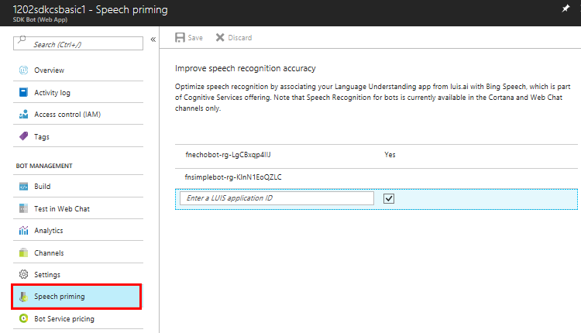

## **Additional Resources**

* To learn more enabling speech in Web Chat see [Enable speech in the Web Chat channel](https://docs.microsoft.com/en-us/bot-framework/bot-service-channel-connect-webchat-speech).
* To learn more about speech priming, see [Speech Support in Bot Framework – Web Chat to Directline, to Cortana](https://blog.botframework.com/2017/06/26/Speech-To-Text/).
* To learn more about LUIS apps, see [Language Understanding Intelligent Service](https://www.luis.ai/).

# Migrate your bot to Azure

All **Azure Bot Service (Preview)** bots created in the [Bot Framework Portal](http://dev.botframework.com/) must migrate to the new Bot Service in Azure by 3/31/2018.

Note

Migration is currently enabled for registration bot types only. Migration for SDK bots and Functions bots will be coming soon.

To migrate your bot, do the following:

1. Sign into the [Bot Framework Portal](http://dev.botframework.com/) and click **My bots**.
2. Click **Migrate** button for the bot you want to migrate.

Note

Before migrating a Functions bot using Node.js, it is recommended that you use the Azure Functions Pack to package the Node.js modules together. Doing so will improve performance during migration and execution of the Functions bot after it is migrated. For more information about, see [Azure Functions Pack](https://github.com/Azure/azure-functions-pack).

1. Accept the **Terms** and click **Migrate** to start the migration process or click **Cancel** to cancel this action.

Important

While the migration task is in progress, do not navigate away from the page or refresh the page. Doing so will cause the migration task to stop pre-maturely and you will have to perform the action again. To ensure the migration completes successfully, wait for the confirmation message.

After the migration process complete successfully, the **Migration status** will indicate that the bot is migrated and a **Roll back migration** button is available if you need to undo the migration.

Clicking the name of a migrated bot will open the bot in the [Azure portal](http://portal.azure.com/).

## **Migration under the hood**

Depending on the type of bot you are migrating, the list below can help you better understand what is happening under the hood.

* **Web App Bot** or **Functions Bot**: For these types of bots, the source code project is copied from the old bot to the new bot. Other resources such as your bot's storage, Application Insights, LUIS, etc. are left as is. In those cases, the new bot contains a copy of the IDs/keys/passwords to those existing resources.
* **Bot Channels Registration**: For this type of bots, the migration process simply create a new **Bot Channels Registration** and copy the endpoint from the old bot over.
* Regardless of the types of bot you are migrating, the migration process does not modify the existing bot's state in anyway. This allows you to safely roll back if you need to do so.
* If you have [continuous deployment](https://docs.microsoft.com/en-us/bot-framework/bot-service-build-continuous-deployment) set up, you will need to set it up again so that your source control connects to the new bot instead.

## **Roll back migration**

In the event something went wrong with the bot during migration or after it is migrated, you can **Roll back migration**. To roll back a migration, do the following:

1. Sign into the [Bot Framework Portal](http://dev.botframework.com/) and click **My bots**.
2. Click **Roll back migration** button for the bot you want to roll back. A prompt will appear.
3. Click **Yes, roll back** to proceed or **Cancel** to cancel the roll back action.

Note

Roll back functionality for registration bots is coming soon.

# Bot Builder SDK for .NET

The Bot Builder SDK for .NET is a powerful framework for constructing bots that can handle both free-form interactions and more guided conversations where the user selects from possible values. It is easy to use and leverages C# to provide a familiar way for .NET developers to write bots.

Using the SDK, you can build bots that take advantage of the following SDK features:

* Powerful dialog system with dialogs that are isolated and composable
* Built-in prompts for simple things such as Yes/No, strings, numbers, and enumerations
* Built-in dialogs that utilize powerful AI frameworks such as [LUIS](http://luis.ai/)
* FormFlow for automatically generating a bot (from a C# class) that guides the user through the conversation, providing help, navigation, clarification, and confirmation as needed

Important

On July 31, 2017 breaking changes will be implemented in the Bot Framework security protocol. To prevent these changes from adversely impacting your bot, you must ensure that your application is using Bot Builder SDK v3.5 or greater. If you've built a bot using an SDK that you obtained prior to January 5, 2017 (the release date for Bot Builder SDK v3.5), be sure to upgrade to Bot Builder SDK v3.5 or later before July 31, 2017.

## **Get the SDK**

The SDK is available as a NuGet package and as open source on [GitHub](https://github.com/Microsoft/BotBuilder).

Important

The Bot Builder SDK for .NET requires .NET Framework 4.6 or newer. If you are adding the SDK to an existing project targeting a lower version of the .NET Framework, you will need to update your project to target .NET Framework 4.6 first.

To install the SDK within a Visual Studio project, complete the following steps:

1. In **Solution Explorer**, right-click the project name and select **Manage NuGet Packages...**.
2. On the **Browse** tab, type "Microsoft.Bot.Builder" into the search box.
3. Select **Microsoft.Bot.Builder** in the list of results, click **Install**, and accept the changes.

## **Get code samples**

This SDK includes [sample source code](https://docs.microsoft.com/en-us/bot-framework/dotnet/bot-builder-dotnet-samples) that uses the features of the Bot Builder SDK for .NET.

# Bot Builder SDK for Node.js

Bot Builder SDK for Node.js is a powerful, easy-to-use framework that provides a familiar way for Node.js developers to write bots. You can use it to build a wide variety of conversational user interfaces, from simple prompts to free-form conversations.

The conversational logic for your bot is hosted as a web service. The Bot Builder SDK uses [restify](http://restify.com/), a popular framework for building web services, to create the bot's web server. The SDK is also compatible with [Express](http://expressjs.com/) and the use of other web app frameworks is possible with some adaption.

Using the SDK, you can take advantage of the following SDK features:

* Powerful system for building dialogs to encapsulate conversational logic.
* Built-in prompts for simple things such as Yes/No, strings, numbers, and enumerations, as well as support for messages containing images and attachments, and rich cards containing buttons.
* Built-in support for powerful AI frameworks such as [LUIS](http://luis.ai/).
* Built-in recognizers and event handlers that guide the user through the conversation, providing help, navigation, clarification, and confirmation as needed.

## **Get started**

If you are new to writing bots, [create your first bot with Node.js](https://docs.microsoft.com/en-us/bot-framework/nodejs/bot-builder-nodejs-quickstart) with step-by-step instructions to help you set up your project, install the SDK, and run your first bot.

If you are new to the Bot Builder SDK for Node.js, you can start with key concepts that help you understand the major components of the Bot Builder SDK, see [Key concepts](https://docs.microsoft.com/en-us/bot-framework/nodejs/bot-builder-nodejs-concepts).

To ensure your bot addresses the top user scenarios, review the [design principles](https://docs.microsoft.com/en-us/bot-framework/bot-service-design-principles) and [explore patterns](https://docs.microsoft.com/en-us/bot-framework/bot-service-design-pattern-task-automation) for guidance.

## **Get samples**

The [Bot Builder SDK for Node.js samples](https://docs.microsoft.com/en-us/bot-framework/nodejs/bot-builder-nodejs-samples) demonstrate task-focused bots that show how to take advantage of features in the Bot Builder SDK for Node.js. You can use the samples to help you quickly get started with building great bots with rich capabilities.

# Bot Framework REST APIs

The Bot Framework REST APIs enable you to build bots that exchange messages with channels configured in the [Bot Framework Portal](https://dev.botframework.com/), store and retrieve state data, and connect your own client applications to your bots. All Bot Framework services use industry-standard REST and JSON over HTTPS.

## **Build a bot**

You can create a bot with any programming language by using the Bot Connector service to exchange messages with channels configured in the Bot Framework Portal.

Tip

The Bot Framework provides client libraries that can be used to build bots in either C# or Node.js. To build a bot using C#, use the [Bot Builder SDK for C#](https://docs.microsoft.com/en-us/bot-framework/dotnet/bot-builder-dotnet-overview). To build a bot using Node.js, use the [Bot Builder SDK for Node.js](https://docs.microsoft.com/en-us/bot-framework/nodejs/index).

To learn more about building bots using the Bot Connector service, see [Key concepts](https://docs.microsoft.com/en-us/bot-framework/rest-api/bot-framework-rest-connector-concepts).

## **Build a client**

You can enable your own client application to communicate with your bot by using the Direct Line API. The Direct Line API implements an authentication mechanism that uses standard secret/token patterns and provides a stable schema, even if your bot changes its protocol version. To learn more about using the Direct Line API to enable communication between a client and your bot, see [Key concepts](https://docs.microsoft.com/en-us/bot-framework/rest-api/bot-framework-rest-direct-line-3-0-concepts).

# Debug a Bot Service bot

Bot Service bots are built as Azure App Service web apps, or as code running in a Consumption plan upon the Azure Functions serverless architecture. This article describes how to debug your bot after you have set up a publishing process. By downloading a zip file that contains your bot source, you can develop and debug using an integrated development environment (IDE) such as Visual Studio or Visual Studio Code. From your computer, you can update your bot on Bot Service by publishing from Visual Studio, or by publishing with every check-in to your source control service through continuous deployment.

## **Publish any bot source using continuous deployment**

You can publish bot source to Azure using continuous deployment. To set up continuous deployment, [follow these steps](https://docs.microsoft.com/en-us/bot-framework/bot-service-continuous-deployment) before proceeding.

## **Debug a Node.js bot**

Follow steps in this section to debug a bot written in Node.js.

### **Prerequisites**

Before you can debug your Node.js bot, you must complete these tasks.

* Download the source code for your bot (from Azure), as described in [Set up continuous deployment](https://docs.microsoft.com/en-us/bot-framework/bot-service-continuous-deployment).
* Download and install the [Bot Framework Emulator](https://docs.microsoft.com/en-us/bot-framework/bot-service-debug-emulator).
* Download and install a code editor such as [Visual Studio Code](https://code.visualstudio.com/).

### **Debug a Node.js bot using the Bot Framework Emulator**

The simplest way to debug your bot locally is to start the bot in Node and then connect to it from Bot Framework Emulator. First, you must set the NODE\_ENV environment variable. This screenshot shows how to set the NODE\_ENV environment variable and start the bot.

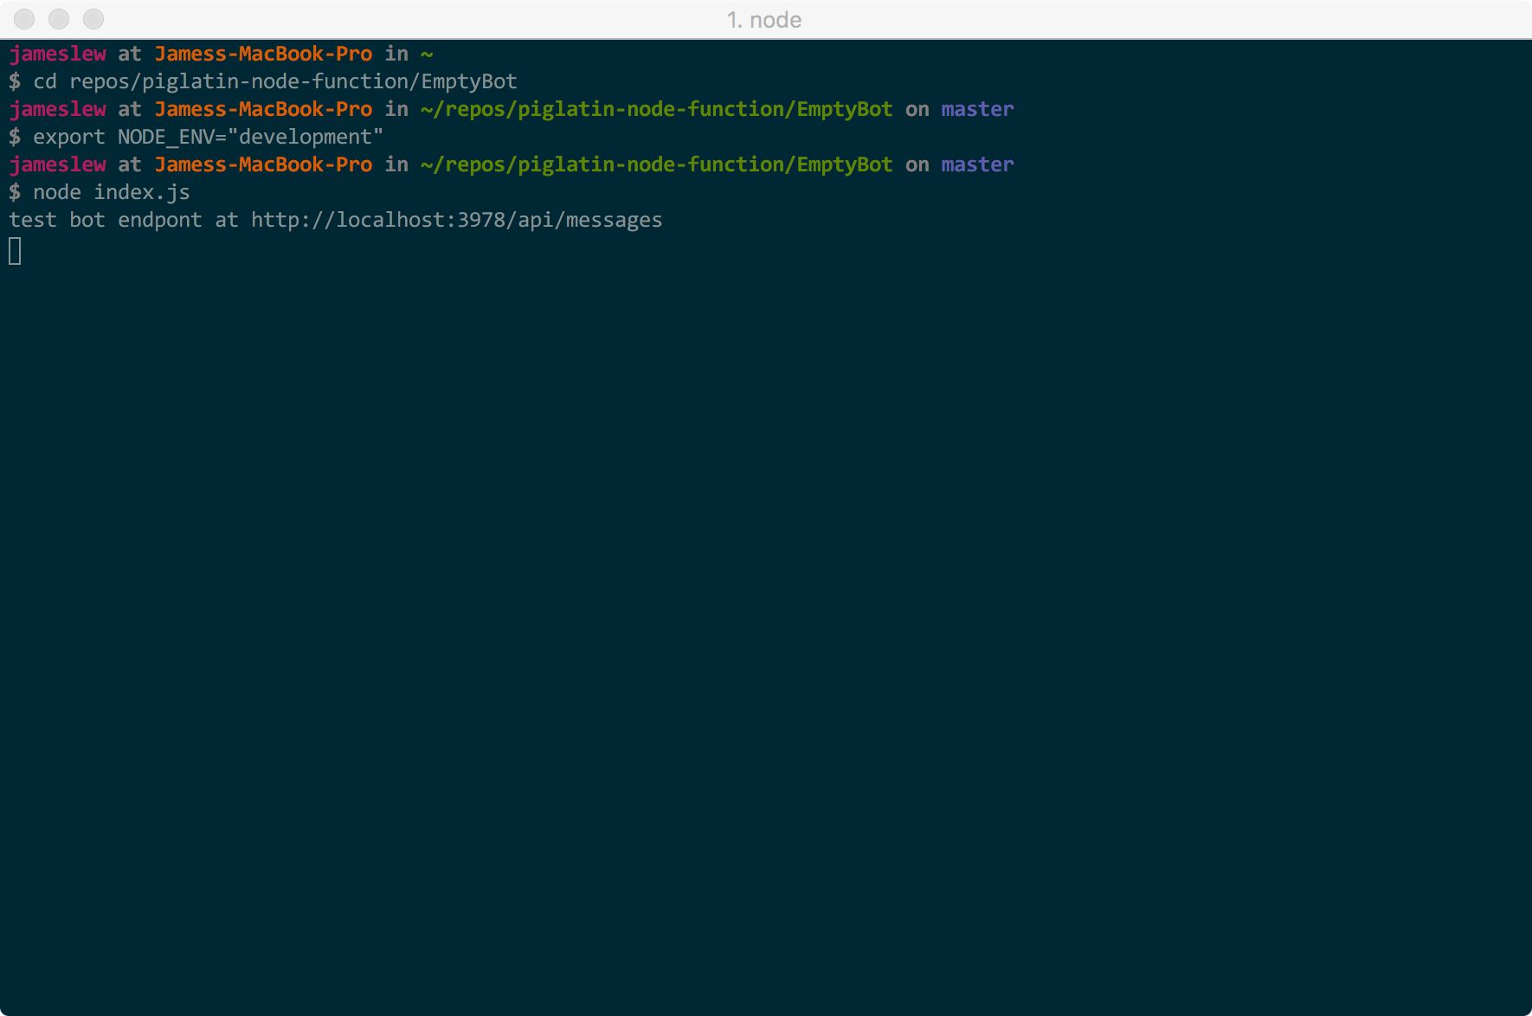

At this point, the bot is running locally. Copy the bot's endpoint from the terminal window (in this example, http://localhost:3978/api/messages), start the Bot Framework Emulator, and paste the endpoint into the address bar of the emulator. Since you do not need security for local debugging, you can leave the **Microsoft App ID** and **Microsoft App Password** fields blank. Click **Connect** to establish a connection to your bot using the specified endpoint.

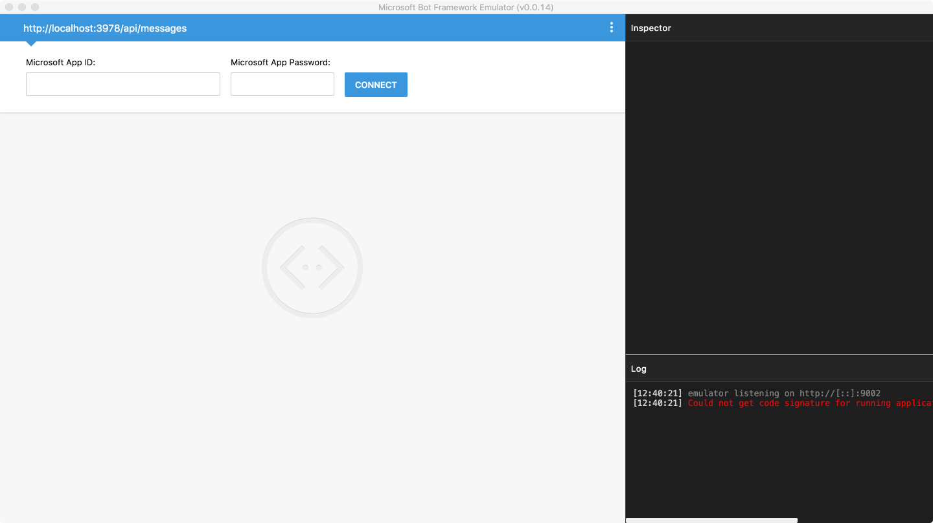

After you have connected the emulator to your bot, send a message to your bot by typing some text into the textbox that is located at the bottom of the emulator window (i.e., where **Type your message...** appears in the lower-left corner). By using the **Log** and **Inspector** panels on the right side of the emulator window, you can view the requests and responses as messages are exchanged between the emulator and the bot.

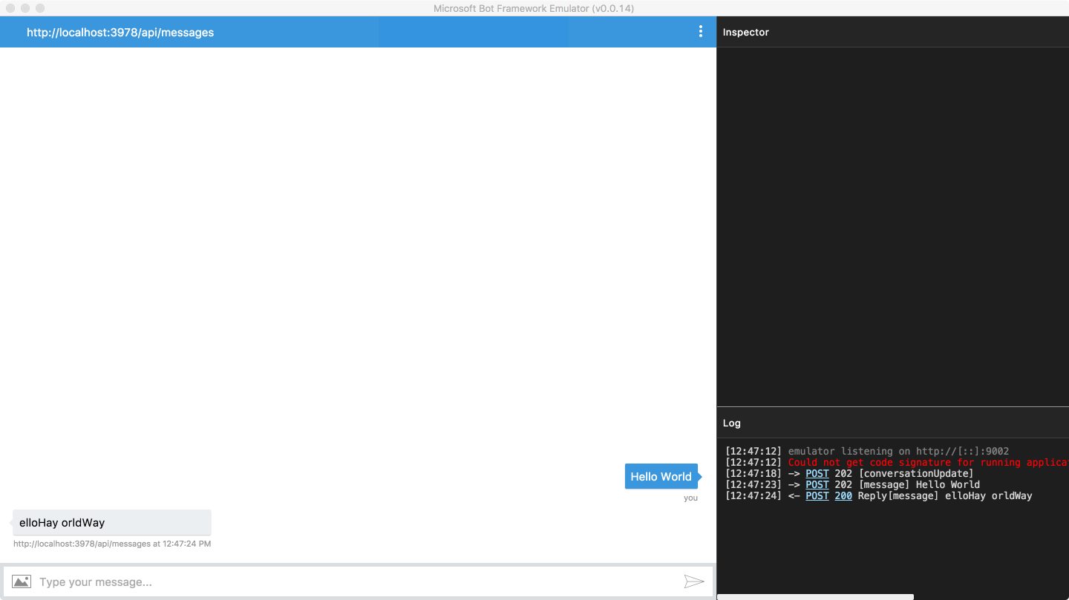

Additionally, you can view log details from the Node runtime in the terminal window.

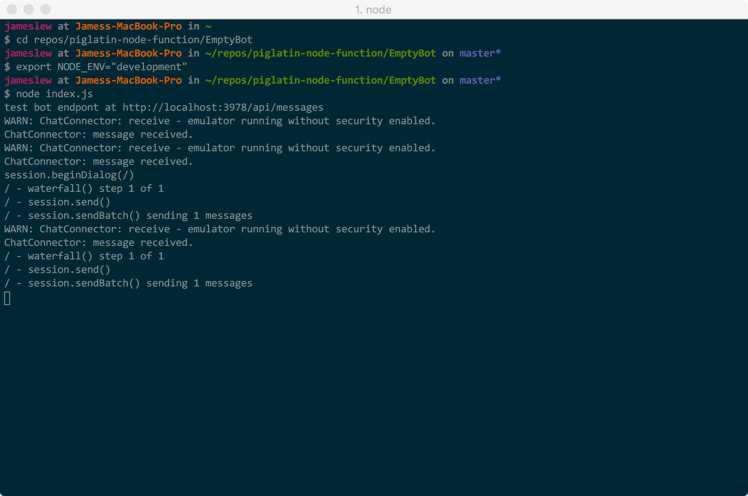

### **Debug a Node.js bot using breakpoints in Visual Studio Code**

If you need more than logs and request / response traces to debug your bot, you can use a local IDE such as Visual Studio Code to debug your code using breakpoints. Using VS Code to debug your bot can be beneficial because you can make changes locally within the editor while you are debugging, and when you push changes to the remote repository, those changes will automatically be applied to your bot in the cloud (since you have enabled continuous deployment).

First, launch VS Code and open the local folder where the source code for your bot is located.

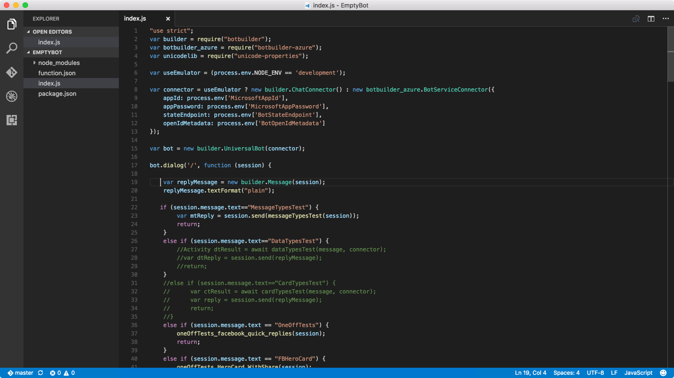

Switch to the debugging view, and click **run**. If you are prompted to select a runtime engine to run your code, select Node.js.

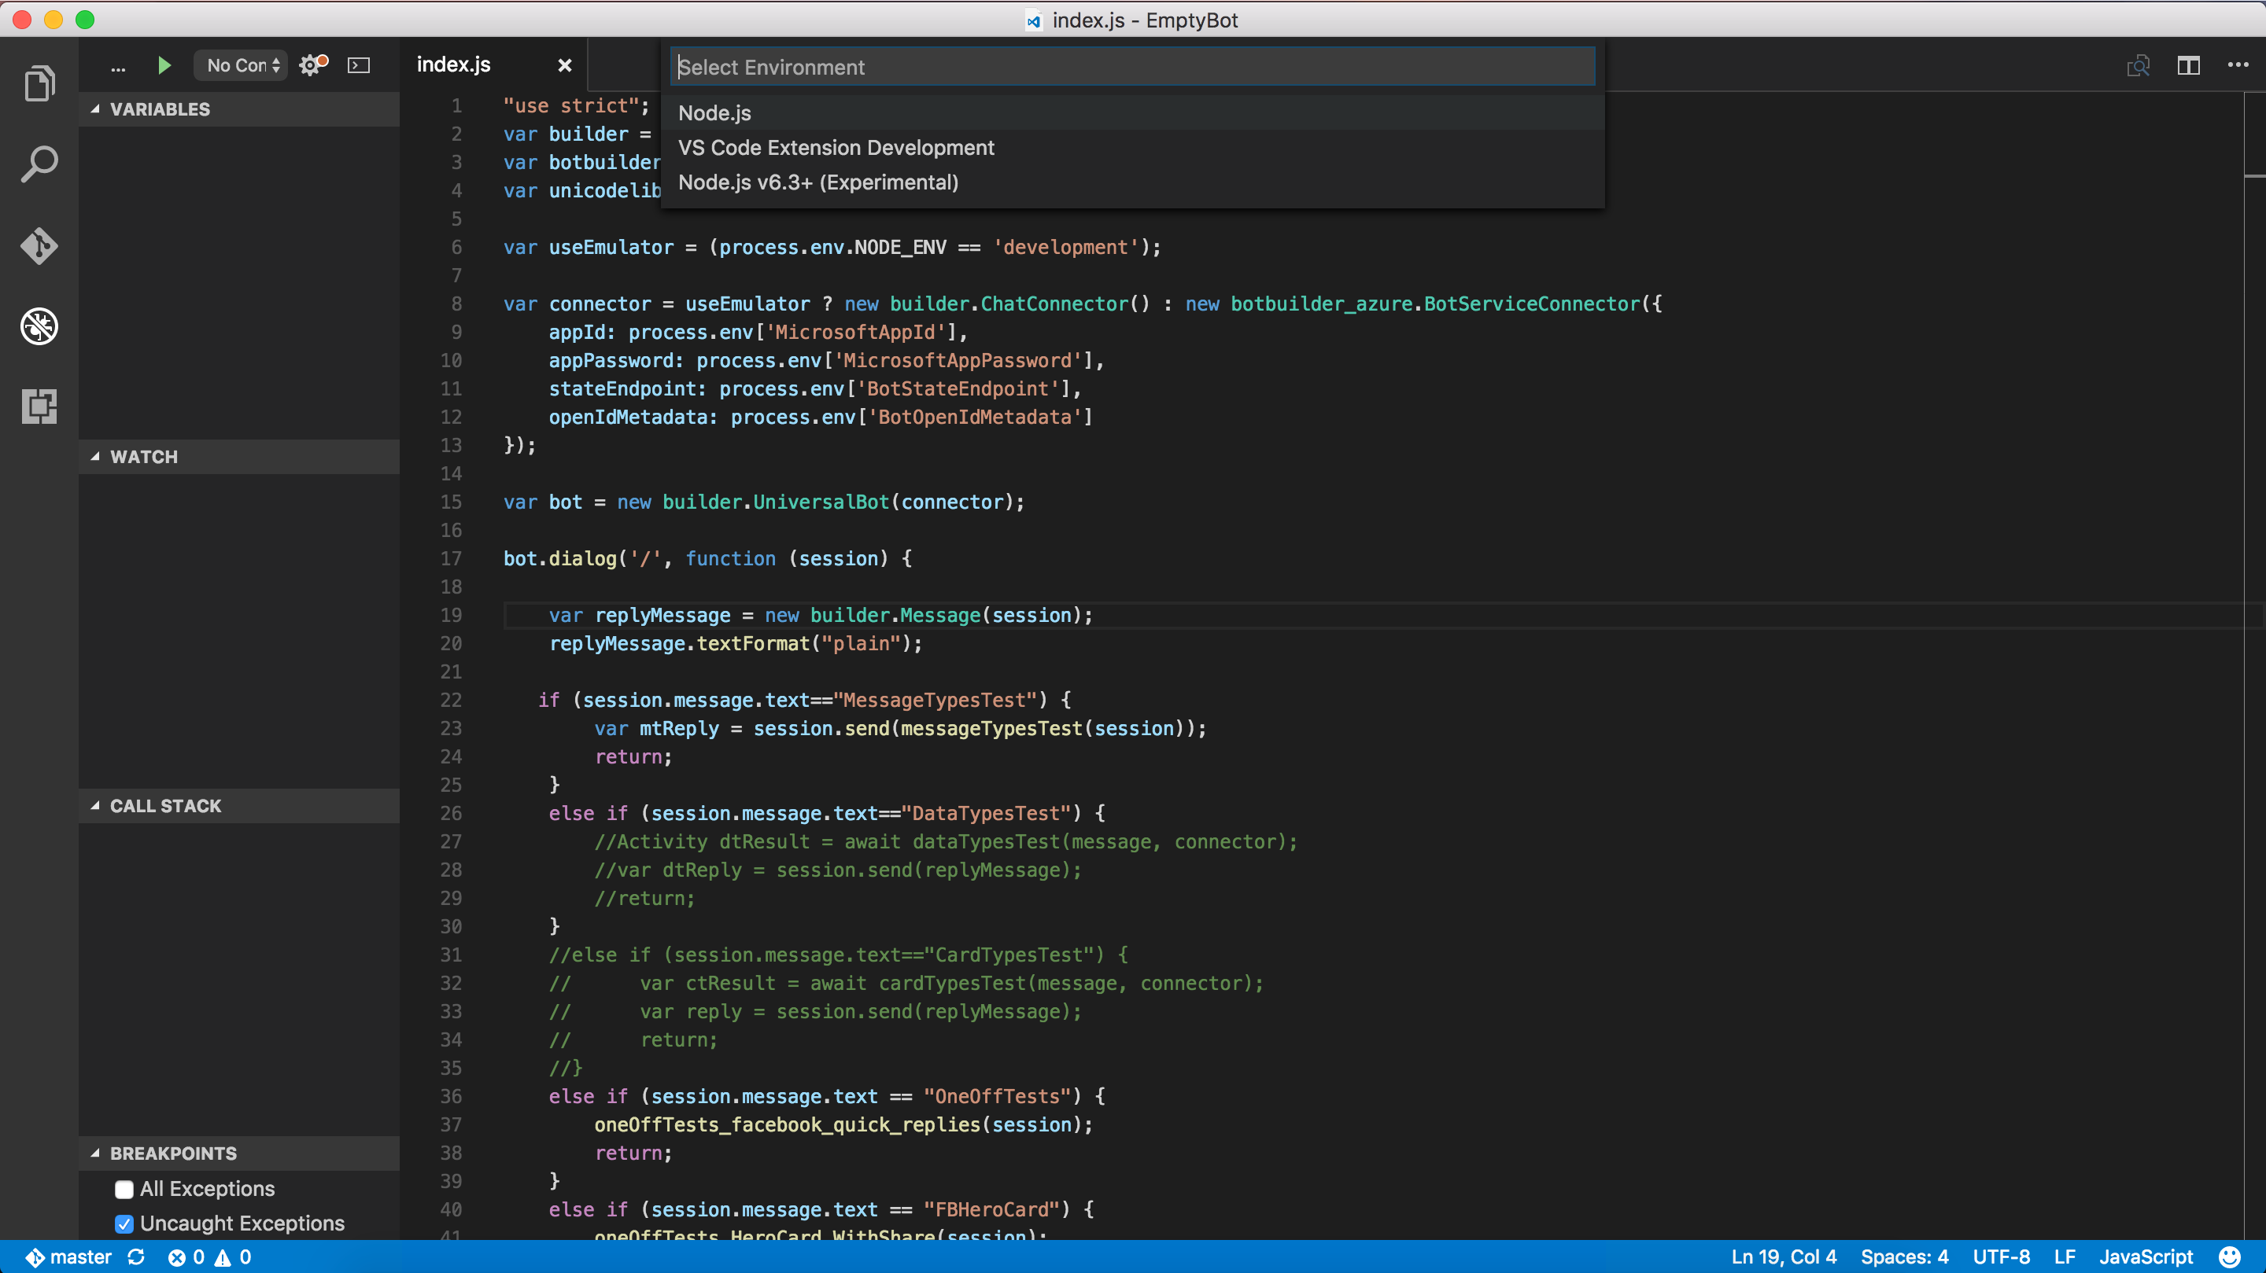

Next, depending on whether you have synced the repository or modified files, you may be prompted to configure the **launch.json** file. If you are prompted, add the env configuration setting to the **launch.json** file (to tell the template that you are going to work with the emulator).

JSONCopy

"env": {

"NODE\\_ENV": "development"

}

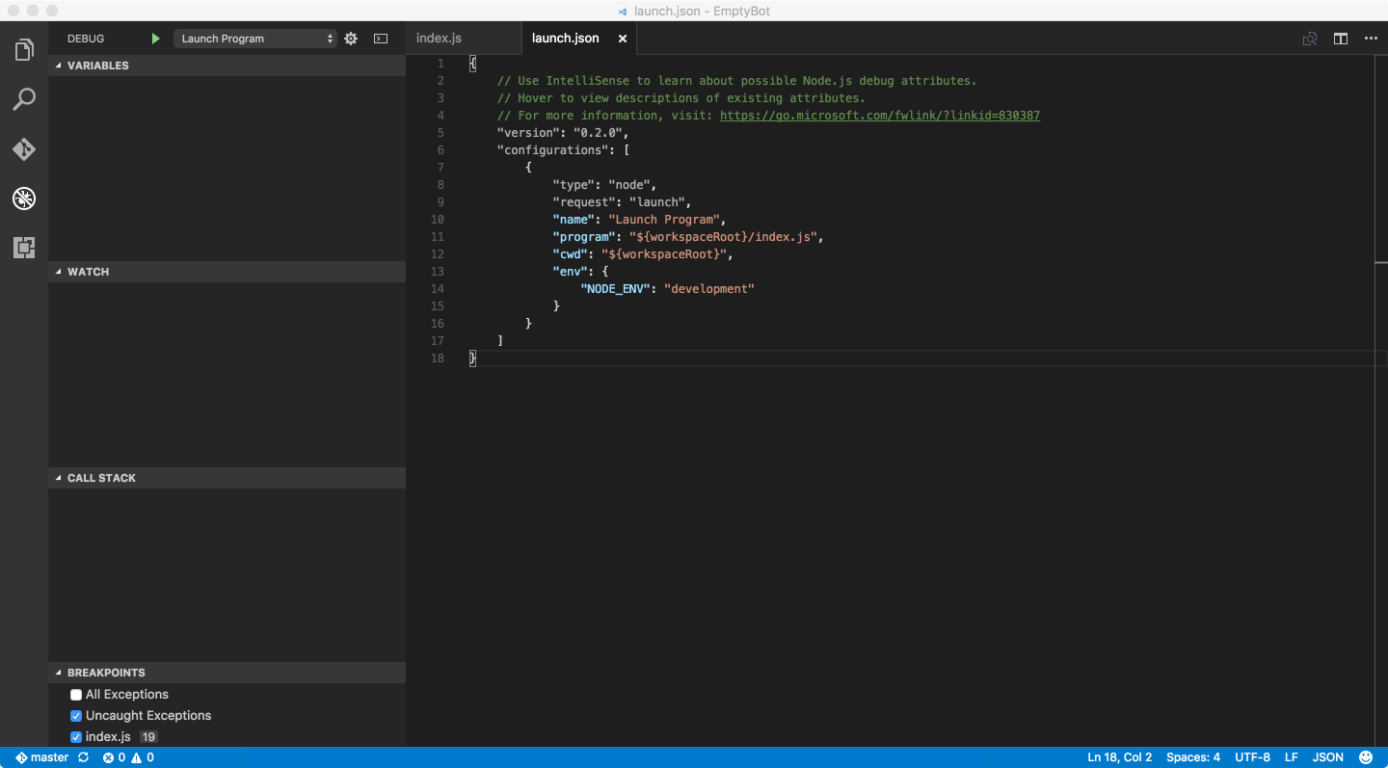

Save your changes to the **launch.json** file and click **run** again. Your bot should now be running in the VS Code environment with Node. You can open the debug console to see logging output and set breakpoints as needed.

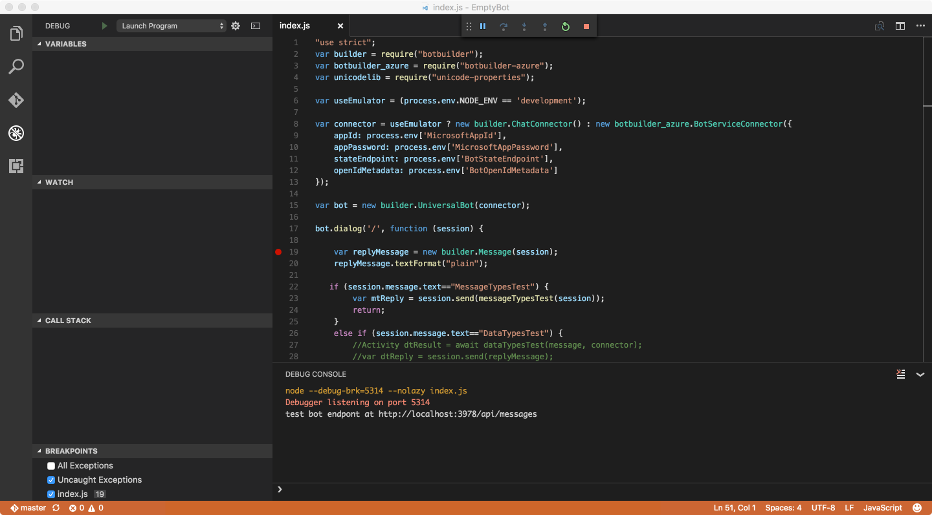

At this point, the bot is running locally. Copy the bot's endpoint from the debug console in VS Code, start the Bot Framework Emulator, and paste the endpoint into the address bar of the emulator. Since you do not need security for local debugging, you can leave the **Microsoft App ID** and **Microsoft App Password** fields blank. Click **Connect** to establish a connection to your bot using the specified endpoint.

After you have connected the emulator to your bot, send a message to your bot by typing some text into the textbox that is located at the bottom of the emulator window (i.e., where **Type your message...** appears in the lower-left corner). As messages are exchanged between the emulator and the bot, you should hit the breakpoints that you set in VS Code.

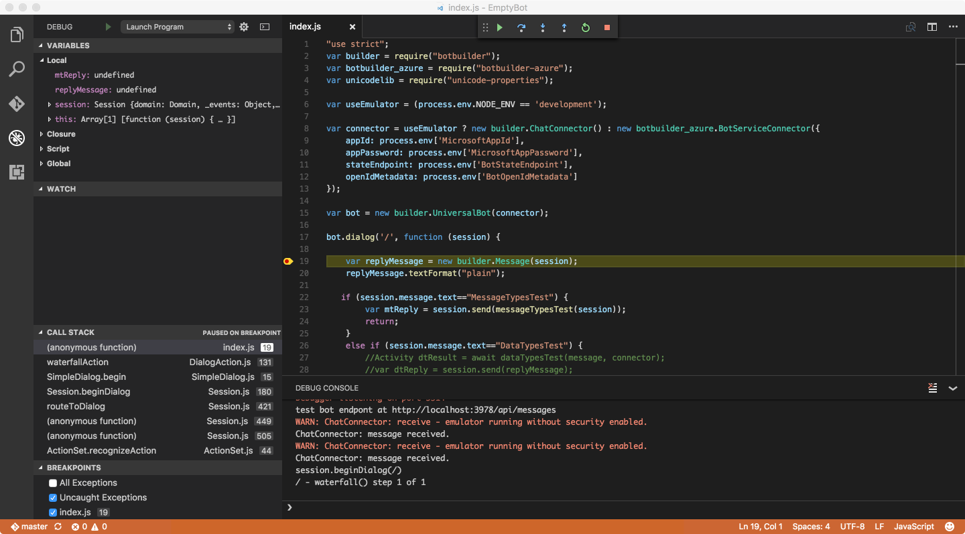

## **Debug an Azure App Service web app C# bot**

You can debug a C# bot Bot Service web app locally in Visual Studio.

### **Prerequisites**

Before you can debug your web app C# bot, you must complete these tasks.

* Download and install the [Bot Framework Channel Emulator](https://docs.microsoft.com/en-us/bot-framework/bot-service-debug-emulator).
* Download and install [Visual Studio 2017](https://www.visualstudio.com/downloads/) (Community Edition or above).

### **Get and debug your source code**

Follow these steps to download your C# bot source.

1. In the Azure Portal, click your Bot Service, click the **BUILD** tab, and click **Download zip file**.
2. Extract the contents of the downloaded zip file to a local folder.
3. In Explorer, double-click the .sln file.
4. Click **Debug**, and click **Start Debugging**. Your bot's default.htm page appears. Note the address in the location bar.
5. In the Bot Framework Channel Emulator, click the blue location bar, and enter an address similar to http://localhost:3984/api/messages. Your port number might be different.

You are now debugging locally. You can simulate user activity in the emulator, and set breakpoints on your code in Visual Studio. You can then [re-publish your bot to Azure](https://docs.microsoft.com/en-us/bot-framework/bot-service-continuous-deployment).

## **Debug a Consumption plan C# script bot**

The Consumption plan serverless C# environment in Bot Service has more in common with Node.js than a typical C# application because it requires a runtime host, much like the Node engine. In Azure, the runtime is part of the hosting environment in the cloud, but you must replicate that environment locally on your desktop.

### **Prerequisites**

Before you can debug your Consumption plan C# bot, you must complete these tasks.

* Download the source code for your bot (from Azure), as described in [Set up continuous deployment](https://docs.microsoft.com/en-us/bot-framework/bot-service-continuous-deployment).
* Download and install the [Bot Framework Emulator](https://docs.microsoft.com/en-us/bot-framework/bot-service-debug-emulator).
* Install the [Azure Functions CLI](https://www.npmjs.com/package/azure-functions-cli).
* Install the [DotNet CLI](https://github.com/dotnet/cli" \t "_blank).

If you want to be able to debug your code by using breakpoints in Visual Studio 2017, you must also complete these tasks.

* Download and install [Visual Studio 2017](https://www.visualstudio.com/downloads/) (Community Edition or above).
* Download and install the [Command Task Runner Visual Studio Extension](https://visualstudiogallery.msdn.microsoft.com/e6bf6a3d-7411-4494-8a1e-28c1a8c4ce99).

Note

Visual Studio Code is not currently supported.

### **Debug a Consumption plan C# script bot using the Bot Framework Emulator**

The simplest way to debug your bot locally is to start the bot and then connect to it from Bot Framework Emulator. First, open a command prompt and navigate to the folder where the **project.json** file is located in your repository. Then, run the command dotnet restore to restore the various packages that are referenced in your bot.

Note

Visual Studio 2017 changes how Visual Studio handles dependencies. While Visual Studio 2015 uses **project.json** to handle dependencies, Visual Studio 2017 uses a **.csproj** model when loading in Visual Studio. If you are using Visual Studio 2017, [download this **.csproj**file](https://aka.ms/bf-debug-project) to the **/messages** folder in your repository before you run the dotnet restorecommand.

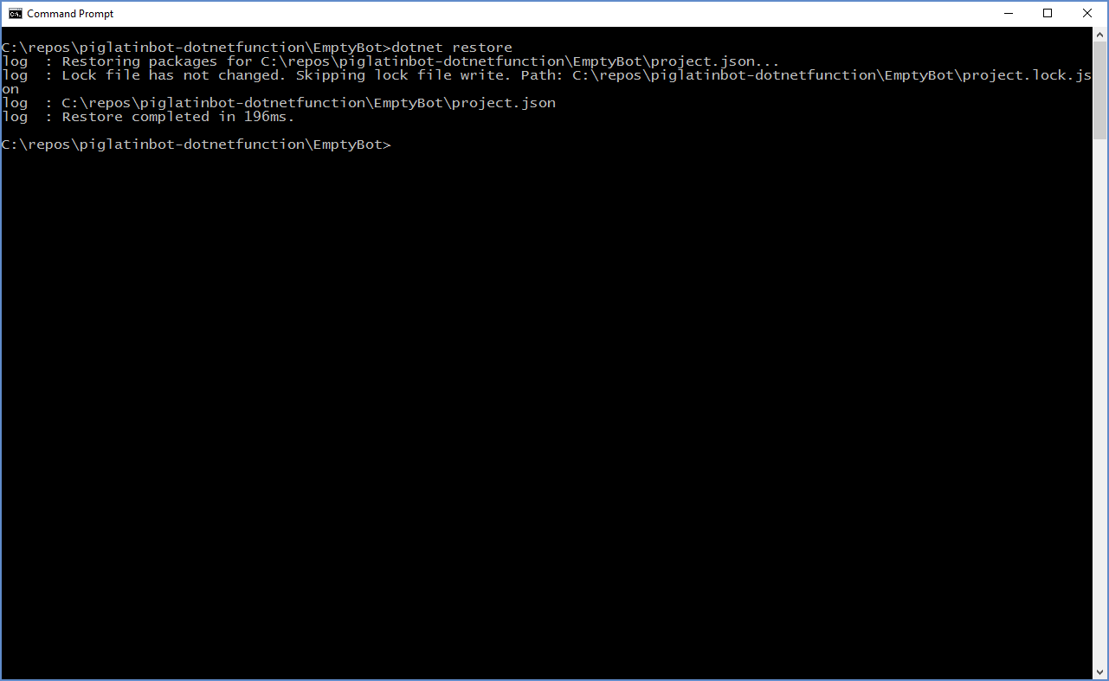

Next, run debughost.cmd to load and start your bot.

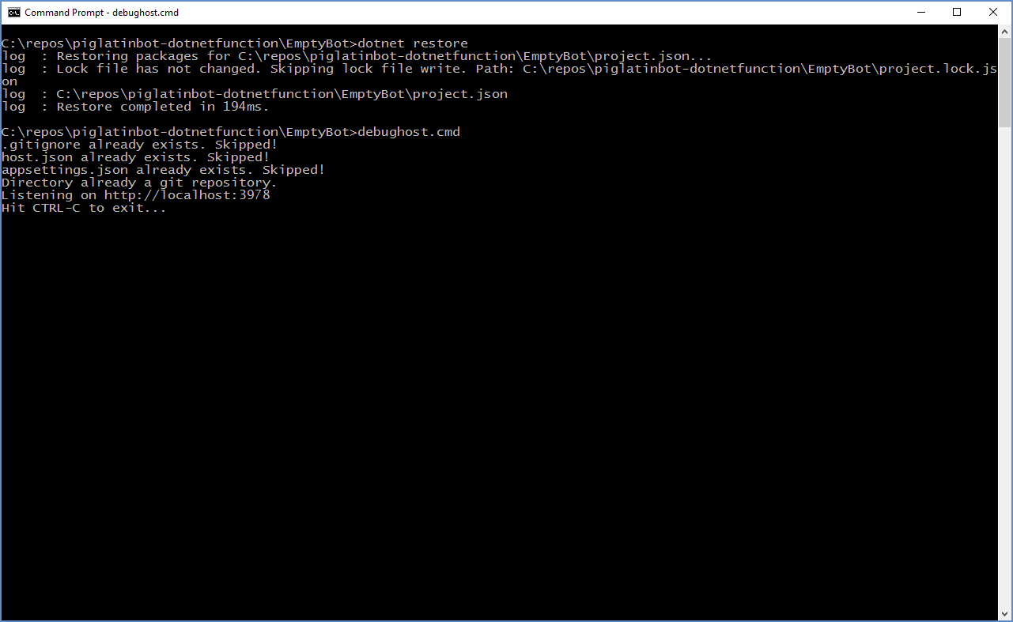

At this point, the bot is running locally. From the console window, copy the endpoint that debughost is listening on (in this example, http://localhost:3978). Then, start the Bot Framework Emulator and paste the endpoint into the address bar of the emulator. For this example, you must also append /api/messages to the endpoint. Since you do not need security for local debugging, you can leave the **Microsoft App ID** and **Microsoft App Password** fields blank. Click **Connect** to establish a connection to your bot using the specified endpoint.



After you have connected the emulator to your bot, send a message to your bot by typing some text into the textbox that is located at the bottom of the emulator window (i.e., where **Type your message...** appears in the lower-left corner). By using the **Log** and **Inspector** panels on the right side of the emulator window, you can view the requests and responses as messages are exchanged between the emulator and the bot.



Additionally, you can view log details the console window.

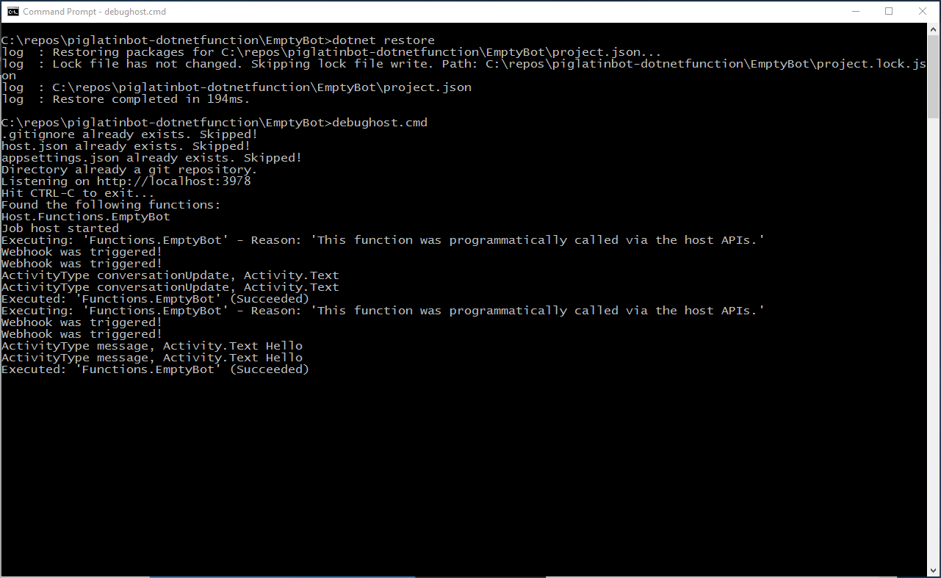

### **Debug a Consumption plan C# bot using breakpoints in Visual Studio**

To debug your bot using breakpoints in Visual Studio 2017, stop the **DebugHost.cmd** script, and load the solution for your project (included as part of the repository) in Visual Studio. Then, click **Task Runner Explorer** at the bottom of the Visual Studio window.

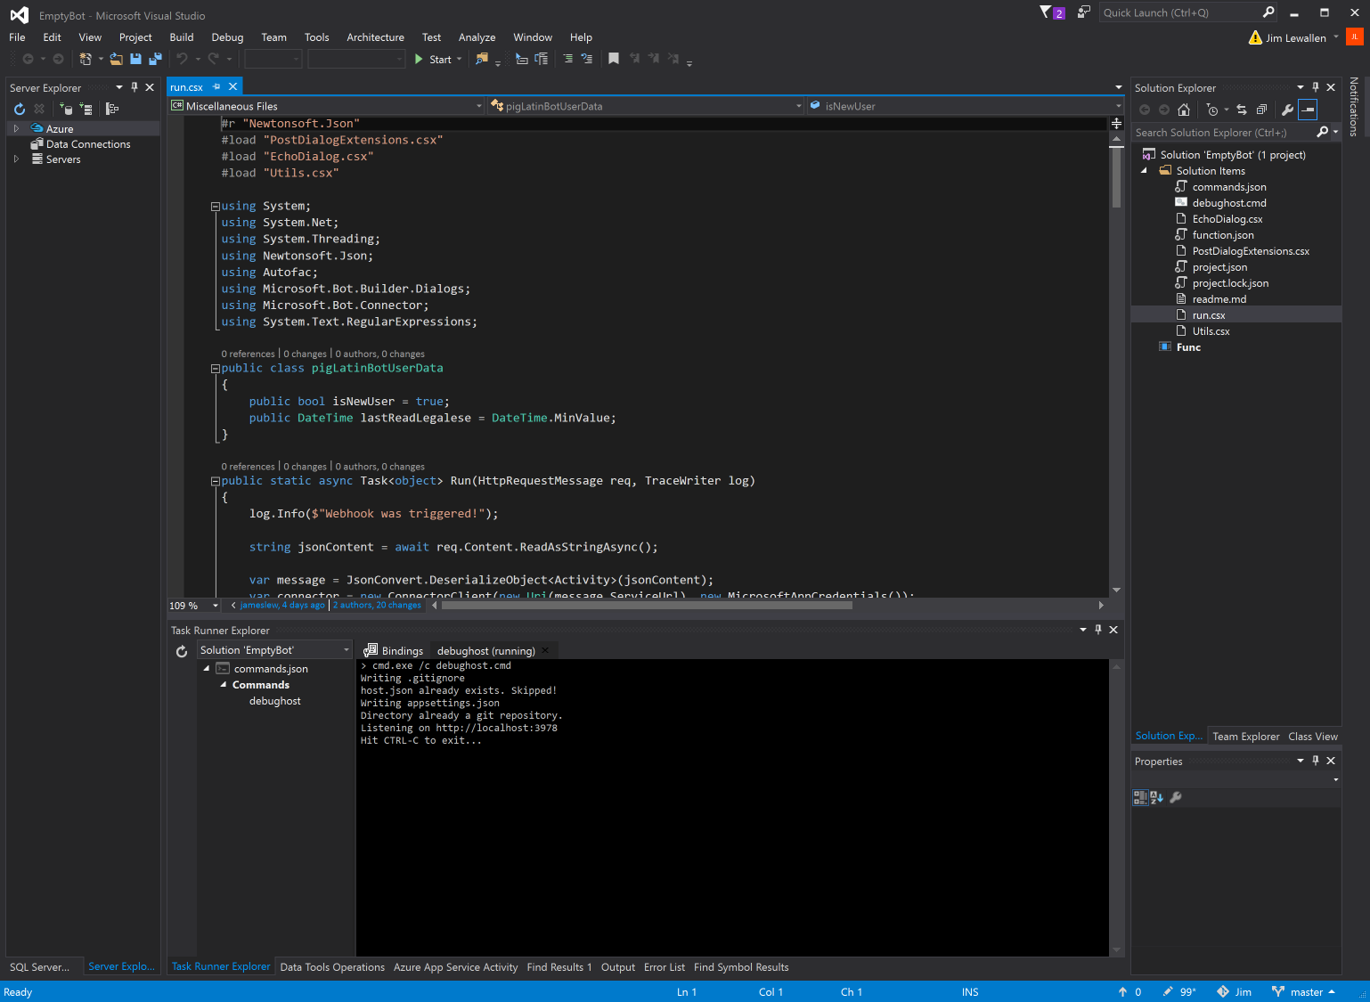

You will see the bot loading in the debug host environment in the **Task Runner Explorer**window. Your bot is now running locally. Copy the bot's endpoint from the **Task Runner Explorer** window, start the Bot Framework Emulator, and paste the endpoint into the address bar of the emulator. For this example, you must also append /api/messages to the endpoint. Since you do not need security for local debugging, you can leave the **Microsoft App Id** and **Microsoft App Password** fields blank. Click **Connect** to establish a connection to your bot using the specified endpoint.

After you have connected the emulator to your bot, send a message to your bot by typing some text into the textbox that is located at the bottom of the emulator window (i.e., where **Type your message...** appears in the lower-left corner). As messages are exchanged between the emulator and the bot, you will see the responses as well as logged output within **Task Runner Explorer** in Visual Studio.

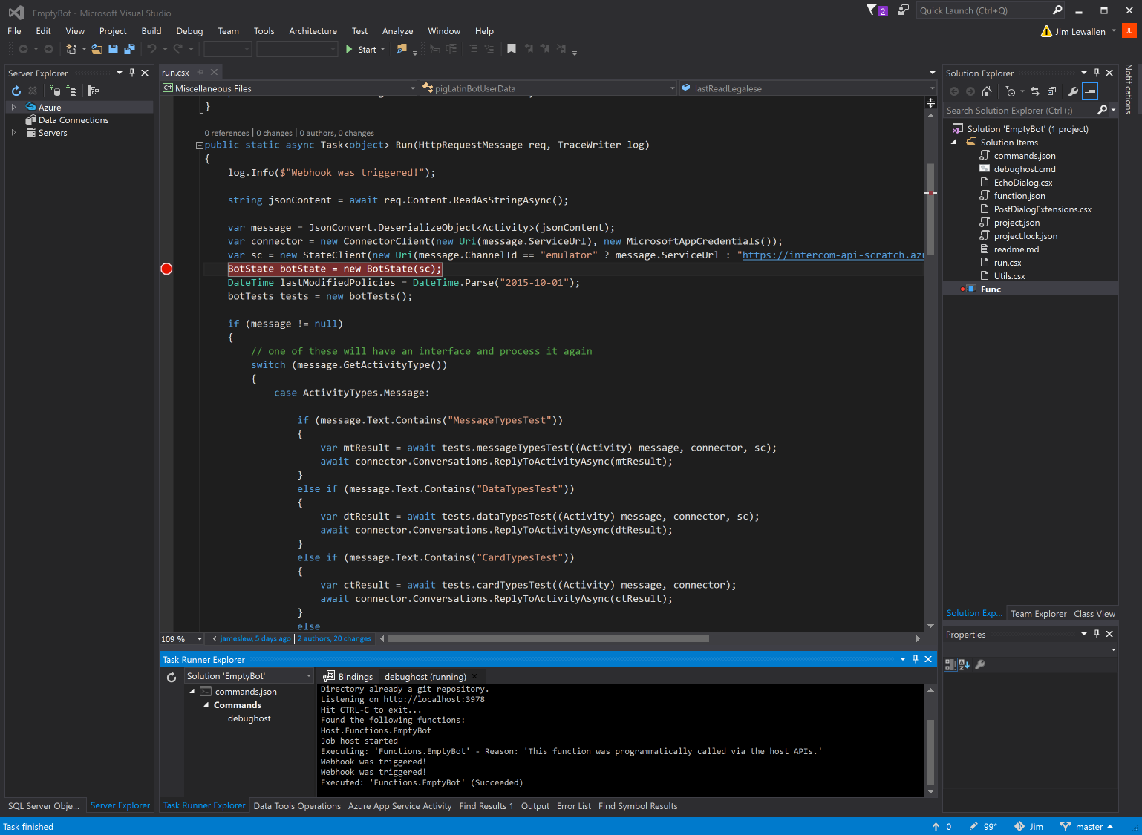

You can also set breakpoints for your bot. The breakpoints are hit only after clicking **Start** in the Visual Studio environment, which will attach to the Azure Function host (func command from Azure Functions CLI). Chat with your bot again using the emulator and you should hit the breakpoints that you set in Visual Studio.

Tip

If you cannot successfully set a breakpoint, a syntax error likely exists in your code. To troubleshoot, look for compile errors in the **Task Runner Explorer** window after you try to send messages to your bot.

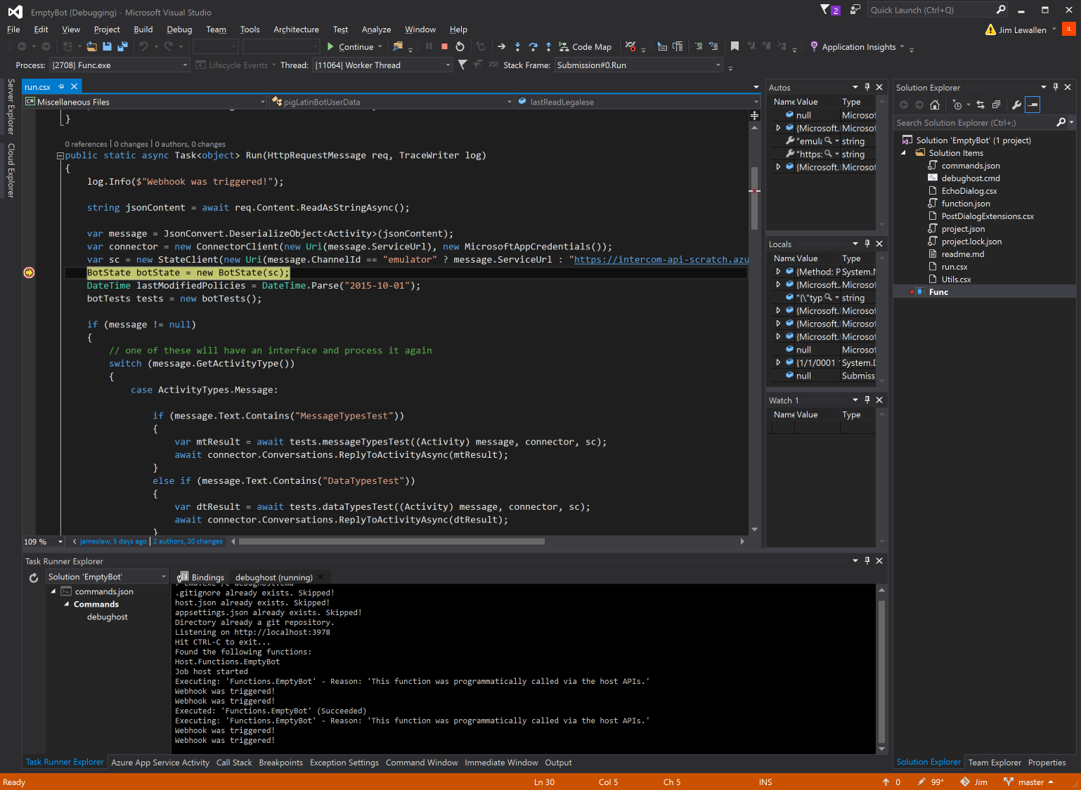

# Debug bots with the Bot Framework Emulator

The Bot Framework Emulator is a desktop application that allows bot developers to test and debug their bots, either locally or remotely. Using the emulator, you can chat with your bot and inspect the messages that your bot sends and receives. The emulator displays messages as they would appear in a web chat UI and logs JSON requests and responses as you exchange messages with your bot.+

Tip

Before you deploy your bot to the cloud, run it locally and test it using the emulator. You can test your bot using the emulator even if you have not yet [registered](https://docs.microsoft.com/en-us/bot-framework/bot-service-quickstart-registration) it with the Bot Framework or configured it to run on any channels.

## **Prerequisites**

### **Download the Bot Framework Emulator**

Download packages for Mac, Windows, and Linux are available via the [GitHub releases page](https://github.com/Microsoft/BotFramework-Emulator/releases).

### **Install and configure ngrok**

If you are using Windows and you are running the Bot Framework Emulator behind a firewall or other network boundary and want to connect to a bot that is hosted remotely, you must install and configure **ngrok** tunneling software. The Bot Framework Emulator integrates tightly with [ngrok](https://ngrok.com/) tunnelling software (developed by [inconshreveable](https://inconshreveable.com/)), and can launch it automatically when it is needed.

To install **ngrok** on Windows and configure the emulator to use it, complete these steps:

1. Download the [ngrok](https://ngrok.com/) executable to your local machine.
2. Open the emulator's App Settings dialog, enter the path to ngrok, select whether or not to bypass ngrok for local addresses, and click **Save**.

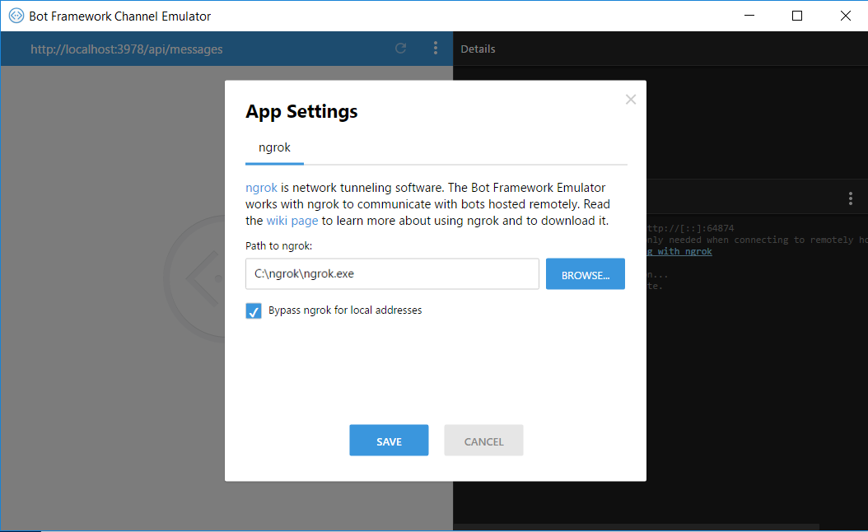

When the emulator connects to a bot that is hosted remotely, it displays messages in its log that indicate that ngrok has automatically been launched. If you've followed these steps but the emulator's log indicates that it is not able to launch ngrok, ensure that you have installed ngrok version 2.1.18 or later. (Earlier versions have been known to be incompatible.) To check ngrok's version, run this command from the command line:

ngrok -v

## **Connect to a bot that is running on localhost**

Launch the Bot Framework Emulator and enter your bot's endpoint into the emulator's address bar.

Tip

If your bot was built using the Bot Builder SDK, the default endpoint for local debugging is http://localhost:3978/api/messages. This is where the bot will be listening for messages when hosted locally.

Next, if your bot is running with Microsoft Account (MSA) credentials, enter those values into the **Microsoft App ID** and **Microsoft App Password** fields. For localhost debugging, you will not typically need to populate these fields, although doing so is supported if your bot requires it.

Finally, click **Connect** to connect the emulator to your bot. After the emulator has connected to your bot, you can send and receive messages using the embedded chat control.

## **Connect to a bot that is hosted remotely**

Launch the Bot Framework Emulator and enter your bot's endpoint into the emulator's address bar.

Next, populate the **Microsoft App ID** and **Microsoft App Password** fields with your bot's credentials.

Note

To find your bot's **AppID** and **AppPassword**, see [MicrosoftAppID and MicrosoftAppPassword](https://docs.microsoft.com/en-us/bot-framework/bot-service-manage-overview" \l "microsoftappid-and-microsoftapppassword).

Ensure that [ngrok](https://docs.microsoft.com/en-us/bot-framework/bot-service-debug-emulator" \l "ngrok) is installed and that the emulator's App Settings specify the path to the **ngrok**executable. **ngrok** enables the emulator to communicate with your remotely-hosted bot.

Finally, click **Connect** to connect the emulator to your bot. After the emulator has connected to your bot, you can send and receive messages using the embedded chat control.

## **Enable speech recognition**

The Bot Framework Emulator supports speech recognition via the [Cognitive Services Speech API](https://docs.microsoft.com/en-us/azure/cognitive-services/Speech/home). This allows you to exercise your speech-enabled bot, or Cortana skill, via speech in the emulator during development. The Bot Framework Emulator provides speech recognition free of charge for up to three hours per bot per day.

## **Send system activities**

You can use the Bot Framework Emulator to emulate specific activities within the context of a conversation, by selecting from the available options under **Conversation** > **Send System Activity** in the emulator's settings menu:

* conversationUpdate (user added)
* conversationUpdate (user removed)
* contactRelationUpdate (bot added)
* contactRelationUpdate (bot removed)
* typing
* ping
* deleteUserData

## **Emulate payment processing**

You can use the Bot Framework Emulator to emulate payment processing. In emulation mode, no real payment will be processed. Instead, the process payment logic simply returns a successful payment record. For payment processing, the emulator remembers your payment methods, shipping addresses, and it support form field validation.

# Test a Cortana skill

If you've built a Cortana skill using the Bot Builder SDK, you can test it by invoking it from Cortana. The following instructions walk you through the steps required to try out your Cortana skill.

## **Register your bot**

If you [created your bot](https://docs.microsoft.com/en-us/bot-framework/bot-service-quickstart) using Bot Service in Azure, then your bot is already registered and you can skip this step.

If you have deployed your bot elsewhere or if you want to test your bot locally, then you must [register](https://docs.microsoft.com/en-us/bot-framework/bot-service-quickstart-registration) your bot so that you can connect it to Cortana. During the registration process, you will need to provide your bot's **Messaging endpoint**. If you choose to test your bot locally, you will need to run a tunneling software such as [ngrok](http://ngrok.com/) to get an endpoint for your local bot.

## **Get messaging endpoint using ngrok**

If you are running the bot locally, you can get an endpoint to use for testing by running tunneling software, such as [ngrok](https://ngrok.com/). To use ngrok to get an endpoint, from a console window type:

cmdCopy

ngrok.exe http 3979 -host-header="localhost:3979"

This configures and displays an ngrok forwarding link that forward requests to your bot, which is running on port 3978. The URL to the forwarding link should look something like this: https://0d6c4024.ngrok.io. Append /api/messages to the link, to form a messaging endpoint URL in this format: https://0d6c4024.ngrok.io/api/messages.

Enter this endpoint URL in the **Configuration** section of your bot's [Settings](https://docs.microsoft.com/en-us/bot-framework/bot-service-manage-settings) blade.

## **Enable speech recognition priming**

If your bot uses a Language Understanding (LUIS) app, make sure you associate the LUIS application ID with your registered bot service. This helps your bot recognize spoken utterances that are defined in your LUIS model. For more information, see [Speech priming](https://docs.microsoft.com/en-us/bot-framework/bot-service-manage-speech-priming).

## **Add the Cortana channel**

Open the blade for your bot and click **Channels**. From the list of channels, click the **Cortana** icon.

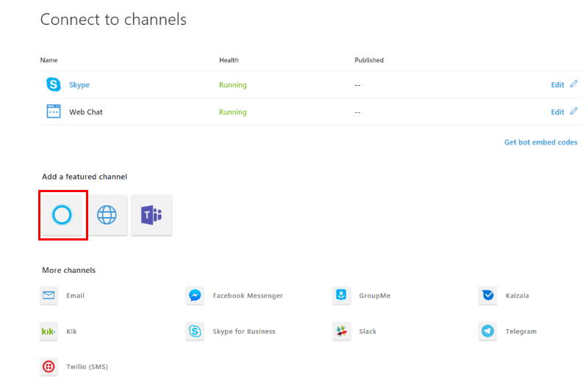

Note

[Secure your bot](https://docs.microsoft.com/en-us/bot-framework/dotnet/bot-builder-dotnet-security) by configuring the **AppID** and **AppPassword** in your **Web.config** file. To find your bot's **AppID** and **AppPassword**, see [MicrosoftAppID and MicrosoftAppPassword](https://docs.microsoft.com/en-us/bot-framework/bot-service-manage-overview" \l "microsoftappid-and-microsoftapppassword).

### **Configure Cortana**

When connecting your bot with the Cortana channel, some basic information about your bot will be pre-filled into the registration form. Review this information carefully. This form consists of the following fields.

| Field | Description |
| --- | --- |
| **Skill icon** | An icon that is displayed in the Cortana canvas when your skill is invoked. This is also used where skills are discoverable (like the Microsoft store). (32KB max, PNG only). |
| **Display name** | The name of your Cortana skill is displayed to the user at the top of the visual UI. (30 character limit) |
| **Invocation name** | This is the name users say when invoking a skill. It should be no more than three words and easy to pronounce. See the [Invocation Name Guidelines](https://aka.ms/cortana-invocation-guidelines) for more information on how to choose this name. |
| **Description** | A description of your Cortana skill. This is used where skills are discoverable (like the Microsoft store). |
| **Short description** | A short description of your skill’s functionality, used to describe the skill in Cortana’s notebook. |

### **Request user profile data (Optional)**

Cortana provides access to several different types of user profile information, that you can use to customize the bot for the user.

Note

You can skip this step if you don't need to use user profile data in your bot.

To add user profile information, click the **Add a user profile request** link, then select the user profile information you want from the drop-down list. Add a friendly name to use to access this information from your bot's code. See [Cortana-specific entities](https://aka.ms/lgvcto) for more information on using these fields.

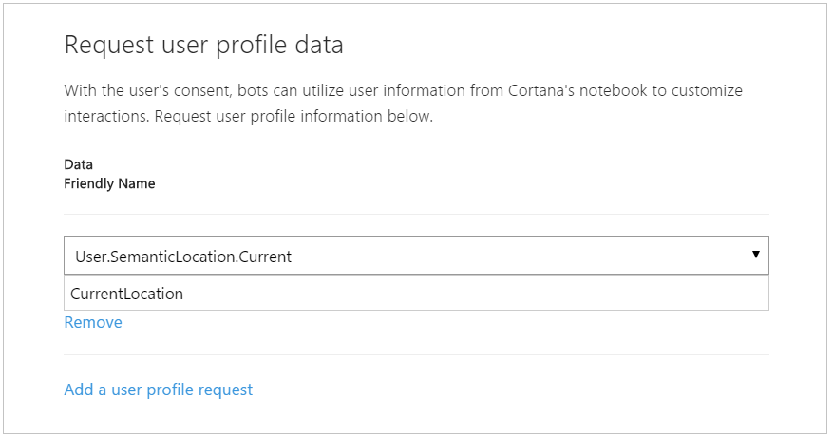

### **Manage user identity through connected services (Optional)**

If your skill requires authentication, you can connect an account so that Cortana will require users to log in into your skill before they can use it. Currently, only **Auth Code Grant** authentication is supported, and **Implicit Grant** is not supported. See [Secure your skill with authentication](https://aka.ms/vsdqcj) for more information.

Note

You can skip this step if your bot doesn't require authentication.

### **Connect to Cortana**

When you are done filling out the registration form for your Cortana skill, click **Save** to complete the connection. This brings you back to your bot's **Channels** blade and you should see that it is now connected to Cortana.

At this point your bot has already been automatically deployed as a Cortana skill to your account.

## **Test using Web Chat control**

To test your bot using the integrated web chat control in Bot Service, click **Test in Web Chat** and type a message to verify that your bot is working.

## **Test using emulator**

To test your bot using the [emulator](https://docs.microsoft.com/en-us/bot-framework/bot-service-debug-emulator), do the following:

1. Run the bot.
2. Open the emulator and fill in the necessary information. To find your bot's **AppID** and **AppPassword**, see [MicrosoftAppID and MicrosoftAppPassword](https://docs.microsoft.com/en-us/bot-framework/bot-service-manage-overview" \l "microsoftappid-and-microsoftapppassword).
3. Click **Connect** to connect the emulator to your bot.
4. Type a message to verify that your bot is working.

## **Test using Cortana**

You can invoke your Cortana skill by speaking an invocation phrase to Cortana.

1. Open Cortana.
2. Open the Notebook within Cortana and click **About me** to see which account you're using for Cortana. Make sure you are signed in with the same Microsoft account that you used to register your bot.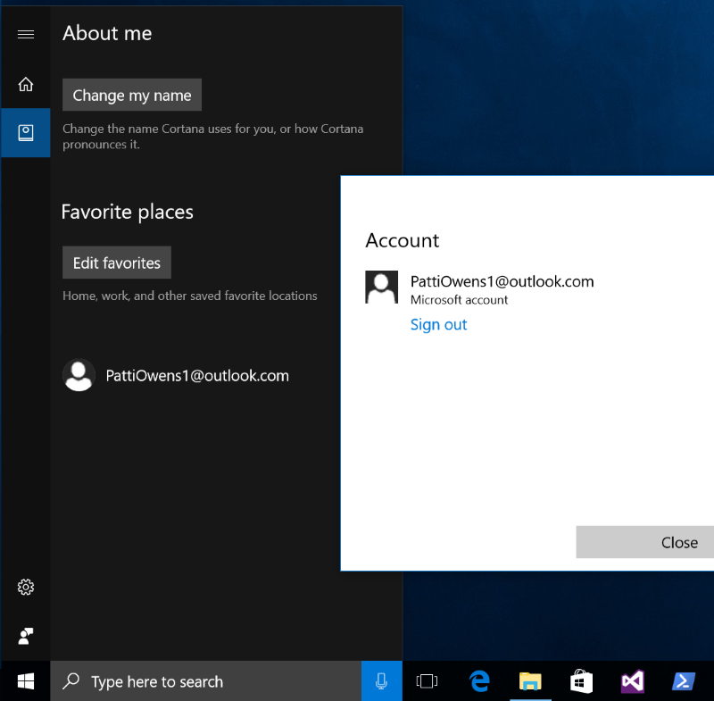
3. Click on the microphone button in the Cortana app or in the "Ask me anything" search box in Windows, and say your bot's [invocation phrase](https://aka.ms/cortana-invocation-guidelines). The invocation phrase includes an invocation name, which uniquely identifies the skill to invoke. For example, if a skill's invocation name is "Northwind Photo", a proper invocation phrase could include "Ask Northwind Photo to..." or "Tell Northwind Photo that...".

You specify your bot's Invocation Name when you configure it for Cortana. 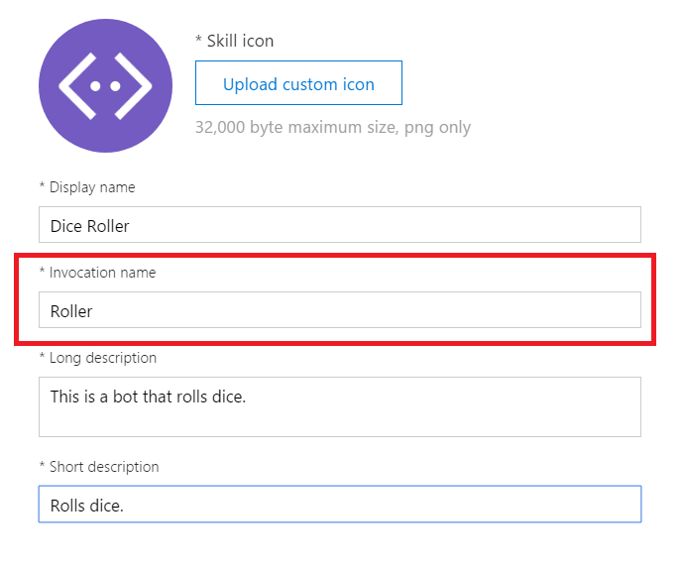

1. If Cortana recognizes your invocation phrase, your bot launches in Cortana's canvas.

## **Troubleshoot**

If your Cortana skill fails to launch, check the following:

* Make sure you are signed in to Cortana using the same Microsoft account that you used to register your bot in the Bot Framework Portal.
* Check if the bot is working by clicking **Test in Web chat** to open the **Chat** window and typing a message to it.
* Check if your invocation name meets the [guidelines](https://aka.ms/cortana-invocation-guidelines). If your invocation name is longer than three words, hard to pronounce, or sounds like other words, Cortana might have difficulty recognizing it.
* If your skill uses a LUIS model, make sure you [enable speech recognition priming](https://docs.microsoft.com/en-us/bot-framework/bot-service-manage-speech-priming).

See the [Enable Debugging of Cortana skills](https://aka.ms/cortana-enable-debug) for additional troubleshooting tips and information on how to enable debugging of your skill in the Cortana dashboard.